Registration Form

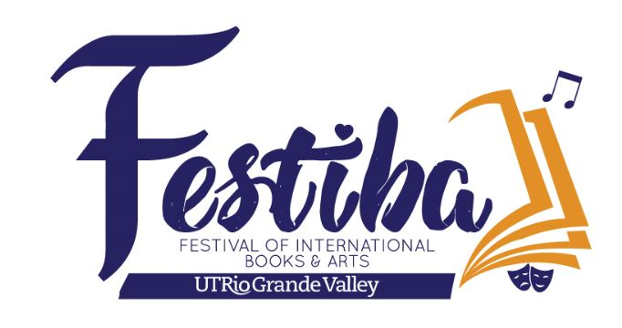
MARIACHI FESTIVAL 2023
March 3rd and 4th

School: _______________________________________ City: _______________________________________

Circle One: Individual Elementary Middle School High School

No. of Students Registering For Workshop: ________ No. of Directors: ________

Check appropriate participation(s): Competition ____Showcase ____ Master Class ______

List all directors: _____________________________________________________________________________

Email Address: _______________________________________________________________________________

School Phone: _________________________________Cell Phone: _____________________________________

Enrollment Fee: $45 per student (includes Masterclasess, Group Competition/Showcase, and Grand Concert)

Additional $20 per student competing in Vocal Competition.

If the Vocal Contestant wishes to attend the workshops, the $45.00 registration fee applies.
Directors may attend all events free of charge.

Total number of paying students: __________ @ $45.00 = $ _________

Submit registration form to festiba@utrgv.edu
Please submit payment at the PAC Box Office (956-665-3881) or UTRGV School of Music Office (956-665-3471). For more information call 956-665-3471 or email dahlia.guerra@utrgv.edu
or norma.salinas@utrgv.edu.

Workshop Registration Form cont.

School _____________________________________________ City: _______________________________

Circle One: Individual Elementary Middle School High School

Student Name Instrument
1.
2.
3.
4.
5.
6.
7.
8.
9.
10.
11.
12.
13.
14.
15.
16
17.
18.
19.
20.
21.
22.
23.
24.
25.
26.
27.
28.

Group Competition Registration Form
MARIACHI FESTIVAL 2023
March 3rd and 4th

School: ______________________________________________City: _____________________________

Circle One: Middle School High School Varsity 6A High School Varsity 5A
High School Varsity 4A High School Varsity 3A High School Varsity 1A/2A

High School Junior Varsity 1A - 6A

Stage Name: ___________________________________________________________________________

No. of Students Competing: _________________________

List all directors: ____________________________________________________________________________

School Phone: _________________________________Cell Phone: ______________________________________

Email Address: __________________________________________________________

Music to be performed: (Middle School: 6 to 8 minutes; High School: 8 to 10 minutes)

_____________________________________________________________________________________

_____________________________________________________________________________________

Rules and Regulations of Competition
1. Groups may enter the following categories: High School Varsity (Classifications: 6A, 5A, 4A, 3A or 2A/1A), High School Junior Varsity
6A – 1A, or Middle School. If there are not 2 or more groups in a single category, the groups will be moved up to the next category. Each category awards 1st, 2nd, and 3rd place winners. A Grand Champion from the High School 1A - 6A categories will be selected to play on the concert. Winners of the Vocal Competition and Middle School Competition will also perform on the concert.
2. High School Groups are allowed to play from 8 to 10 minutes. Middle School Groups are allowed to play from 6 to 8 minutes. Groups exceeding the time limit established for the competition will not be disqualified, but will be deducted points.
The clock starts with the first note played. Directors please refrain from excessive preparation time on stage
3. The stage plot will be the same for all groups (see stage plot). To assure the same sound quality for everyone, please do not move any microphones with the exception of the cordless mics.
4. All members of the performing group must be registered for FESTIBA 2023 Mariachi Festival.
5. Students may compete with only one mariachi ensemble and must be registered under one school.
6. If your school has only one mariachi, the group must compete at Varsity level.
7. A Middle School student may compete at the HS level, but not vice-versa. Students may compete with only one mariachi ensemble.
8. Please be ready at least thirty minutes before scheduled competition time.

Public Admission to Competition: $5.00 at the door

Vocal Competition Registration Form
MARIACHI FESTIVAL 2023
March 3rd and 4th

Student’s Name: ______________________________________________________________________

Circle One: Middle School High School

Director(s): ___________________________________________________________________________

Email Address: _________________________________ School: ________________________________

Cell Phone: ____________________________________

Name of song to be performed: ____________________________________________________________

Are you registered with a school group? __________

If yes, name of mariachi: __________________________________________________________________

Online vocal submissions are due February 5th. Audition videos should be uploaded to YouTube. Send link to francisco.loera@utrgv.edu. (For questions call Francisco Loera at 956-533-7483).
The videos will be reviewed by a panel of distinguished mariachi musicians.

Finalists will be announced February 15th. The finalists will be presented at the Vocal Competition Finals Concert.

Enrollment Fee: $20 per student competing in vocal competition.
If the Vocal Contestant wishes to attend the workshops, the $45.00 registration fee applies.

Submit registration form to festiba@utrgv.edu
Please submit payment at the PAC Box Office (956-665-3881) or UTRGV School of Music Office
(956-665-3471).

