Increasing Student Engagement Through Technology
Welcome to our workshop! We hope that you will find the tools we share with you today to be effective, flexible, and engaging alternatives to methods traditionally used in the university setting. These tools have applications in face-to-face, hybrid, and fully online courses. If you have any questions, we’d be happy to help: Katherine.christoffersen@utrgv.edu and Nicole.nicholson@utrgv.edu.
Please use this graphic organizer to help you take notes and, more importantly, to begin to imagine how you might implement these tools in your own classroom.

Tool 1: Yammer
Tool description: Social networking service used for private communication in organizations | Applications in the classroom:  - Whole-group announcements  - Small group chats  - Individual messaging with instructor | Notes:
Access:
- Yammer is provided to UTRGV automatically with the Office 365 Suite. Look for this icon:
- To download the app:
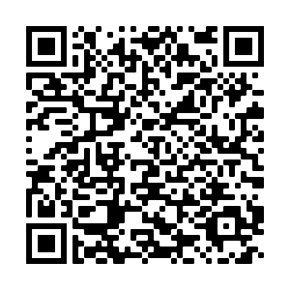

For which courses could I use this tool?

How might I apply this tool in these courses?

Tool 2: OneDrive
Tool description: File hosting and synchronization service, similar to GoogleDocs | Applications in the classroom:  - Materials sharing with students  - Collaborative writing/group work  - Tracked changes  - Online submission of assignments (essays, reports, etc.) | Notes:
Access:
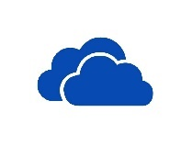
- OneDrive is provided to UTRGV automatically with the Office 365 Suite. Look for this icon:

For which courses could I use this tool?

How might I apply this tool in these courses?

Tool 3: OneNote Class Notebooks
Tool description: OneNote is a program for free-form information gathering and multi-user collaboration. It gathers users’ notes, drawings, screen clippings, and audio commentaries.  The Class Notebook feature is managed by the teacher; students have read-only access, collaborative space, and individual space. | Applications in the classroom:  - Research or reflection journals  - Small group collaborative assignments  - Assignment distribution and submission | Notes:
Access:
- OneNote is provided to UTRGV automatically with the Office 365 Suite. OneNote Class Notebooks are also available through the Office 365 sign-on. Look for this icon:

- The Class Notebook option is also linked automatically to Blackboard courses (though not the gradebook).
- The Class Notebook add-in can be run online or downloaded and synched to your personal computer.
For which courses could I use this tool?

How might I apply this tool in these courses?

Tool 4: Zoom
Tool description: Cloud-based communication that combines video conferencing, online meetings, chat, screen-sharing, and mobile collaboration. | Applications in the classroom:  - Whole-group virtual instruction  - Individual conferencing  - Small group collaboration  - Automatic captions available | Notes:
Access:
- Zoom is available to UTRGV students, faculty, and staff.
- It can be used on computers and on smartphones.
- You can find links for downloads and trainings here: https://www.utrgv.edu/it/software/zoom/index.htm
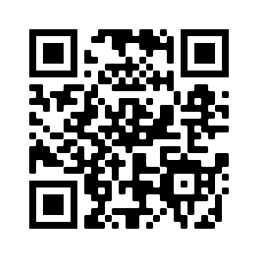
For which courses could I use this tool?

How might I apply this tool in these courses?

Tool 5: FlipGrid
Tool description: online video discussion board | Applications in the classroom:  - Video discussion board  - Formative feedback  - Alternative to written discussion boards | Notes:
Access:

- Free access at flipgrid.com (There is a separate educator log-on, and you can require that students use their UTRGV log-in.)
- Students can download an app to their phone. You can also provide QR codes and/or links to each discussion prompt.
- Flipgrid Student Guide
- Flipgrid Teacher Guide
- Educator’s Guide to FlipGrid
- Learning from Home Guide

For which courses could I use this tool?

How might I apply this tool in these courses?

Tool 6: Kahoot
Tool description: Online quiz game | Applications in the classroom:  - Review  - Check understanding  - Formative feedback | Notes:
Access:
- Free access to all at kahoot.com
- Students access the quiz through the unique code at kahoot.it

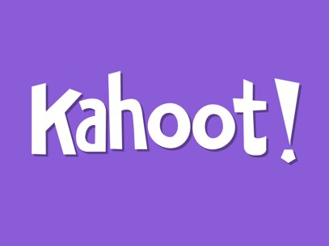
For which courses could I use this tool?

How might I apply this tool in these courses?

Tool 7: PollEverywhere
Tool description: Free service for taking polls of student understanding or information, similar to clickers | Applications in the classroom:  - Quick polls, quizzes  - See graphs and responses in real time  - Formative assessment | Notes:
Access:
- Free access at polleverywhere.com
- You can integrate these into Powerpoint and Google Slides.
- They are also quick to create 'on the fly.' (You can share these on your screen during a Zoom meeting.)
- Great option for a starter activity or 'exit ticket.'
For which courses could I use this tool?

How might I apply this tool in these courses?

Tool 8: Calendly
Tool description: Free online appointment scheduling software; syncs with Microsoft Outlook Calendar, including your UTRGV teaching and personal calendars. | Applications in the classroom:  - Scheduling virtual office hours  - Scheduling F2F office hours during busy times of the semester (required conferences, for example)  - UTRGV students can have the event synced to their Outlook calendars too | Notes:
Access:
- The free version supports only one kind of meeting (meeting length, meeting title, single/multiple invitees) at a time.
- To sign up and download the free app:
https://calendly.com/
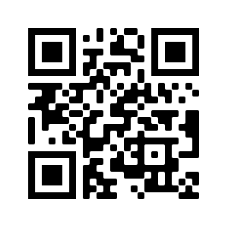

For which courses could I use this tool?

How might I apply this tool in these courses?

