

**Sport Clubs**

Officer and Participant Handbook

**Sport Club Staff**

Travis Hughes, Director of University Recreation

Annette Livas, Associate Director of University Recreation

Mike Ostman, Intramural and Sport Club Coordinator

Art Cabrera, Recreation Specialist

**Email**

recsports@utrgv.edu

**Phone Numbers**

Sport Club Office 655-7815

University Recreation 665-7808

University Police 665-7151 (Edinburg)

882-8232 (Brownsville)

**Main Facilities**

Recreation Field Complex

University Recreation Building

**Web Address**

www.utrgv.edu/urec

[www.utrgv.collegiantlink.net](http://www.imleagues.com/utpa)

**Table of Contents**

**Sport Club Program Overview 6**

**Definition 6**

**Recognition Criteria 6**

**How to Start a New Sport Club 8**

**Step 1: Complete Student Involvement’s Request for Permission to Temporarily Organize Form 8**

**Step 2: Get Approval from Student Involvement 8**

**Step 3: Complete Your Constitution and get it Approved 8**

**Step 4: Create your V Link Page 8**

**Step 5: Apply to be a Sport Club with University Recreation 9**

**Step 6: If accepted, schedule a meeting with the Sport Club Office to go over how to open your off-campus bank account. 9**

**Step 7: Begin populating V Link with your roster and announcement of the formation of your club. 9**

**Optional Step: IF NOT ACCEPTED 9**

**Constitution 10**

**Guidelines for Writing a Constitution 10**

**Bylaws 11**

**How can I use my Constitution & Bylaws? 12**

**Sport Club Tier Classification and Points Systems 13**

**Tier Classification System 13**

**Points System- Will be in trial period for 16’-17’ academic year 14**

**Policies and Procedures 20**

**Accountability 20**

**Club Officers 20**

**Officer Election 21**

**Coaches and Instructors 22**

**Membership 22**

**Forms and Reports 23**

**Facilities 23**

**Community Involvement 24**

**Competition 25**

**Conference & League Affiliation 25**

**Scheduling 25**

**Scheduling Officials 25**

**Visiting Teams 25**

**Spectators 25**

**National Championships 25**

**University ID 26**

**Financing, Purchasing and Payments 27**

**Bank Accounts 27**

**Sources of Revenue 27**

**Budget Appropriation Process 28**

**New Clubs 28**

**Fundraising and Development 28**

**Contracts 29**

**Tax Deductible Donations/Sponsorships 29**

**Purchasing 29**

**Reimbursements 30**

**Equipment 30**

**Tournament Entry Fees 31**

**Travel Procedures 32**

**Approval 32**

**Travel Authorization Packet 32**

**Pre-Trip Meetings 32**

**Extended Distance Travel 33**

**Trip Leader 33**

**Alcohol and Drugs 33**

**Request for Travel Authorization 33**

**Insurance 33**

**Reimbursements 33**

**Drivers 34**

**Methods of Travel 34**

**Lodging 35**

**Safety & Risk Management 36**

**First Aid/CPR/AED 36**

**First Aid Kits 36**

**Facility Inspections 36**

**Injury Reports 36**

**Head Injuries 37**

**Incident Reporting 37**

**Hazing 37**

**Major infractions 38**

**Social Media 39**

**Administrative Assistance 40**

**Coordinator for Intramural and Sport Clubs 40**

**Recreation Specialist 40**

**Sport Club Supervisor 40**

**Publicity 40**

**Storage 41**

**Meeting Space 41**

**Mail Service 41**

**General Office Support 42**

**Absence Letters 42**

**Appendix 43**

**Appendix A- Student Involvement Request for Temporary Permission to Organize 43**

**Appendix B- Constitution Requirements Checklist 44**

**Appendix C- Sample Constitution 45**

**Appendix D- Club Roster Form 49**

**Appendix E- Club Officer Form 50**

**Appendix F- Monthly Participation Report 51**

**Appendix G- Student Travel Packet 52**

**Appendix H- Travel Roster 56**

# Sport Club Program Overview

The Sport Club Program at The University of Texas- Rio Grande Valley provides a variety of opportunities for UTRGV students, faculty and staff to learn a new sport, network, live a healthy lifestyle and for full-time students compete against other university clubs or varsity teams. Sport Club organizations meet regularly for practices, demonstrations, clinics, seminars, social activities and may compete regionally and nationally. Any new policies made during the current academic year shall be deemed official even though they may not yet appear in the printed version.

## Definition

Sport Clubs at The University of Texas- Rio Grande Valley are defined as participation based student organizations that meet one or more of the following criteria:

* Members meet regularly to pursue an interest in competitive sports
* Clubs with similar interests that have an equivalent competitive university program
* Recreational physical activities

## Recognition Criteria

A student organization must meet all of the following criteria to be recognized as a sport club organization.

1. The organization must meet the requirements of a registered student organization as defined by the Office of Student Involvement
2. The organization must meet the University Recreation definition of a Sport Club
3. The organization’s primary activity must not duplicate that of an existing Sport Club organization on their campus
4. The organization must offer activities for which approved space is available
5. The organization must have a minimum of 5 full-time student members
6. Full-time University of Texas- Rio Grande Valley students must comprise at least 51% of the membership of the organization
   1. Faculty/staff at the University of Texas- Rio Grande Valley (either campus) may seek membership as non-travel/non-competitive members provided the organization still maintains 51% student membership at all times
   2. Individuals with no formal affiliation to the University may not seek membership in sport club organizations
7. Full-Time University of Texas- Rio Grande Valley students must fill the leadership roles within the organization
8. Only full-time University of Texas- Rio Grande Valley students may travel and compete on behalf of UTRGV’s Sport Clubs
   1. Exemptions to this rule may be made if a student is completing his/her final semester prior to graduation and requires less than 12 credits (undergraduate) or 9 credits (graduate) for graduation
   2. Faculty/staff may be granted exceptions to travel on a case-by-case basis (e. g. for added supervision, but may not compete on behalf of a student sport club)
9. All organizational decisions must be made by full-time students, elected leaders
   1. Membership in the organization must be open to all University of Texas- Rio Grande Valley students regardless of either the club or the prospective member’s campus location
   2. ***Organizations may be exclusively male or exclusively female provided there is a second club partaking in the same activity exclusive to the other gender (e.g. Men’s Soccer and Women’s Soccer)***
   3. ***The organization may not exclude any students from joining their club for any reason unless meeting the gender specific club requirements. However clubs may hold tryouts to select a traveling team if necessary.***

# How to Start a New Sport Club

All clubs must first be recognized with the Office of Student Involvement as a general student organization before applying for membership into the UREC Sport Club Program. Student Involvement can be contacted at involvement@utrgv.edu.

Please check with the Sport Club Office prior to beginning the registration process to ensure that a duplicate club does not already exist.

## Step 1: Complete Student Involvement’s Request for Permission to Temporarily Organize Form

The form can be downloaded from V-Link, or found in the Appendix of this handbook

1. Complete all the fields in the form. Print it out. Get it signed by your advisor and yourself. If you do not have an advisors outside of UREC put down
   1. Mike Ostman, Intramurals and Sport Clubs Coordinator, 956-665-7815, michael.ostman@utrgv.edu
2. Scan the form into your computer
3. Then log in to V Link with the same username and password as your UTRGV email.
   1. Click "Organizations" at the top, then search for “Student Involvement”
      1. Once on the Student Involvement page, click on "Forms" in the middle of the page
4. Click on the Request for Permission to Temporarily Organize form
   1. Complete all the required fields and at the bottom of the page upload your completed form that you scanned in. Hit submit

## Step 2: Get Approval from Student Involvement

Student Involvement will review your materials, ensure that your club does not duplicate an already existing one, ensure that all your members and advisor are actually enrolled or working at UTRGV, and potentially meet with you. Once all this is done they will sign off and your club will be temporarily approved.

## Step 3: Complete Your Constitution and get it Approved

Student Involvement will assist you in writing your Club Constitution. Please refer to the Constitution section of this handbook and the *Constitution Requirements Checklist* found in the Appendix for a starting point. Once you have written it you will meet with one of Student Involvement's staff. Their staff will go through your constitution with you and make sure it meets the standards of UTRGV, the Handbook of Operating Procedures and Student Involvement.

## Step 4: Create your V Link Page

Student Involvement will work with you to create a V Link page for your club.

## Step 5: Apply to be a Sport Club with University Recreation

Once your V Link page is created you can officially apply to be a member of the University Recreation Sport Club program.

1. On the V Link organizations page search for "University Recreation"
   1. Go to *Forms* in the middle of the page
      1. Click on the *Application for Acceptance into University Recreation Sport Club Program*
      2. Complete the form and hit submit.
2. After you submit your form you will be contacted by the Sport Club Office within 48 working hours to schedule a meeting. Upon completion of the meeting you will receive written notification within 1 business day of your acceptance, or reason for non-acceptance.

## Step 6: If accepted, schedule a meeting with the Sport Club Office to go over how to open your off-campus bank account.

## Step 7: Begin populating V Link with your roster and announcement of the formation of your club.

Designate one club member to be the organizer of your V Link page. Their job is to make sure it is continuously updated with current members, club announcements, photos, etc.

## Optional Step: IF NOT ACCEPTED

Non-Accepted clubs can appeal the decision to the Sport Club Council by completing the Sport Club Membership Appeal on V Link. You will be contacted within 48 hours of submission as to when your case will be heard. The Sport Club Council’s decision is final. You may reapply for membership at the beginning of eachacademic year.

# Constitution

Each club is required to have an updated constitution at the beginning of each academic year

## Guidelines for Writing a Constitution

*Article I Name*

State the name of the organization—for example, "The name of this organization shall be (insert name of organization here) at the University of Texas- Rio-Grande Valley."

*Article II Purpose & Goals*

Provide a general statement about the purpose and goals of the organization, as well as the type and scope of the organization’s activities. This is also an appropriate place to mention the organization’s affiliation with other groups, if any (for example, if the group is a chapter of a national organization).

*Article III Membership*

Provide a general statement about membership eligibility, standards, and requirements.

Recognized student organizations at University of Texas- Rio Grande Valley are required to be nondiscriminatory in membership unless otherwise permitted by applicable federal law (for example, Title IX). The language suggested is: "Membership is open to students, faculty, and staff of the University of Texas- Rio Grande Valley regardless of race, national origin, political affiliation, sex, creed or religion, age, disability, sexual orientation, veteran’s status, or weight." The membership selection process, types of membership, and procedures for disciplining and/or removing members should also be outlined here if not already appearing in the bylaws.

A majority of the total active membership of the student organization must be enrolled students. Only enrolled students may represent UTRGV at competitions, vote, and hold office.

*Article IV Officers*

In sections under this article; list the titles of offices to be established, qualifications for each office, the method, time, and process of selection, and the term of office. The duties, powers, and responsibilities of each officer as well as procedures for removal from office and filling vacancies should also be outlined here if not already appearing in the bylaws.

At a minimum, each student organization is expected to select one officer as the chief student leader (usually titled "president") and one officer authorized to deal with the organization’s finances (usually titled "treasurer"). The titles of these positions may vary according to the needs of the organization, but the two separate job functions must be provided for in this article. In addition, noting which officer has the responsibility of preparing and submitting the bi-annual Update Packet is strongly recommended.

This article is also the appropriate place to outline the selection process, qualifications,

responsibilities, and the term of office for the organization’s official university advisor(s).

*Article V Finances*

Provide a general statement about the way in which the finances of the organization should be handled, including what should happen to the organization’s funds if the organization is ended. Detailed financial procedures including the amount and collection procedures for dues, if any, should also be outlined here if not already appearing in the bylaws.

*Article VI. Amendments & Ratification*

This article should explain how constitutional amendments may be made, as well as the procedure for adopting this constitution and any future amendments. At a minimum, your constitution must be voted on and approved by the general membership of your organization.

This article should also include a statement requiring prompt submission of an updated constitution and bylaws to the Office for Student Involvement for review by the Committee on Student Organizations should the document be changed following recognition.

To be valid, the constitution must be signed by at least the organization’s chief student officer and primary advisor. You will want to provide a space for these individuals to sign and date the document.

## Bylaws

Bylaws are secondary principles that govern the internal affairs of an organization. Bylaws are essentially an expansion of the articles or sections of the constitution. They describe in detail the procedures and steps the organization must follow in order to conduct business effectively and efficiently.

*Why should I have Bylaws?*

Student organizations are not required to have bylaws, but may find them helpful to the organization’s operations. The constitution covers the fundamental principles but does not provide specific procedures for operating your organization. Bylaws should set forth in detail the procedures your group must follow to conduct business in an orderly manner. They provide further definition to the provisions contained in the constitution and can be changed more easily as the needs of the organization change.

*What should I include in my Bylaws?*

Bylaws must not go against rules in the constitution. They generally contain, as needed, more specific information on the topics outlined below. If your organization has chosen not to develop bylaws, this information may be included in the appropriate sections of your constitution. The following are some standard articles that commonly appear in organization bylaws:

* **Membership -** Sections under this article should discuss and detail the various aspects of membership that may be applicable: membership selection process, types of membership, and procedures for disciplining and/or removing members.
* **Officers -** Sections under this article should discuss the officer selection process, duties, powers, and responsibilities of each officer, and procedures for removal from office and filling empty officer positions.
* **Committees** - Sections under this article should discuss and detail standing and special committees (formation, selection, powers, and duties) and the executive committee (membership, powers, and duties), along with the roles and responsibilities of committee chairs.
* **Meetings -** Sections under this article should discuss types of meetings, how and when they are to occur, requirements for notice, attendance, and quorum (number of members needed present to transact business), meeting format, and parliamentary rules of order (usually Robert’s Rules of Order).
* **Financial Procedures** - Sections under this article should discuss and detail (if applicable) dues, initiation fees, and fines, collection procedures, and other financial procedures (budgets, expenditures, etc.).
* **Amendment Procedures** - Sections under this article should discuss the procedure for amending the bylaws (means of proposals, notice required, and voting requirements). Lastly, this is where you can include other specific policies and procedures unique to your organization that may be necessary for its operation.

## How can I use my Constitution & Bylaws?

Remember the reasons for having a constitution and bylaws. They articulate the purpose of your organization and spell out the procedures to be followed for its orderly functioning. Constitutions usually require a 2/3 vote of the membership for adoption. Bylaws only require a simple majority for passage. Once you have developed your constitution and bylaws, review them often. The needs of your group will change over time and it is important that the constitution and bylaws are kept up to date to show the current state of affairs.

# Sport Club Tier Classification and Points Systems

The classification system was established to recognize that individual clubs have goals and objectives unique to that club. The Sport Club Program has limited resources in funding, facilities, and equipment for the program. This classification system allows the program to bring consistency in the allocation of resources to all clubs. At the end of each year, the Sport Club Office will review the status of each club and determine whether they met the requirements for to remain in their tier for the next year. The staff has the authority to change the status of a club based on any number of unforeseen changes including, but not limited to budget restrictions, facility limitations, university policy changes, problems with club behavior, club purpose changes, and/or failure to meet any of the guidelines set in the Sport Club Handbook.

## Tier Classification System

**Tier I- Can Receive up to 50% of approved budget**

* Are members of a recognized collegiate league, conference or National Governing Body
* Must have at least fifteen (15) active members
* Host at least three (3) or more competitions, exhibits, seminars
* Must raise 50% of funds allocated from UREC
* Must participate in at least three (3) community services events (at least 10 members
* Required attendance at practice to compete
* Any coach or instructor is approved by the Sport Club Coordinator
* Must have submitted their budget request/proposal on-time
* End of the Year Points=40 or more

**Tier II- Can Receive up to 40% of approved budget**

* Must join a league or host a tournament
* Must have at least twelve (12) active members
* Host at least two (2) or more competitions, exhibits, seminars
* Must raise 50% of funds allocated from UREC
* Must participate in at least two (2) community service events (at least 6 members)
* Required attendance at practice to compete
* Any coach or instructor is approved by the Sport Club Coordinator
* Must have submitted budget request/proposal on-time
* End of the Year Points= 35-39

**Tier III- Can receive up to 30% of approved budget**

* Must have at least eight (8) active members
* At least ½ of the members must compete in a tournament or league
* Must raise 50% of funds allocated from UREC
* Must participate in at least one (1) community service event (at least 6 members)
* Must have submitted budget request/proposal on-time
* End of the Year Points=30-34

**Tier IV- Funding by special circumstance only**

* Clubs may be classified as Tier IV if
  + They failed to meet the classifications of Tier III
  + Primary Function is an recreational activity
  + They finish the year with less than 30 points
  + They are inactive
  + New Clubs

Any club wishing to be reclassified to a higher tier for the following academic year will need to make a formal written request to the Sport Club Office no later than March 1st. The officers of clubs requesting reclassification will meet with the Sport Club Coordinator prior to the Sport Club Office’s budget review. A decision on reclassification will be made by the Sport Club Office and the club will be notified prior to budget allocations.

## Points System- Will be in trial period for 16’-17’ academic year

The purpose of the University of Texas- Rio Grande Valley Sport Clubs Points System is to ensure that all Sport Clubs are fulfilling the requirements necessary to be a Sport Club, and are following all Sport Club and University Recreation policies. Clubs are not required to do anything extra outside of categories marked as “required”, but are encouraged to earn as many points as possible if they want to be included in a certain tier that has a higher requirement.

**What will points be used for?**

* Tier Placement
* Determining allocations
* Field/Space Priority
* Financial Rewards/End of the Year Awards
* Penalties and Sanctions against clubs

**Criteria for receiving points**:

All types of clubs have equal opportunities to earn points through various tasks and activities. There are many ways to earn points, some which differ based on your type of club; competitive or recreational.

**Why the system is called a “Points System”?**

Each club begins the year with 30 points, which, as indicated by the point levels below, is the optimal level clubs aim to maintain. This is the minimum points score required to operate with all privileges clubs are entitled to. Clubs must maintain a sufficient point score by submitting forms on time and meeting club expectations. Failure to do so will result in point deductions and other penalties, as outlined below. Points can be earned back through various tasks (such as fundraising or marketing) in order to return to the required minimum score of 30. Negative balances do not rollover annually.

**Point Levels**

* 30 or above: Club is operating at the appropriate level and is entitled to all privileges offered to UTRGV Sport Clubs.
* Under 30: If a club ends the year under 30 they will automatically be placed in Tier IV for the following year.
* 20: Once a club reaches 20 points they must meet with the Sport Club Coordinator. Clubs cannot use allocated university funds if they have 20 points or less
* Under 15: Club cannot travel
* Under 10: Club cannot hold any on campus events/competitions
* Under 5: Club cannot practice/hold meetings. Events like fundraisers or community service to earn points are the only club functions permitted.
* 0 or Negative Points: Club cannot operate in any way and must appear before the Sport Club Council to present their case and plan in writing to get back into good standing. All tier requirements for the following year will double regardless if the club ends the year over 30.

**Category #1: REQUIRED for a Successful Start to the Year (How you keep your 30 points)**

There are several meetings and requirements that club officers must complete every year. Failure to attend these meetings will result in significant point deductions:

* **Fall Officer Training-** The President, Vice- President, Secretary, and Treasurer from each club must attend this training in order to keep points. Each of the officers not in attendance will result in -3 points per officer.
* **Club Recognition-** Each club must complete the recognition process by filling out the form on V-Link by September 13, 2015, or prior to any official club events (whichever comes first). Failure to complete the form will result in -10 points.
* **First Aid/ CPR Certifications**- All clubs must show proof of 2 members who are CPR/AED certified. Failure to show proof of CPR/AED certifications will result in -4 points (per certification) every week starting on September 13, 2015. Please plan accordingly. Exceptions will be granted if there is not a First Aid/CPR training provided before that date.

**Category #2: Club Culture**

* **Support for other clubs-** Clubs are encouraged to attend events put on by other sport clubs and support them. In order to receive points clubs must wear something that denotes which club they belong to (uniform/shirt/etc.). Clubs will receive 1 point for each member in attendance with a maximum of 10 points awarded per event. Clubs can earn 5 bonus points by bringing 20+ members.
* **Participation in Sport Club Council-** Each club is required to designate one member as their Sport Club Council Representative. Sport Club Council meetings will take place once a month. Attendance from each club is required. Failure to attend will result in a -10 deduction. If the Sport Club Council Representative cannot attend another club member by attend in their place up to 3 times.
* **Participation in Special Events-** University Recreation and Sport Clubs will put on different special events throughout the year. If 25% of your roster participates in these events you will receive 5 points. Clubs can earn 5 points for each special event with no maximum and will be notified for each event.
* **Outdoor Adventures-**25% of your entire roster must participate to get points. Participation in an Outdoor Adventures program put on by University Recreation will gain the club 5 points. Clubs may only earn points for Outdoor Adventures 4 times per year, with a maximum of 20 points.
* **Fitness Events-** 25% of your entire roster must participate to get points. Participation in a special Fitness Event put on by University Recreation (Healthy Cook-Out, 5k, etc.) will gain the club 5 points. Clubs may only earn points for fitness events 4 times per year, with a maximum of 20 points.
* **Intramural Sports** – 25% of your entire roster must participate to get points. Participation in an intramural sport will gain the club **5 points.** Clubs may only earn points for intramural sports 4 times a year, with a maximum total of **20 points.**

**Category #3: Fundraising**

Clubs can earn points for funds raised by the club that are deposited into their off-campus account as fundraising (does not include member dues). This can come in the form of letter writing campaigns, donations, sponsorships, candy sales, etc. If your club needs fundraiser ideas, please contact your Sport Club Coordinator. Clubs must submit a Fundraiser Points request form (also found on V-Link) after the completion of these fundraisers as well as receipts, bank statements, invoices etc., that provide proof of income. Maximum points awarded will not exceed **20 points** in this category per semester. Points awarded are based on profit (revenue - cost of fundraiser).

* Fundraisers with a profit between $0-$99.99 will receive **1 point.**
* Fundraisers with a profit between $100-$499.99 will receive **5 points.**
* Fundraisers with a profit between $500-$999.99 will receive **10 points.**
* Fundraisers with a profit over $1,000 will receive **20 points.**

**Category #4: Dues**

Member dues are dues paid by each individual club member to participate. Charging member dues is not required, but suggested. This does not include funds from external parties of funds raised nor does it include league dues. The price range below reflects dues charged to each member, not a club's collective dues. Clubs will not receive points until everyone on the roster has paid. Clubs that charge:

* Dues between $10.00 - $19.00 will receive **1 point.**
* Dues between $20.00 - $39.99 will receive **2 points.**
* Dues between $40.00-$59.99 will receive **3 points.**
* Dues between $60.00-$79.99 will receive **4 points.**
* Dues between $80.00-$99.99 will receive **5 points.**
* Dues of $100 or more will receive **6 points.**

**Category #5: Community Service**

Throughout the year clubs are expected to give back to the community that supports them through various community service projects. Clubs may complete additional community service points ONLY if they complete the Community Service Request Form found on V-Link. The Community Service Points Request Form is **due 5 days** after the Community Service occurred, and must have at least 30% of the entire roster in attendance for the event. Forms that are not filled out properly WILL NOT BE ACCEPTED. Through a community service project, a club **cannot** receive any compensation for their work until they have completed the three events required for the tier system. Clubs can reach a maximum of **50 points** in this category.

**Community Service**—5 pointsfor every 10hours

**EXAMPLE:** If 30% of your club is 5 members and 5 members complete 2 service hours that will be awarded 5 points.

**Category #6: Media and Advertising Points**

To keep clubs updating their club’s social media throughout the year, clubs will have the opportunity to earn points for their individual club’s social media activity. Posts must be relevant to the club.

Points can be earned the following ways:

* 2 points- Giving both Mike and Rob full access to all of your social media accounts
* Facebook/Twitter- Facebook must be a PAGE, not a GROUP
  + 5 points per month- 3 posts per week per social media
  + 3 points per month- 2 posts per week per social media
  + 1 point per month- 1 post per week per social media
* Clubs may choose to use other forms of social media as well like Instagram. Mike and Roby must be given access to these accounts but not points will be awarded outside of Facebook/Twitter at this time.
* **Involvement Fairs-** Clubs that table at organization fairs held at UTRGV will receive **5 points.** The purpose of this is to advertise your club with the intent of attracting new members.

**Category #7: Performance Bonus**

Any competitive club that **QUALIFIES** for a regional or national competition will receive points. These competitions must be qualifiers, and cannot be an event that is open to everyone, (also known as “pay to play” events), some regionals such as NIRSA Regional Basketball tournaments are exceptions to this rule. If you have questions contact Mike or Rob.

For Competitive Clubs:

* **5 points** for Regionals (or equivalent)
* **10 points** for National (or equivalent)

For Recreational Clubs:

* **5 points** for events* held **on campus** (10 point maximum)

*Promoted events that people can attend and watch (or participate in). For example, in the past, clubs have held events such as showcases, competitions, instructional sessions etc.

**Category #8: Deduction of Points**

* **Officer Transition Meeting (SPRING) -** All current and future officers must attend this meeting. **Failure to attend will result in -2 point per officer (Max of 6)**. The deduction of points will be reflected in the club's spring semester point balance.
* **Financial Meeting-** Must meet with Sport Club Coordinator at beginning of Fall semester to discuss financials. **Failure to attend will result in -10 points.**
* **Participation Registration-** If **ANY** student travels, or participates in a sport club without filling out the Participant Registration on V-Link, -**5 points** for each student
* **Travel Authorization Packets-** Due 15 business days prior to travel. Late or incomplete travel authorization packets will result in **-2 points per day.** Forms submitted less than 10 days before travel will not be accepted
* **Pre-Trip Meeting-** Clubs traveling must schedule a Pre-Trip meeting with their coordinator at least 1 business day before leaving campus. **Failure to schedule and attend a pre-trip meeting will result in -5 points and the trip will be cancelled.**
* **Injury Report Forms-** Due two business days after an event. The Sport Club Coordinator should be contacted immediately via phone/text or email in the event of injuries or incidents (That require medical attention). Late injury report forms will result in **-2 points per day.**
* **Monday Notes-** Monday Notes must be submitted Monday by 4PM on V-Link. Monday Notes should include results (opponents/scores/place in tournament) from all competition, how an event went (number of people in attendance) and/or at least one update for the club. **Clubs who submit their Monday Notes on time will receive 1 point, late Monday Notes will result in a -1 point deduction per day they are late.**
* **Bank Statements-** Bank statements are due the last day of every month. **Clubs will receive 1 point if they are submitted on time and -5 if they are late.** Failure to present Bank Statements after one week will result in a suspension of the club. Bank Statements must include copies of all checks, and itemized receipts for all transactions. Bank Statements with missing documentation will be considered late.
* **Monthly Participation Reports**- Record of participation (who was there) at events, practices, and competitions. Participation Reports are due the last day of the month. **-2 per day that a report is late.**

**Category #9: Facility Misuse and Conduct**

Disorderly conduct, unsatisfactory storage conditions and disrespect to facilities as well as their employees will **not** be tolerated. Please be respectful of the facilities utilized and its staff. Clubs are required to notify the Sport Club Coordinator in the event that they will not be using scheduled practice space. Incidents and failure to notify the Sport Club Coordinator of unused practice space will result in penalties.

* 1st Offense: Written Warning from the Sport Club Coordinator
* 2nd Offense: $50 fine to the club’s account and a Meeting with the Sport Club Coordinator
* 3rd Offense: Forfeiture of one practice time per week and a -5 point deduction.
* 4th Offense: Forfeiture of all practice time and a -10 point deduction.

# Policies and Procedures

## Accountability

Each Sport Club will be held accountable for all club and club members’ actions both on and off the field/court (home or away). All clubs are encouraged to institute a strict club policy concerning negative behavior and conduct within their club constitution. Negative conduct is inappropriate and will not be tolerated.

It is the responsibility of the club president or designated representative to communicate with the Sport Club Office. Regular meetings will be scheduled, as needed, and held throughout the semester to assist in this process. Each club is responsible for having appropriate representation at all mandatory Sport Club meetings or events.

## Club Officers

All club officers must be students at The University of Texas- Rio Grande Valley. The Sport Club Office highly encourages each club to have different classes (freshman, sophomore, etc.) represented on the club’s executive board in order to maintain continuity in the administration from year to year. Officers are expected to be mature, honest, responsible, and enthusiastic. Each officer is responsible to and for the club. A current list of officers’ contact information must be provided to the Sport Club Office for the upcoming year by May 1st and any changes to the officers or contact information must be updated promptly.

Officers are responsible for the daily operation of any club. Each officer is vital to the overall success of the club, but the president is ultimately responsible for ensuring that the club functions properly. Conducting the daily business of a Sport Club is usually too large for any one individual. Delegating some of the president’s general responsibilities to others helps to alleviate the president’s workload and gives other members a sense of value. A list of suggested officer duties follows:

**President (Required)**

* Preside over meetings
* Know the Sport Club Handbook and follow its policies
* Maintain consistent and adequate communication with the Sport Club Office
* Attend all officer trainings and meetings held by the Sport Club Coordinator or appoint a representative
* Ensure overall club success and compliance with Sport Club Policies and Procedures
* Be aware of team finances

**Vice President (Required)**

* Assist the President
* Preside in the absence of the President
* Ensure each club member has the appropriate identification at each practice
* Oversee the treasurer and team finances (access to bank account)
* Handle appropriate responsibilities as assigned by the President or Sport Club Coordinator

**Secretary (Required)**

* Maintain all club records
* Handle all club correspondence
* Circulate publicity
* Maintain club roster and other appropriate paperwork
* Submit the End of Year Report to the Sport Club Office

**Treasurer (Required)**

* Handle all financial actions
* Maintain adequate financial records
* Assist with club budget requests
* Ensure compliance with all bank requirements

**Trip Leader/Secondary Safety Officer**

* Responsible for attending all Pre-Trip Meetings when club will be traveling
* Responsible for turning in all paperwork in relation to travel: *Travel Request Form, Post-Trip Report, etc.*
* Assist the treasurer and Sport Club Coordinator in making travel arrangements
* Must be CPR, First Aid, AED certified
* Assist the Safety officer with responsibilities

**Safety Officer/Secondary Travel Officer**

* Responsible for inspecting fields, facilities and equipment for safety
* Must be CPR, First Aid, AED Certified
* Ensure that all club members have the appropriate paperwork on file with the Sport Club Office prior to engaging in any club activities: *Medical Release and Indemnification Agreement*
* Maintain the club’s first aid kit and report low supplies to the Sport Club Office
* Serve as primary contact for all safety related issues
* Assist the Trip Leader with travel responsibilities

All officers are required to attend **all** Officer Meetings or Clinics. If the Sport Club Office or the club executive board deems anyone unfit to serve as a club officer and every measure has been taken to try to rectify the situations, that person can and will be removed from office.

## Officer Election

Each club will be required to hold officer elections prior to the last day before spring break. A complete list of officers (outgoing and incoming) must be submitted to the Sport Club Office by spring break. It is the responsibility of all outgoing officers to properly train newly elected officers in their position to ensure continued success of their club. Please contact the Sport Club Office if any participant has any questions regarding new officer training.

## Coaches and Instructors

Some clubs operate with students, faculty and/or staff as coaches, while others have non-University related individuals. Clubs may only have a maximum of three coaches and/or instructors. Anyone interested in volunteering their time to coach a Sport Club must complete the a *Sport Club Coaching Application*, submit proof of appropriate certifications, complete a University Volunteer Form (when applicable) and meet with the Sport Club Coordinator and/or Director of University Recreation, and, once approved, must complete a Coach’s Agreement. A Coach’s Agreement is valid for one academic year.

As a benefit up to three (3) coaches and/or instructors, based on club size/tier will be issued a Sport Club Coach Membership valid at all University Recreation Facilities. All coaches are expected to follow the policies and procedures of the Sports Club Program, University Recreation and The University of Texas- Rio Grande Valley. A coach should be knowledgeable within the specific area of instruction and is solely responsible for restricting their contribution to teaching the specific sport to all club members. In conjunction, the club coach should encourage and display good sportsmanship on and off the field/court.

Each sport club is a student organization and therefore all decision making and administration will be handled by the club’s members and officers. Under no circumstances does the coach represent or speech on behalf of the Sport Club Program, University Recreation or the University of Texas- Rio Grande Valley. University Recreation has an obligation to protect the club and its members. If deemed appropriate, a coach may be removed at any time for any reason by the Sport Club Office.

Clubs are responsible for making sure their coaches and/or instructors are approved and have an agreement on file. If a club is found to be in violation of any policies regarding coaches and/or instructors the club will immediately have all club activity suspended until a formal disciplinary hearing is held.

## Membership

Clubs belonging to a national governing body may have specific membership requirements (enrollment status, age requirement, etc.) which must be followed and stated in the club constitution. In addition, Sport Club membership is restricted to only currently enrolled students, faculty, and staff of The University of Texas- Rio Grande Valley. (Alumni are ineligible for Sport Clubs.) Clubs may determine their own membership rules in addition to the above, but they must be free of restrictions based on race, color, sexual orientation, religion, *gender, age, national origin, or handicaps. Each club constitution must carry a statement to this effect.

\**Gender specific clubs are allowed when there is a club for each gender.*

Clubs may not, for any reason, deny membership to anyone based on his or her skill level. Clubs may designate “A” or “B” teams, traveling squads, etc. for the purpose of competition, but must consult the Sport Club Coordinator before designating such teams. In any case, all members must be in good standing with the University and the Department of University Recreation.

Varsity athletes are prohibited from club involvement in their sports. Former Varsity athletes may be restricted from participation based on league rules. Please check with the club league or association prior to allowing former varsity players to participate. Please contact the Sport Club Office with any questions.

## Forms and Reports

The club officers are responsible for completing and turning in the appropriate forms and reports by the designated deadlines to the Sport Club Office via V-Link, email or hard copy. Each form or report plays an important role in processing and communication information. The purpose of each form is to help ensure that the Sport Club Program is operating in a positive and productive direction.

## Facilities

Any club wishing to use space on campus for a practice, meeting, game or tournament should file a *Facility Request Form* with the Sport Club Office on V Link. Priority for reserving a facility managed by University Recreation will be based on the following: 1) how long in advance the request is made (minimum 14 days), 2) if the space is available, 3) current status in the Sport Club Program, and 4) current sport season. For non-University Recreation Facilities the Sport Club Office will submit a department request on behalf of all sport clubs.

Many different groups from both the University and surrounding community utilize our facilities. For this reason, all clubs must learn to be flexible and patient and turn facility requests in within a timely manner and/or by semester deadlines. Clubs are responsible for set-up and cleanup (including visiting team and spectator area) during their use of facilities.

Misuse of facilities and/or equipment, inappropriate behavior or failure to abide by University Recreation policies and procedures may affect future facility privileges and reservations. Employees of University Recreation or other University Officials have the authority to deny unauthorized persons, persons abusing facilities or equipment and persons violating other policies and procedures access to any University Recreation Facility. This can include, but is not limited to anyone not having the proper paperwork on file with the Sport Club Office or practicing without proper identification.

If clubs find facilities or equipment to be damaged, broken, destroyed, vandalized or mistreated by spectators, club members, and/or visiting team they should immediately report such occurrences to the Sport Club Coordinator as soon as possible via an email or phone call. Damages and corrections will be assessed once the Sport Club Coordinator has reviewed the situation. If it is determined that a club I negligent in reporting facility or equipment problems, the club will be held responsible for the repairs.

Please be aware that facility status can change suddenly. The Sport Club office will notify clubs in these situations as quickly as possible. Clubs are encouraged to check with the Sport Club Office if there is a question involving facility status.

## Community Involvement

According to the Sport Club definition, clubs are designed for student development. Therefore, community and other outside users are not allowed to represent UTRGV at any Sport Club competition. *Prior authorization may be approved for certain special events (i.e. racquetball tournament), but must be approved before the event in question.* If a club is found violating this policy, the club will have an automatic two week suspension from all club activity. A second violation will result in the club being removed from the Sport Club Program.

# Competition

## Conference & League Affiliation

All clubs are encouraged to affiliate with a league, conference, or National Governing Body in order to maintain a consistent schedule. Before joining a league or conference, affiliations must be approved by the Sport Club Coordinator. Although clubs are open to everyone on campus, restrictions or limitations may apply based on the sport or conference in which they participate. These restrictions or limitations must be noted in the club’s constitution and may affect the available equipment, staffing, etc. from University Recreation. It is the responsibility of the club president to be familiar with and follow all conference or league policies and procedures pertaining to their sport.

## Scheduling

All scheduling must be done in conjunction with the Sport Club Office. In order to prevent scheduling conflicts, a game, tournament, conference and/or travel schedule must be submitted to the Sport Club Office at the start of the semester. Any adjustments or changes must be updated promptly.

## Scheduling Officials

For all club contests, it is important to select qualified and impartial officials. All requests for the payment of officials using University Recreation funding must receive advance approval from the Sport Club Coordinator. No club member will be paid for officiating his or her own club.

## Visiting Teams

Visiting teams or competitors may be permitted to use the shower and dressing facilities. These privileges should be requested at the time the Facility Request is submitted. Clubs will not be granted access to the facilities if prior arrangements were not made. The host club is responsible for the behavior of the visiting team.

## Spectators

Spectators are welcome to all Sport Club related activities, but they do not have facility use privileges. Spectators are restricted to the area hosting the competition. Each Sport Club is responsible for the behavior of its spectators and guests.

## National Championships

University Recreation is an institutional member of the National Intramural-Recreational Sports Association. NIRSA conducts national championship events for some clubs each year. If NIRSA conducts a national championship in a particular activity, University Recreation will only support a club to participate at the NIRSA event.

* NIRSA Sponsored Sports
  + Basketball
  + Flag Football
  + Soccer
  + Tennis
* Other National Governing Bodies
  + USA Rugby
  + USA Ultimate
  + USA Swimming
  + USA Underwater Hockey
  + CWPA- Water Polo
  + US Quidditch
  + NCBA- Baseball
  + NCSA- Softball
  + NCFA or ICFF- Football
  + NCTFA or NIRCA- Track & Field
  + NCVF- Volleyball
  + NCHL- Ice Hockey
  + NCGCA- Golf
  + NSSA- Surfing
  + MLG- e-Sports
  + CBF- Fishing

Any club wishing to travel to these events will need to schedule a meeting with the Sport Club Coordinator to discuss travel options and to coordinate the process. If additional funds are requested, the Sport Club Coordinator will assist in creating a proposal for the Sport Club Council. Any proposal submitted prior to meeting with the Sport Club Coordinator will be denied.

## University ID

All club members are required to have their University ID with them when using University Recreation facilities. Spot checks will be conducted to ensure compliance with this policy. Failure to do so will result in disciplinary action.

# Financing, Purchasing and Payments

## Bank Accounts

Your organization’s money should be kept at a bank. Which bank you choose is up to you. But before choosing, think about what is important to you in a bank. Some things to consider are:

* Cost for the type of account you will have (monthly fees for checking accounts, transaction costs for savings accounts, penalties)
* Service quality
* Convenience
* Location, sometimes a bank that has no monthly fee may be too inconvenient to use (e.g., it may be located too far from campus) or a bank that has a relatively high fee might be very convenient.

Research several banks, create a list and compare to help you choose your organization’s bank.

You might also want to consider talking to an account manager at the bank. Your group, by virtue of its standing as a registered organization, may be able to receive a discount or some other perk.

Opening the Account

Before you open an account at any bank, you will need two key pieces of information:

* An authorization form (e.g., a signature card)
* An Employee Identification Number (EIN)
* The EIN is a nine-digit federal ID number for the organization that allows you to engage in financial transactions just like a social security number would do for an individual. It’s quick and easy to get one by filling out IRS Form SS-4, and you can even get the number over the phone. For more information, see the SS-4 instructions at [www.irs.gov/pub/irspdf/iss4.pdf and the form itself at www.irs.gov/pub/irs-fill/fss4.pdf](http://www.irs.gov/pub/irspdf/iss4.pdf).

The authorization form or signature card will be provided by your bank and is simply a way that the bank records signatures of those people who are authorized to sign checks and withdraw funds from the bank. It is good practice to require two signatures on checks (e.g. treasurer and president)

Registration Letters

If your bank requires a letter from the University in order to open an account in the organization’s name, contact your coordinator. We will print a letter stating that your organization is officially registered with the University and list the officers. *NOTE: Make sure your V Link is complete before requesting the letter.*

## Sources of Revenue

The three primary sources of revenue for all Sport Clubs at The University of Texas- Rio Grande Valley are 1) Dues, 2) Fundraising, and 3) University Recreation funding. Each club that requests money from University Recreation is encouraged to assess semester dues to help offset the cost of travel and other club related expenses. Furthermore, fundraising efforts should offset the operational costs of the club. These two areas are key focus points the Sport Club Office looks for when making University Recreation money appropriations.

Clubs must submit an *Annual Report* each spring showing all monies received through dues, fundraisers, and donations. The *Annual Report* must be turned in by May 1st to receive their University Recreation funding for the following year. Clubs must demonstrate their commitment to their club and The University of Texas- Rio Grande Valley by making a good faith effort to raise money on their own. Clubs who do not put forth a substantial effort to help themselves can expect a drop in their funding for University Recreation.

## Budget Appropriation Process

Each club treasurer/president should work closely with the Sport Club Office in developing their annual budget. The *Budget Request Form* is to be used by each club to request monetary allocations from University Recreation. Each club must prepare and complete their annual budget by March 1st for the following academic year. Organization and planning are key elements in this development. The Sport Club Office will provide tools to assist with the process.

Financial support from University Recreation will be affected if budget requests are not completed by March 1st. The Sport Club Office will disseminate all funds from allocated from University Recreation to Sport Clubs between the clubs and operational budget for the Office. The Sport Club Office will meet with each club after the allocations have been determined to discuss their finances for the upcoming year.

## New Clubs

Budget appropriations for new clubs will be discussed with the Sport Club Coordinator during the formation process. The club will have to meet all the requirements for starting a club and demonstrate active participation in the Sport Club Program. Clubs in their first year will be eligible for limited support based on available funds. New clubs will be able to request a budget for the following academic year by submitting a *Budget Request* by March 1st.

## Fundraising and Development

There are many ways to fundraise and develop club funds. Examples of fundraising include BBQ sales, car washes, raffles and donations. For clubs interested in seeking donations, please refer to the *Tax Deductible Donations* section of this handbook. All fundraising efforts must be communicated to and approved by the Sport Club Office. University Recreation will offer fundraising opportunities throughout the year for help with Special Events for clubs that have completed their community service requirement. Fundraising opportunities will be open to all clubs and handled on a first-come, first-serve basis.

## Contracts

All contractual agreements made by a club for competition or for any other purpose must be approved by the Sport Club Coordinator. Any agreements made will be in the name of the club and not in the name of The University of Texas- Rio Grande Valley or University Recreation. Agreements entered into by the club are not binding upon University Recreation or the University. No club may enter into an agreement with a guarantee of funding from the University.

## Tax Deductible Donations/Sponsorships

All donations or sponsorships (cash or in-kind) must be approved by University Recreation before they can be accepted. If donors/sponsors wish their contribution to be tax deductible, the club must follow University protocol before the item(s) can be accepted.

You can receive donations/sponsors from businesses and thank them for their help, but you cannot sell items which will in any way monetarily benefit that outside business, or that are received on consignment.

If a tax deduction is not desired, the club may accept the item once the Sport Club Coordinator has approved the donation/sponsorship.

## Purchasing

The Sport Club Office will be responsible for disbursing all University funding intended for Sport Clubs.

When using University Recreation funding for purchasing equipment, a club must have approval from the Sport Club Coordinator before equipment is purchased. It takes the University at least 10 business days to process orders. Please be aware of this when submitting all requests and determining the deadline the needs to the order. There is no guarantee items will arrive on time. The Sport Club Coordinator will approve and place the order for the club and have delivery made to the Sport Club Office. Equipment purchased with University money becomes part of the University inventory for that club. All equipment must be marked to identify it as UTRGV Sport Club property.

University Recreation Funds may not be used for:

* Banquets, meetings, awards or decorations
* Salaries, wages or other compensation for coaches, advisors or instructors
* Any item that will become a permanent possession of a participant (i.e. jackets)
* Meals and mileage for coaches, advisors or family members

University Recreation Funds can be used for:

* Payment of officials
* Purchasing equipment and uniforms (will become property of the University)
* Paying league dues or tournament entry fees
* Renting vehicles or hotel rooms

When using University Recreation Funds to pay for services an invoice, statement or copy of the agreement must be given to the Sport Club Office at least 10 business days prior to the due date or before the service is rendered. The invoice must have pertinent information (date of service, name, address, phone number, type of service provided, etc.) in order to be processed in a timely manner.

The Sport Club Office must control how University Recreation funds associated with each club are being spent. This information is vital in order to conform to financial disbursement policies as outlined by the State of Texas and The University of Texas- Rio Grande Valley.

## Reimbursements

In order to be reimbursed for approved expenditures, all original receipts and a completed *Reimbursement Form* submitted on V Link. Need to be turned into the Sport Club Office within seven days of the purchase and/or clubs return to campus. Only an individual (not a group) may be reimbursed and only the name listed on the receipt will be reimbursed. Only expenses with prior approval will be reimbursed.

Under no circumstance, should a club coach, instructor or advisor pay (i.e. hotels, rental cars, gas, entry fees, equipment) for the club. Such individuals will not be reimbursed for those items.

## Equipment

All equipment that is purchased with funds from University Recreation is available for use only the club for which it was purchased. Upon receipt of the equipment, the club becomes responsible for its maintenance and care. The University remains the owner of the equipment and the club and/or individual members may be billed by University Recreation for lost or damaged equipment. Sport Club equipment must be kept safe and secure to ensure future use of the equipment by future members of the Sport Club Program.

Club Uniforms will be issued per game. Upon return from travel, the uniforms must be returned to the Sport Club Office along with the travel binder within 24 hours of returning from the approved trip. Missing and/or damaged uniforms will immediately be billed accordingly. Uniforms should be distributed to clubs once all dues have been paid by club members to ensure payment of dues.

All Sport Clubs must keep an updated *Inventory Report* on file with the Sport Club Office. This should be filed within one week after completion of the season or by the last day of class each semester, whichever comes first. The Club President may either elect to sign for all the clubs equipment or he/she can make each club member sign for the equipment checked out to them individually. In either case, the person who signs for the equipment is solely responsible for the care and return of the items and will be billed for damaged or unreturned items.

Club members cannot be reimbursed with funds from University Recreation for lost, damaged or stolen equipment, nor for unauthorized purchases made with personal funds. If clubs are in need of equipment or supplies, they should inform the Sport Club Coordinator in advance so that arrangements can be made to purchase the items.

## Tournament Entry Fees

Clubs are encouraged to use their University Recreation funding to pay for tournament entry fees. In order to process payment for these fees, the club must submit proof of the tournament fee. For example, an email with the tournament records, an invoice, a registration, etc.

In order to be considered valid for payment and to be processed, the proof must include all of the following information:

* Name of Tournament/Contest
* Tournament/Contest Date(s)
* Payment Amount
* Name of Payee
  + School, group or club requesting payment must provide their Federal ID number
  + Individuals requesting payment must provide their Social Security number
* Address of where to send payment

**NOTE: Payment will not be processed without all of this information!**

This information must be provided to the Sport Club Office at least 15 business days before the scheduled event to allow for processing. If a club fails to adhere to this rule, a club member will be responsible for paying for the tournament and must request a reimbursement with the proper receipt upon returning. There will be no exceptions to this rule.

# Travel Procedures

The travel of Sport Club teams is governed by the regulations of University Recreation, The University of Texas- Rio Grande Valley and the State of Texas. The Sport Club Staff will assist all clubs in making their travel arrangements. Clubs must receive approval prior to departure and have sufficient funds to cover travel expenses.

## Approval

For each trip, a club must submit a *Travel Authorization Packet* to the Sport Club Office. All information on this form must be submitted a minimum of 15 business days prior to departure to set-up arrangements. The Sport Club Coordinator regardless of the funding source must approve all travel arrangements.

## Travel Authorization Packet

A *Travel Authorization Packet* must be completed and submitted for any trip that takes place more than 25 miles off campus. If this packet is not on file or is incomplete or inaccurate, a club’s travel request will be denied.

The *Travel Authorization Packet* must include:

* Completed *Authorization for Student Travel* form
* A roster of who is all attending

A completed *Release of All Claims* form for each individual listed on the roster

Forms can be found on the Dean of Student’s website and in the Appendix of this handbook

## Pre-Trip Meetings

Before traveling on any Sport Club related activity, at least one club member must be designated as the trip leader. The trip leader must schedule and attend a Pre-Trip Meeting held by the Sport Club Coordinator. This meeting will be used to discuss the following information:

* Applicable rules of conduct per the University’s Student Conduct Code and the Student Travel Policy
* Itinerary and contact information
* Safety issues while traveling and while at the destination point

In addition to the -10 points deductions for missing a pre-trip meeting, failure to attend the Pre-Trip Meeting will result in the following:

* **First offense:**  The club will not receive funding for its next trip
* **Second offense:** The club will be suspended from all travel including any regional or national tournaments they may have qualified to attend

## Extended Distance Travel

Before traveling more than **TEN** hours from the club's main campus each club must receive permission for travel from the Director of University Recreation. Depending on the situation the Sport Club Office reserves the right to modify the method of travel as a result of the distance (i.e. from personal car to coach bus).

## Trip Leader

A club may only designate two officers as Trip Leaders. These individuals are responsible and will be held accountable for knowing all policies and procedures relating to travel. This includes, but is not limited to:

* Submitting a *Travel Authorization Packet*
* Ensuring accuracy and compliance with travel regulations (waivers, insurance copies)
* Attending the Pre-Trip Meeting
* Serving as the University official on the trip and enforce all policies

## Alcohol and Drugs

Consumption and/or transportation of alcohol or illegal drugs is strictly forbidden during Sport Club programs, practices, games, matches, tournaments or during travel to and from a contest. Alcoholic beverages and illegal drugs are prohibited from all University facilities (indoor and outdoor). Infractions of this policy will not be tolerated. The club is responsible for enforcing these guidelines. Clubs or individuals failing to abide by this policy will face disciplinary actions.

## Request for Travel Authorization

Employees of the University of Texas- Rio Grande Valley who are not students are required to complete a *Request for Travel Authorizations Form* in order to travel with the club. It is the responsibility of the individual to ensure all necessary paperwork and approvals are received by the Sport Club Office. Coaches, instructors and advisors employed by the University should be made aware of this procedure.

## Insurance

Any club member who elects to drive, personal or rental vehicle, for the club is required to have a driver’s license and vehicle insurance. Any club member who fails to submit the appropriate information will not be allowed to drive and if warranted, can face disciplinary actions.

## Reimbursements

To receive reimbursement for approved travel expenses, legitimate receipts must be submitted with a *Reimbursement Form* within seven days of return. A legitimate receipt is printed on the company’s letterhead with the correct date clearly indicated and billing amount itemized. The names on receipts must match the name of the individual requesting reimbursement. The Sport Club Office will process the paperwork for reimbursements. Please expect at least a 10 business day processing period. Under no circumstances should a club coach, instructor or advisor pay for the club. Such individuals will not be reimbursed for those items (i.e. hotels, rental cars, entry fees. It is the Sport Club Office’s expectation that all gas purchases will be paid using the club’s bank card.

## Drivers

Drivers are responsible for the safety of all passengers and are expected to use extreme care when transporting club members to an event/tournament. Drivers must be capable of operating a vehicle (rested, sober) and comfortable operating the type/size vehicle being used. Additionally, the driver is expected to:

* Inspect the tires and adjust the seat and mirrors before starting the vehicle
* Ensure that the vehicle is not driven if there is a mechanical problem
* Obey all traffic, parking and safety laws, including the speed limit. Drivers assume responsibility for all traffic and parking tickets
* Keep a safe following distance
* Drive defensively – be prepared for the unexpected
* Stop for fuel when the fuel gauge drops below 1/4 full
* Use caution when traveling or stopping on unpaved surfaces to avoid getting struck
* Reduce speed in rain, fog, snow or ice. Change drivers often. Pull over if conditions are too hazardous for safe driving
* No more than 10 hours of driving is to be completed during any one day
* No driving between the hours of 11 p.m. and 6 a.m. is allowed without prior approval from the Sport Club Coordinator or Director of University Recreation
* Focus on driving. Do not change the ration station, adjust the temperature, etc. The front seat passenger is responsible for these actions
* The driver’s personal liability insurance will be responsible for covering any liability that may result for the use of their private vehicle for the proposed travel.

These travel regulations are designed to protect the safety of participants and when on a Sport Club approved trip, all travelers must abide by them. Failure to comply with these regulations may result in penalties for the entire club and may jeopardize Sport Club status.

## Methods of Travel

Clubs have several resources available to them when planning an upcoming trip. The Sport Club Office is available to help assist in making these arrangements once travel has been approved. The following information is to help assist in making such arrangements.

**Rental Vehicles**

University Recreation will rent vehicles from Enterprise when allocations are available. The following information is required with the *Travel Request Form* for all rentals: approximate time and date of pickup and drop-off and names of drivers

**Private Vehicles**

It is the responsibility of club officers to make sure the owner of any vehicle used for club purposes has adequate automobile insurance coverage. The owner of the vehicle assumes total liability for everything that happens to and in that vehicle. The University of Texas- Rio Grande Valley and University Recreation assumes no responsibility for the use of private vehicles. Friends or relatives are not allowed to travel with club members. Only approved travelers may ride in the vehicle.

**Airlines & Charter Buses**

In the event that a club should need to use either an airline or charter bus for their travel, the Sport Club Coordinator will work with the club to research and secure the best option. In either case, the club’s funds will only be used to pay for club members, coaches, instructors or advisors traveling with the team. Parents, family and friends may not charge their seats to the club.

## Lodging

If a club needs to stay in a hotel/motel, a designated club officer should work with the Sport Club Coordinator to secure the club’s reservations. The Sport Club Office will help the club secure hotel rooms but will not do the work for the club. A club needs to present the Sport Club Office with the necessary information in order to make the reservation on the *Travel Request Form*. Any cancellation fees will be deducted from the club’s University Recreation allocated funds. Remember that hotel rooms sell out quickly on busy weekends. Please be advised that not all hotels will accept advance payment, so the club must ensure that they can pay for the rooms. In this case, reimbursement can be done when the club returns.

Lodging accommodations need to made with four people to a room. There will be an exception to this rule when the male/female ratio makes this impossible or when coaches travel with the club. Clubs must ensure that all hotel charges are paid in full prior to departure. University Recreation will not pay for room service, phone charges or any other charges accumulated while traveling. Only the initial room charge will be covered by the club’s funds.

To request payment, the following information must be included on the *Travel Request Form*:

* The complete name, mailing address and phone number where the club has made or wants to make reservations (if applicable)
* The name under which the reservation is placed (i.e. Jane Smith or UTRGV Women’s Soccer)
* The dates the club has/wants reserved, the number of rooms reserved and the names of the people staying in each room.
* The rate the club was quoted and if necessary, the date the reservation was made.
* Confirmation number for reservations made in advance.

# Safety & Risk Management

The safety of participants is of the utmost importance. There are inherent risks involved in all recreational/competitive sports programs. Participants in the Sport Club Program should be aware that involvement is totally voluntary. It is the responsibility of each club to minimize the risk of injury at all club functions.

## First Aid/CPR/AED

All clubs are required to have at least two people who are active members on their membership roster certified in First Aid, CPR and AED by the American Heart Association or an equivalent certification. This should be the responsibility of the club’s trip leader and safety officer, who should regularly attend practices and contests held during the entire school year. A coach or instructor cannot fulfill this requirement but is encouraged to seek certification as well. It is the responsibility of each individual to pay for the course and submit a copy of the certifications to the Sport Club Office when the course is not provided by University Recreation.

Certifications are due by September 13th, or by your first competition.

## First Aid Kits

A stocked First Aid kit will be provided to each club at the beginning of each semester. Each club is responsible for notifying the Sport Club Office of additional supplies needed throughout the semester. The first aid kit must be returned to the Sport Club Office by the last day of classes. Failure to do so will result in the club being billed. The first aid kit must be at all club functions: practices, games, travel, etc.

## Facility Inspections

Clubs are responsible for inspecting fields and facilities prior to every practice session, game or special event. Report any unsafe conditions to the Sport Club Office immediately. If at an off-campus sites, clubs must report the condition to the proper managing authority. Do not use facilities or equipment if it appears unsafe. If problems arise and a club is found at fault for failing to report the problem, the club will have facility privileges suspended.

## Injury Reports

Each club must file an *Injury Report* for all injuries in which the participant is unable to return to play that occurs during practice or competition, in or out of town. These forms must be turned into the Sport Club Office no later than 48 hours after the club returns to campus. If an accident/injury or emergency situation should occur, the first priority is to seek medical attention if necessary. If the accident/injury requires that the person be transported to the hospital or EMS was called to the scene, contact the Sport Club Coordinator as soon as possible. Follow up with an *Injury Report*.

## Head Injuries

Head Injuries are extremely dangerous. It is the clubs responsibility to make sure that no participant who exhibits signs, symptom or behaviors consistent with a concussion, such as loss of consciousness, headache, dizziness, confusion or balance problems, shall be disallowed from further participation in any contest or activity. All participants with suspected head injuries will be required to seek approval of a medical professional before they can return to games or practice. Any infraction will not be tolerated. The club and each of its individual members may be held accountable for all infractions.

## Incident Reporting

Clubs are required to inform the Sport Club Coordinator any time something out of the ordinary occurs during a practice session, game or special event. Situations that warrant such reporting include, but are not limited to: University or local police called to the scene for any reason, physical confrontation between club members and other participant, visitors, or spectators, or someone is ejected from a game or facility by officials. The Sport Club Coordinator should be notified immediately after the incident.

## Hazing

One of the many keys to success for student organizations is the acceptance of new members. Often organizations have a formal process under which they bring new members into their group. Whether using a formal or informal process it is important to recognize that The University of Texas- Rio Grande Valley and the State of Texas as well many international organizations have strict guidelines governing components of new member programs, initiations, or sustaining membership procedures that may be outside of the boundaries of good decision-making.

In an effort to assist organizations with the development and coordination of safe, successful practices we offer the following:

A student organization can suffer great consequences if hazing and discrimination are a part of its activities.

Hazing and discrimination are against state law and both are actions UTRGV will not tolerate.

**What is the definition of hazing?**

"Hazing" means any intentional, knowing, or reckless act, occurring on or off campus of The University of Texas- Rio Grande Valley, by one person alone or acting with others, directed against a student, that endangers the mental or physical health or safety of a student for the purpose of pledging, being initiated into, affiliating with, holding office in, or maintaining membership in any organization whose members are or include students at The University of Texas- Rio Grande Valley.

The term includes but is not limited to:

* Any type of physical brutality, such as whipping, beating, striking, branding, electronic shocking, placing of a harmful substance on the body, or similar activity.
* Any type of physical activity, such as sleep deprivation, exposure to the elements, confinement in a small space, calisthenics, or other activity that subjects the student to an unreasonable risk or harm or that adversely affects the mental or physical health or safety of the student.
* Any activity involving consumption of a food, liquid, alcoholic beverage, liquor, drug, or other substance which subjects the student to an unreasonable risk of harm or which adversely affects the mental or physical health or safety of the student.
* Any activity that intimidates or threatens the student with ostracism, that subjects the student to extreme mental stress, shame, or humiliation, or that adversely affects the mental health or dignity of the student or discourages the student from entering or remaining registered in an educational institution, or that may reasonably be expected to cause a student to leave the organization or the institution rather than submit to acts described in this subsection.
* Any activity that induces, causes, or requires the student to perform a duty or task that involves a violation of the Penal Code.

## Major infractions

Apply to any actions with unacceptable standards of conduct or that are in violation of the Sport Club Program policies and procedures, University Recreation or The University of Texas- Rio Grande Valley. Because of their nature, Major Infractions are dealt with outside of the Points System. Major infractions may include, but are not limited to:

* Conduct that is recognized as unacceptable by the Sport Club Program and the University of Texas- Rio Grande Valley
* Misuse of University Recreation or external funds
* Allowing ineligible individuals to participate in club activities, including not having University IDs while using University Recreation facilities
* Misuse of any University Recreation or The University of Texas- Rio Grande Valley facilities

All participants in the Sport Club Program are accountable for their actions and represent the Sport Club Program, University Recreation and The University of Texas- Rio Grande Valley both on and off the field at all times. As students at The University of Texas- Rio Grande Valley, all participants are responsible for complying with the Student Code of Conduct at all times.

Punishment for major infractions may include, but are not limited to:

* **Fine**
* **Suspension**
* **Probation**
* **Expulsion**

Punishment for infractions may be carried out coincidentally or independently and one action is not dependent on another. It is the responsibility of the Sport Club Coordinator to carry out these actions when necessary. If clubs feel it necessary to appeal the decision of the Sport Club Coordinator, a written appeal must be made within one week of the decision. All appeals will go to the Director of University Recreation. The Director’s decision is final.

## Social Media

Sport Clubs and their members are representatives of the Sport Club Program, University Recreation and The University of Texas- Rio Grande Valley. As such, the image that these members present to others has a direct impact on this University. Therefore, no Sport Club member will be permitted to post pictures of inappropriate conduct or offensive language. This includes, but is not limited to: the advertisement of drugs and alcohol, team members participating in the consumption of drugs or alcohol or photos of an inappropriate nature. This includes personal pages, any club message boards, blogs, websites, etc.

Any club member found in violation of this rule will be subject to disciplinary action. In severe cases, the club may lose its privileges and be removed from the Sport Club Program.

# Administrative Assistance

University Recreation oversees the Sport Club Program by providing administrative support, financial support and assists in the scheduling of facilities for club meetings, practices and games. Staff members have many resources available to them, which can be of great assistance to Sport Clubs. Contacts with other schools, written materials and equipment are just a few of the various resources. Club should utilize the Sport Club Office the extent which they feel they need to, as it can help in a great deal of ways.

## Coordinator for Intramural and Sport Clubs

The role of the Coordinator for Intramural and Sport Clubs is to provide encouragement, guidance and supervision in order for the clubs to have a more positive, well-rounded, educational experience at The University of Texas- Rio Grande Valley. The Coordinator will maintain an “Open Door Policy” to the clubs from accommodating their needs or dealing with concerns. Each club will have regularly scheduled meetings with the Sport Club Coordinator.

## Recreation Specialist

The role of the Recreation Specialist is to assist clubs in making purchases, including, equipment, travel, and entry fees. The Recreation Specialist will be able to assist clubs in updating their travel binder or restocking their first aid kits.

## Sport Club Supervisor

University Recreation may hire supervisors to be representatives of the department and Sport Club Program. The Sport Club Supervisors will provide assistance with the daily operations of the Sport Club Program. Supervisors will oversee all club functions to ensure all policies and procedures are being upheld to include, but not limited to paperwork, coach’s conducts and random ID checks at practice. In addition, they will be responsible for providing game day management for home games/contests host at any University Recreation Facility. They will inspect the facilities and make any on-site decision regarding inclement weather or unsafe playing conditions. Sport Club Supervisors have the authority to address any warranted situation from basic first aid to removing unauthorized persons from the area.

## Publicity

Clubs are strongly encouraged to promote and advertise their events. Any type of media or publicity (posters, t-shirts, flyers, program, newspaper ads, etc.) must be approved by the Sport Club Coordinator by emailing a final copy of each club’s advertisement. The Coordinator will make any appropriate changes and insert the Sport Club and University Recreation logos. This is to ensure that clubs are properly adhering to publicity and media guidelines established by University Administrators. Club social events are not sponsored by University Recreation and must not be advertised as part of official club activities.

University Recreation will help assist in producing publicity materials. Do not wait until the last minute to ask for help. Submit to the Sport Club Coordinator the specifics regarding the advertisement material, so that it can be completed efficiently and accurately. If clubs wish to have information about their organization posted on the University Recreation website, those requests must be made to the Sport Club Coordinator.

The Sport Club Program also maintains bulletin boards throughout University Recreation Facilities. Club are welcome to display promotional materials and schedules on this board, provided the Sport Club Office has approved them.

## Storage

All equipment must be returned and inventoried at the end of the sport season. The club officers will meet with the Sport Club Coordinator to make arrangements for the club to store their equipment.

## Meeting Space

Sport Clubs are allowed to make facility reservations in others areas of the University such as the Student Union. The Sport Club Coordinator needs to be informed and approve the function before making facility requests. If the necessary information (date, time, room choice, etc.) is provided, the Sport Club Office can assist but is not assured in making these reservations for each club.

## Mail Service

Clubs must use University Recreation as a mailing and shipping address in order to have a consistent means of communication with outside groups or persons. The addresses are:

UTRGV Sport Clubs

1201 W. University Dr. (University Recreation Building)

Edinburg, TX 78539

UTRGV UREC

One West University Blvd. (Garza 102)

Brownsville, TX 78520

If a club receive mail in the Sport Club Office, the appropriate club representative will be notified to come pick it up.

## General Office Support

The Sport Club Office provides general office support for each club. This includes making photocopies, absence excuse letters, etc. Club should allow two working days for these services. If the work cannot be completed in two days, the club will be told beforehand.

## Absence Letters

Requests for notification of absence from class letters are available from the Sport Club Office. Requests should be sent to the Coordinator for Intramural and Sport Clubs. Letters will be typed and can be mailed to the instructor by the Sport Club Coordinator. Any club member not appearing on the form will not have a letter processed.

Absences letters only serve as a notification to confirm that participants are absent from class as a representative of the University. It is the individual’s responsibility to make prior arrangements with their professors to make up any missed work. It is the decision of the professor as to whether or not the absence will be excused.

# Appendix

## Appendix A- Student Involvement Request for Temporary Permission to Organize

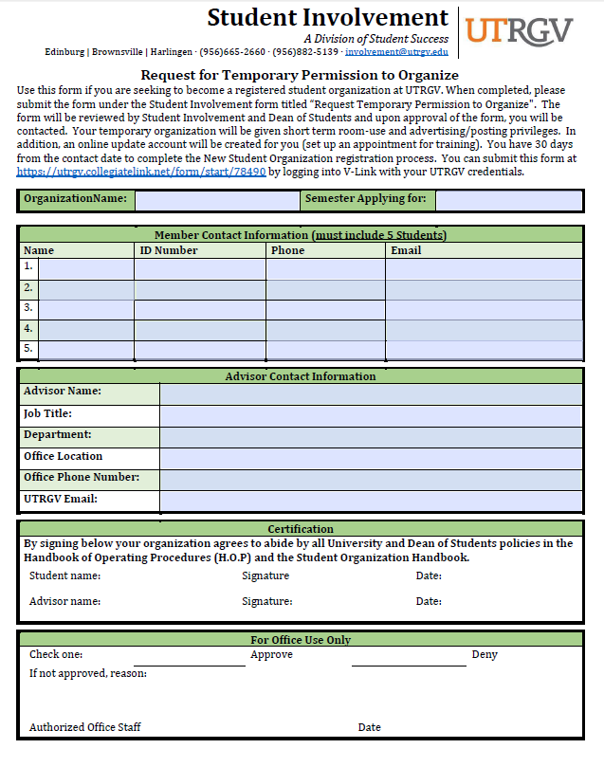

## Appendix B- Constitution Requirements Checklist

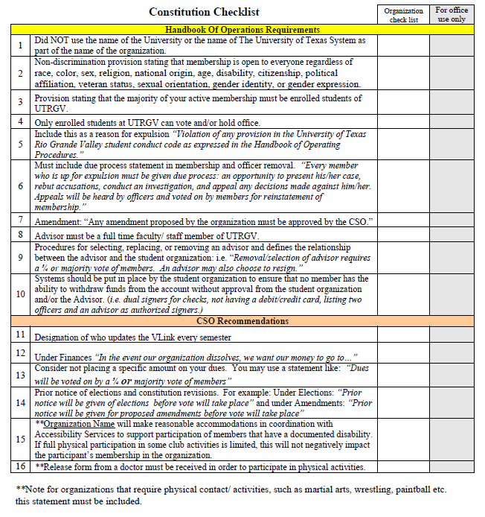

## Appendix C- Sample Constitution

New and emerging student clubs can use this example when developing a constitution and bylaws specific to their club needs. Established clubs can use this when updating or changing their bylaws.

**ARTICLE I: NAME & PURPOSE**

**Section A: Name –** The name of this club shall be [name of club].

**Section B: National Affiliation** – If the club is a member of a national or state organization, add the following statement and attach a copy of the national constitution as it will become part of this document:  “The rules and regulations of the National Constitution shall be followed when not inconsistent with the rules and regulations of CSM.”

**Section C: Purpose** – The purpose of this club shall be:

1. [List in detail the purposes and objectives of the clubs.]

2.

3.

4.

**ARTICLE II: MEMBERSHIP & DUES**

**Section A: Eligibility** - Membership shall be open to [define membership qualification, i.e., majors in a particular academic area, etc.] upon payment of the dues as outlined in Section C.

**Section B: Dues** – Dues shall be $______ per year. [List national and state dues separately if applicable].

**ARTICLE III: OFFICERS**

**Section A: Officers** – The officers shall be a President, Vice-President, Secretary, and Treasurer. [These are general officers, add officers specific to the needs of the club, if necessary.]

**Section B: Eligibility** – Officers must be_______  [full-time students, carrying at least 1 credit, etc.]

**Section C: Election** – The officers shall be elected by ballot at the last meeting of the spring semester by a majority of the vote cast for that office.

**Section D: Term** – The officers shall serve for one year and their term of office shall begin at the commencement of the fall semester.

**Section E: Vacancy** – If a vacancy occurs in the office of President, the Vice-President shall assume the office for the remainder of the term and vacancies in any other office shall be filled by a special election.

**ARTICLE IV: DUTIES OF OFFICERS**

**Section A: President** – it shall be the duty of the President to:

* Preside at meetings
* Vote only in case of a tie
* Represent the club
* Appoint committee chairpersons subject to the approval of the Executive Committee
* Serve as an ex-officio member of all committees except the nominating committee
* Perform such other duties as ordinarily pertain to this office

**Section B: Vice-President** – It shall be the duty of the Vice-President to:

* Preside in the absence of the President
* Serve as chairperson of the Program Committee

**Section C: Secretary** – It shall be the duty of the Secretary to:

* Record the minutes of all meetings
* Keep a file of the club’s records
* Maintain a current roster of membership
* Issue notices of meetings and conduct the general correspondence of the club

**Section D: Treasurer** – It shall be the duty of the Treasurer to:

* Receive all funds and process Request for Payment, Deposit Slip, and Officer Signature Forms.
* Keep an itemized account of all receipts and expenditures and make reports as directed

**ARTICLE V: MEETINGS**

**Section A:** Meetings – Regular meetings shall be held monthly during the regular school year.

**Section B:** Special Meeting – Special meetings may be called by the President with the approval of the Executive Committee.

**Section C:** Quorum – A quorum shall consist of [example: two-thirds (2/3)] of the membership. [The number required should be small enough to ensure that a quorum will usually be present but large enough to protect the club against decisions being made by a small minority.]

**Section D:** Parliamentary Authority – Robert’s Rules of Orders, shall govern this club in all cases to which they are applicable and in which they are not inconsistent with these bylaws.

**ARTICLE VI: EXECUTIVE COMMITTEE**

**Section A: Responsibility** – Management of this club shall be vested in an Executive Committee responsible to the entire membership to uphold these bylaws.

**Section B: Membership** – This committee shall consist of the officers as listed in Article III and the faculty advisor.

**Section C: Meetings** – This committee shall meet at least once between regular meetings of the club to organize and plan future activities.

**ARTICLE VII: ADVISOR**

**Section A: Selection** – there shall be a faculty/staff advisor who shall be selected each year by the membership.

**Section B: Duties** – The responsibilities of the faculty advisor shall be to:

* Maintain an awareness of the activities and programs sponsored by the student club.
* Meet on a regular basis with the leader of the student club to discuss upcoming meetings, long range plans, goals, and problems of the club.
* Attend regular meetings, executive board meetings as often as schedule allows.
* Assist in the orientation of new officers.
* Explain and clarify campus policy and procedures that apply to the club.
* Maintain contact with the Student Life Office.
* Provide direction in the area of parliamentary procedure, meeting facilitation, group-building, goal setting, and program planning.
* Assist the club treasurer in monitoring expenditures, fundraising activities, and corporate sponsorship to maintain an accurate and up-to-date account ledger.
* Inform club members of those factors that constitute unacceptable behavior on the part of the club members, and the possible consequence of said behaviors.

**ARTICLE VIII: COMMITTEES**

**Section A: Program Committee** – A program committee composed of the Vice-President as chairperson and four other members shall be appointed by the President before the end of spring semester, whose duty shall be to plan the overall program of the club.

**Section B: Other committees** – [List other committees germane to the club such as finance, publicity, membership, professional relations, social, etc.]

**Section C: Special Committees** – The President shall have the authority to appoint any special committees, with the approval of the Executive Committee, from time to time as need demands.

**ARTICLE IX: AMENDMENTS**

**Section A: Selection** – these bylaws may be amended by a two-thirds (2/3) majority vote of the chapter membership.

**Section B: Notice** – All members shall receive advance notice of the proposed amendment at least five days before the meeting. [The time may be extended to the following meeting.]

## Appendix D- Club Roster Form

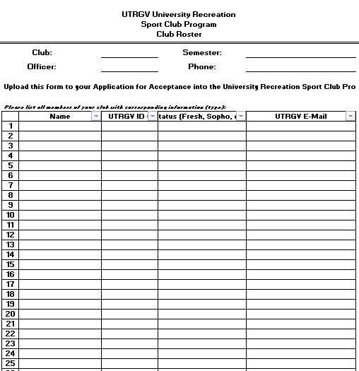

## Appendix E- Club Officer Form

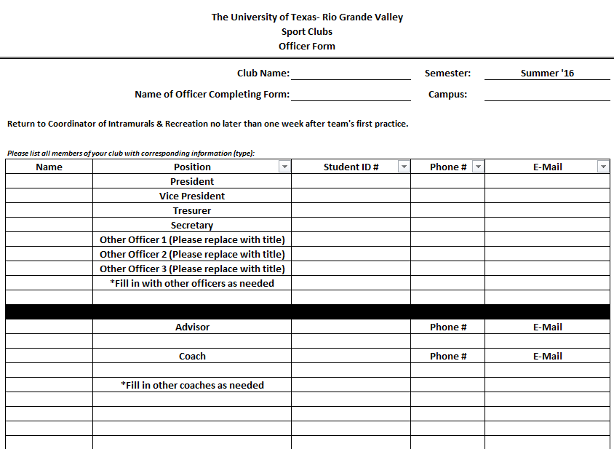

## Appendix F- Monthly Participation Report

Month: ________________________________

Name of Submitter: ________________________________

Submitter’s Signature: ________________________________

|  |  |  |
| --- | --- | --- |
| **Event (Practice/Game v. INSERT OPPONENT/etc.)** | **Date & Location** | **Attendance** |
|  |  |  |
|  |  |  |
|  |  |  |
|  |  |  |
|  |  |  |
|  |  |  |
|  |  |  |
|  |  |  |
|  |  |  |
|  |  |  |
|  |  |  |
|  |  |  |
|  |  |  |
|  |  |  |
|  |  |  |
|  |  |  |
|  |  |  |
|  |  |  |
|  |  |  |
|  |  |  |

## Appendix G- Student Travel Packet

Page 3- Need 1 per trip

Page 4- Need 1 for each student on every trip

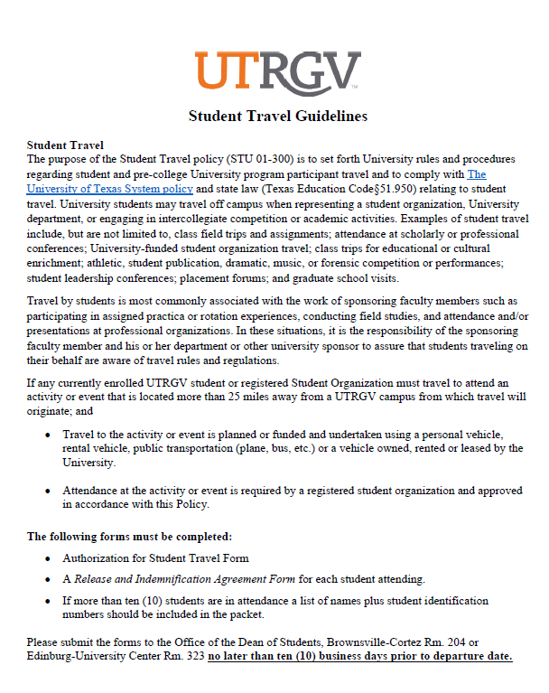

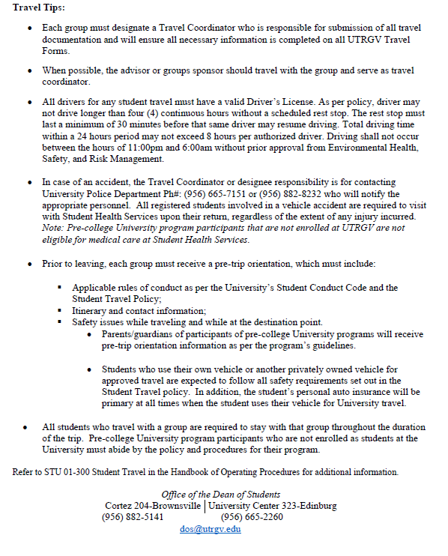

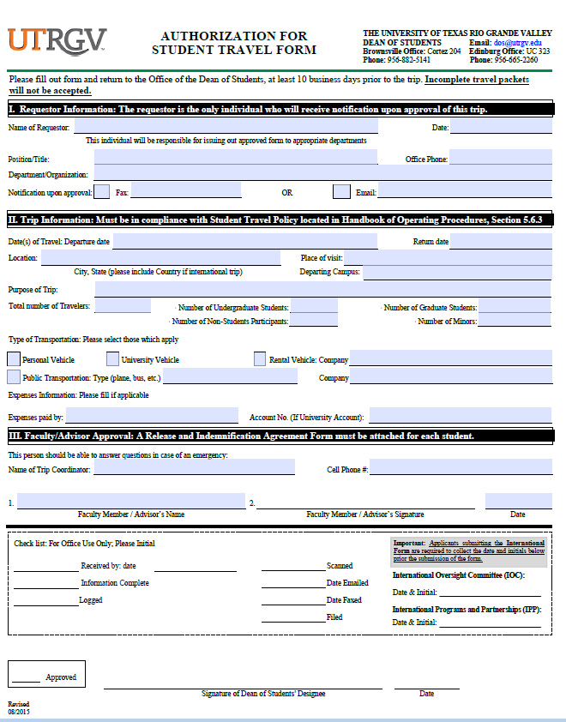

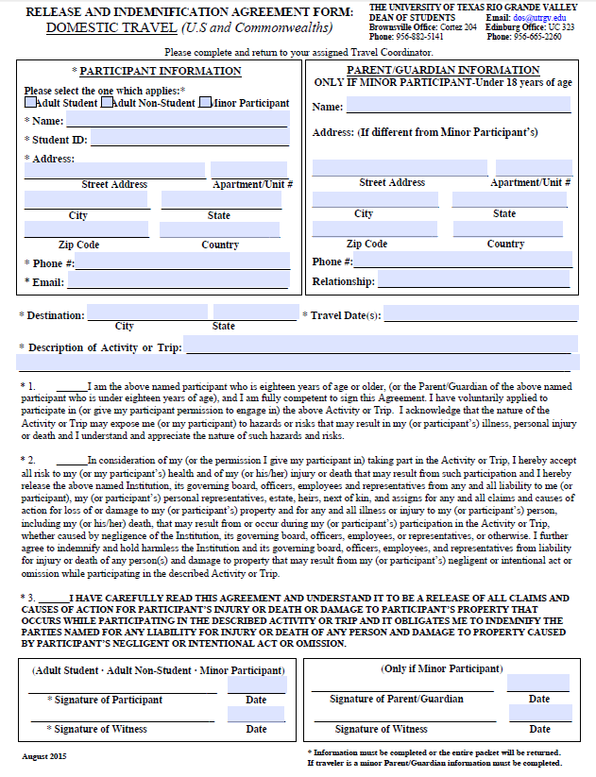

## Appendix H- Travel Roster

Must be turned in with travel packet for each trip

