BANNER Forms Used
SWASECT: Class Scheduling
SSATEXT: Class Section Comment
SFASRPO: Student Registration Permit-Override
Course Restriction Overrides
This manual provides guidance to departments on managing registration overrides for restricted class sections.
- SWASECT is used to schedule course sections and has the option to restrict registration by applying a ‘Special Approval’ (SP) code, which limits enrollment to students who receive an override from the department.
- SSATEXT allows departments to add custom text, such as contact information, that displays under the class course description in ASSIST, helping students identify the appropriate contact for special approval.
- SFASRPO is for departments to process SP overrides and other registration overrides, such as prerequisites, program requirements, and more, allowing approved students to enroll in restricted class sections.
SSASECT/SWASECT
Departments may restrict registration for a class section by adding the “SP” (Special Approval) code when scheduling classes in SWASECT:
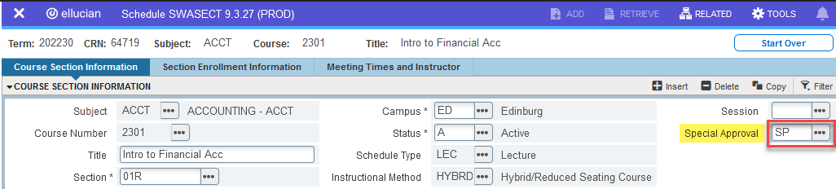

If departments no longer have access to SWASECT, the request may be submitted via a Class Schedule Change Request (CSCR) through the CSCR portal.
Note: When restricting a class section with the ‘SP’ code, please add (or request to add) a comment in SSATEXT with departmental contact information for students who wish to register in the class.

SFASRPO
The department designee may process registration overrides in SFASRPO:
- Enter the student ID number, and term, then click ‘Go.’
- Type “SP” or search for the override permission code by clicking the drop-down menu under the Permit column. Note: Select ‘Insert’ if additional lines are needed.
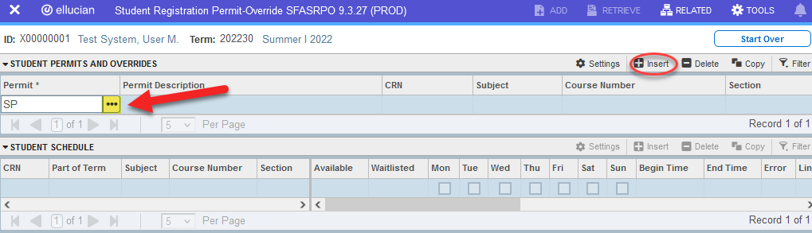
- Under the CRN column, enter the CRN number of the class section the student is allowed to register in – the subject, course number, and class section will auto-populate. Note: By entering a CRN number, the student is restricted to registering only to the specified class section.
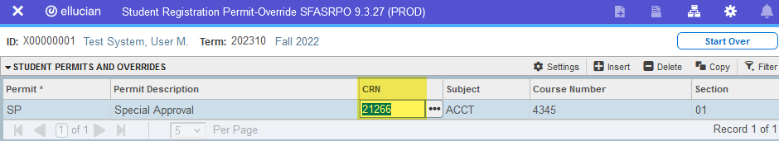
  - If the student is allowed to register in ANY section of a course, instead of entering a CRN number, leave the CRN field blank, and enter the Subject and Course Number. By not entering a CRN number, you do not restrict the student to a specific class section, therefore, the student can register in any scheduled section of the specified course.

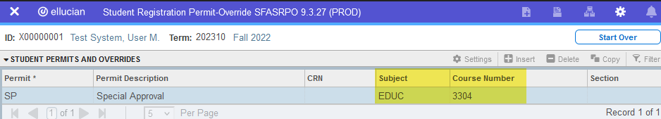
- Click the Save button located at the bottom right corner of the form.
- The student may now self-register through ASSIST (assuming there are no other course/class restrictions).

Permit Code | Permit Code Description | Restriction Type | What it Allows | Error Message to Student
CAPACITY (This override is only available after waitlists have closed and been cleared) | Allow in Closed Class  (This override becomes available after 5pm on the Friday before classes begin for Fall/ Spr/SSI, and on the Wednesday before SSII classes begin) | Class is full and there are no seats available | Permits registration when class is full. (This override is not available while waitlists are active as it disrupts the waitlist process by taking the seat that would otherwise go to a student on the waitlist pending to register in the class) | “This class is full. Waitlist is available.” / “This class is full – No waitlist is available.”
CLASS | Classification Override | Course is restricted to include or exclude a particular classification (e.g., SR, JR,  SO, FR, PB) | Permits student who does not meet the classification restriction to register for the class section | “Your student classification does not allow you to register for this course.”
CO-REQ | Co-requisite Override | Course has co-requisite(s) | Permits registration when student has taken the co-requisite course or is allowed to take it in the future | “Corequisite required.”
COHORT | Cohort Override | Course is restricted to include or exclude students in a particular cohort | Permits student who is not tagged with the cohort code to register in the class | “Cohort restriction.”
DUPLICATE | Allow in repeatable Special Topic class | Course prohibits registration to another section of the same Subject and Course Number | Permits student to register for the class section while already registered for another section of the same course | “Duplicate Course – You are enrolled in the same course.”
LEVEL | Level Override | Course restricted to include or exclude a particular level (e.g., UG, MA, DR) | Permits student who does not meet the level restriction to register for the class section | “You are not allowed to register in 5000-7000 graduate level courses.”
MAJOR | Field of Study Override | Course restricted to include or exclude students in a particular major field of study | Permits student who does not meet the major restriction to register for the class section | “Your declared major does not allow you to register for this course.”
PREREQ | Prerequisite Override | Course restricted to students who have met prerequisite requirements | Permits student who has not met the pre‐requisite(s) restriction to register for the class section | “This course has a prerequisite requirement that you have not met. Please read the course description in the schedule.”
PROGRAM | Program Override | Course restricted to students in a particular curriculum program | Permits student who does not meet the program restriction to register for the class section | “Your declared program does not allow you to register for this course.”
SP | Special Approval | Class section restricted upon request by department and requires approval for each student to register | Permits student to register for the restricted class section | “Special Approval.”
TIMECON | Time Conflict Override | Registration is restricted when class meeting times overlap with another class the student is registered in | Permits student to register in class that conflicts with meeting times of another class | “Time conflict with CRN.”

