

Ad Astra User Manual
SCHEDULING GRIDS CALENDAR



Instructions to View Room Availability by Week

Ad Astra link: https://www.aaiscloud.com/UTXRioGrandeValley
- Log in using UTRGV credentials.
- Select Scheduling Grids under Calendars tab.
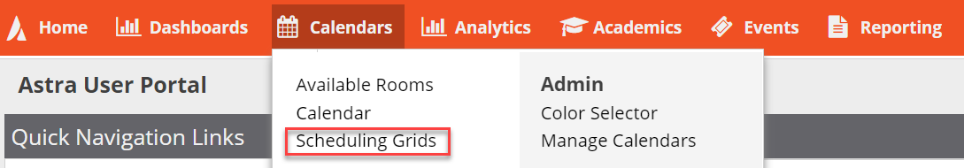
- Choose Calendar: Campus Events and Filter: Events and Academics
- Click on Week and enter dates or select week.
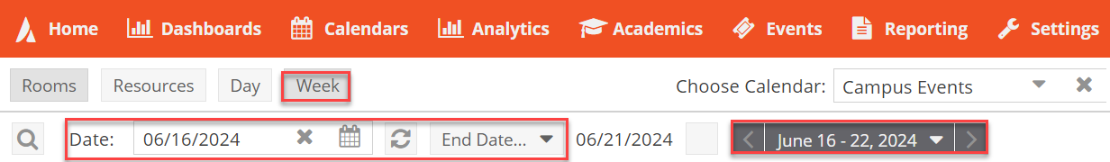
- Click on Advanced Search Options (Magnifying Glass Icon).
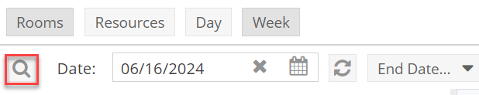
- Add filters (select Campus and 110 Classroom), add capacity (if needed), and click Search.
Note: Click ‘Done’ when selecting a filter.
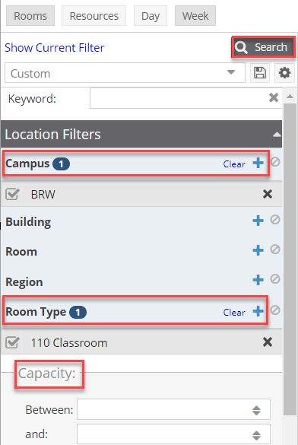
- Click on room(s) to view available days/times.
  - Blue/Orange - Academic Sections
  - Green - Scheduled/Approved Events
  - Gray - Requested Events (Pending to be reviewed)
  - White blocks – Available

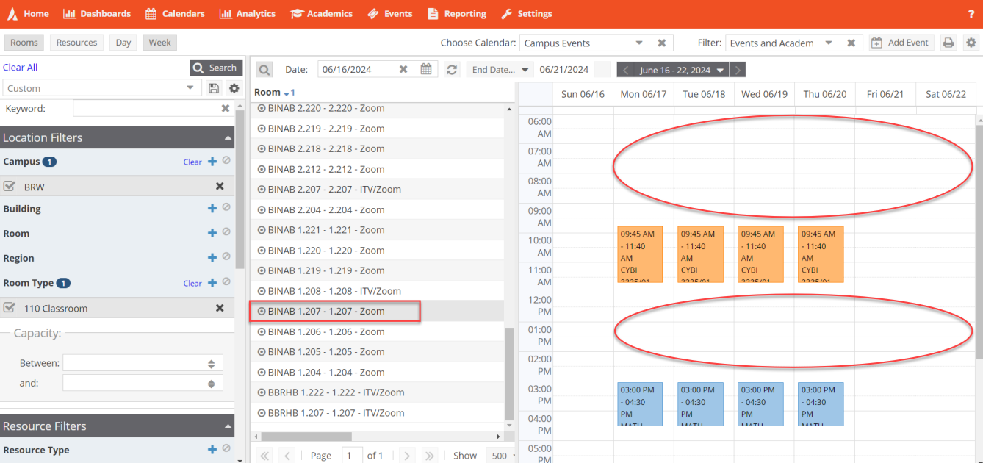

Instructions to View Room Availability by Day

Ad Astra link: https://www.aaiscloud.com/UTXRioGrandeValley
- Log in using UTRGV credentials.
- Select Scheduling Grids under Calendars tab.
- Choose Calendar: Campus Events and Filter: Events and Academics
- Click on Day and select dates.
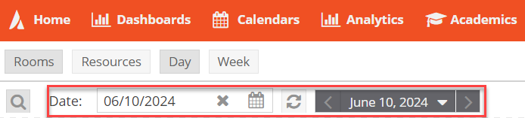

- Click on Advanced Search Options (Magnifying Glass Icon).
- Add filters, capacity, and click Search.
Note: Click ‘Done’ when selecting a filter.
- Click on room(s) to view available days/times.
  - Blue/Orange - Academic Sections
  - Green - Scheduled/Approved Events
  - Gray - Requested Events (Pending to be reviewed)
  - White blocks – Available

