
Ad Astra User Manual
EVENT REQUEST


Event Scheduling Requirements:

- Need access to Ad Astra? Submit a ticket to IT, see link below for instructions.
https://www.utrgv.edu/esa/_files/documents/access-guides/tdx_guide_request_ad_astra_access.pdf

- Submit event requests between the 5-day to 90-day timeframe (Academic Spaces). Requests outside this timeframe may be further reviewed, email scheduling@utrgv.edu. Each form has its own timeframe, contact the appropriate scheduler for questions.

- Room requires prior approval?
  - Contact the room approver (point of contact) to request approval (Review Room Details/Description).
  - Once approved, forward approval to scheduling@utrgv.edu and submit event request (include notes under the Description field).

- Event is being Co-Sponsored with an external entity?
  - Submit the Joint Sponsorship Application. For questions contact conferences@utrgv.edu.
  - Once approved, forward approval to scheduling@utrgv.edu and submit event request (include notes under the Description field).

- Event involves minors under the age of 18 (Non-UTRGV students)?
  - All youth programs are required to officially register on the Youth Programs Ideal-Logic website prior to the beginning of the program. For questions, contact youthprogramprotetction@utrgv.edu.
  - Once approved, forward approval to scheduling@utrgv.edu and submit event request (include notes under the Description field).

- Manually add Police Resources to unlock/lock doors to ALL reservations, especially if your event is after hours or during the weekend (REQUIRED).

- A Work Request is required for ALL events that will need custodial services, room set-ups, etc. regardless of if the event is during business or after hours.

- Please allow 3-5 business days for your event request to be processed.

- To make changes or to cancel an existing reservation, please submit the Event Changes/Cancellation request for review and processing.

Instructions for Requesting an Event

Ad Astra link: https://www.aaiscloud.com/UTXRioGrandeValley

- Log in using UTRGV credentials.
- Select Request Event under the Events tab.

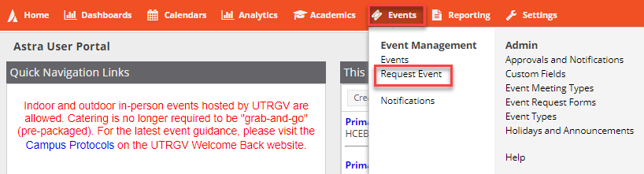
- Select one of the following forms under the Event Request Wizard:
  - I.T. Computer Labs Request Form: Computer labs (IT Managed).
  - McAllen Biomedical Research Facility: Spaces in the McAllen Biomedical Research Facility - School of Medicine building.
  - UTRGV Academic Space Event Request: Classrooms, study rooms, and other spaces considered academic on both Edinburg and Brownsville campuses.
  - UTRGV Non-Academic Space Event Request: Lobbies, conference rooms, and outdoor spaces on both Edinburg and Brownsville campuses.
  - UTRGV School of Medicine- Edinburg: Spaces in the Medical Education Building and the Team Based Learning Center building.
  - UTRGV School of Medicine- Harlingen: Spaces in the Harlingen Clinical Education Building.
  - UTRGV Student Unions/Ballroom Request Form: Spaces in the Student Union buildings (BRW/ED), Chapel (ED), and University Center (ED).

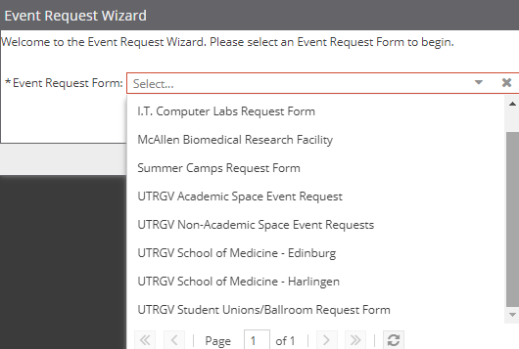
- Read important information regarding the space and complete the form.
Note: Fields with an (*) require information.

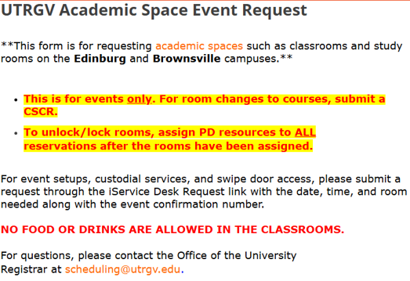

- Select Event Type. General categorization for the type of event.
    - Academic: Educational setting; for events related to students/courses.
    - Administrative: Business setting; for events related to departmental meetings/functions.
    - Student Activity: Open to all UTRGV students.
    - Student Organization: Strictly for a certain student group or organization.

- Click on Add Meeting.

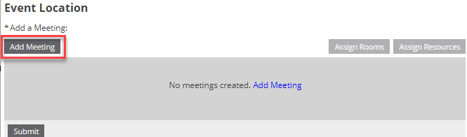

- Create Meeting(s). Featured events will be published in the Campus Events Calendar. Once done, click Add Meeting.
  - Single: Meeting once (Same start and end date).
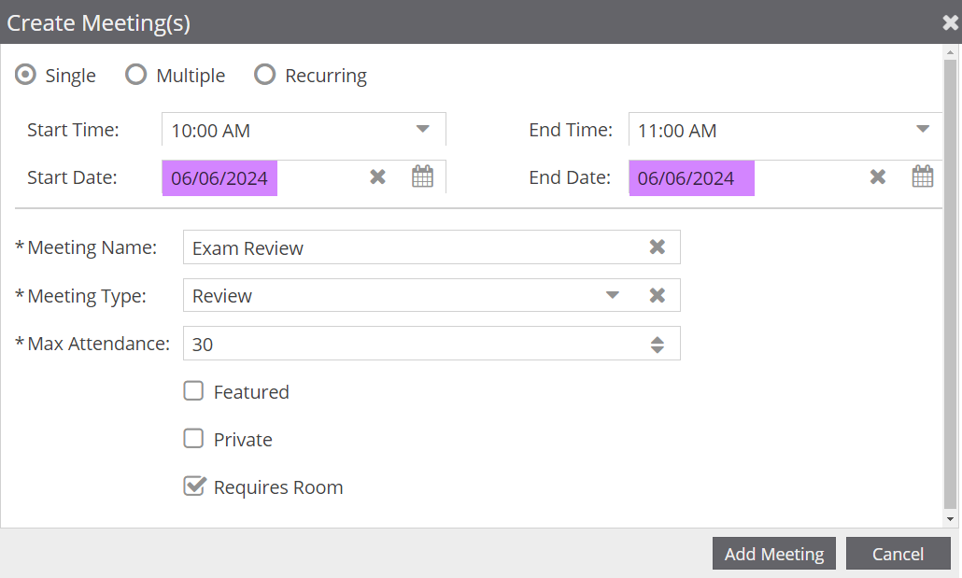
  - Multiple: Meeting multiple days. (Different times can be entered)
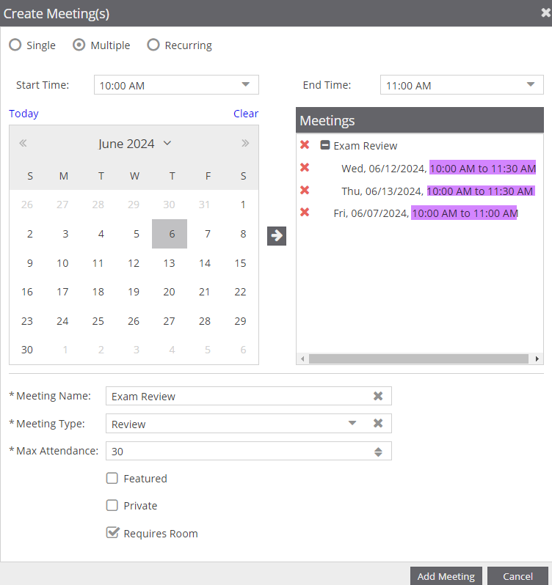
  - Recurring: Meeting periodically.
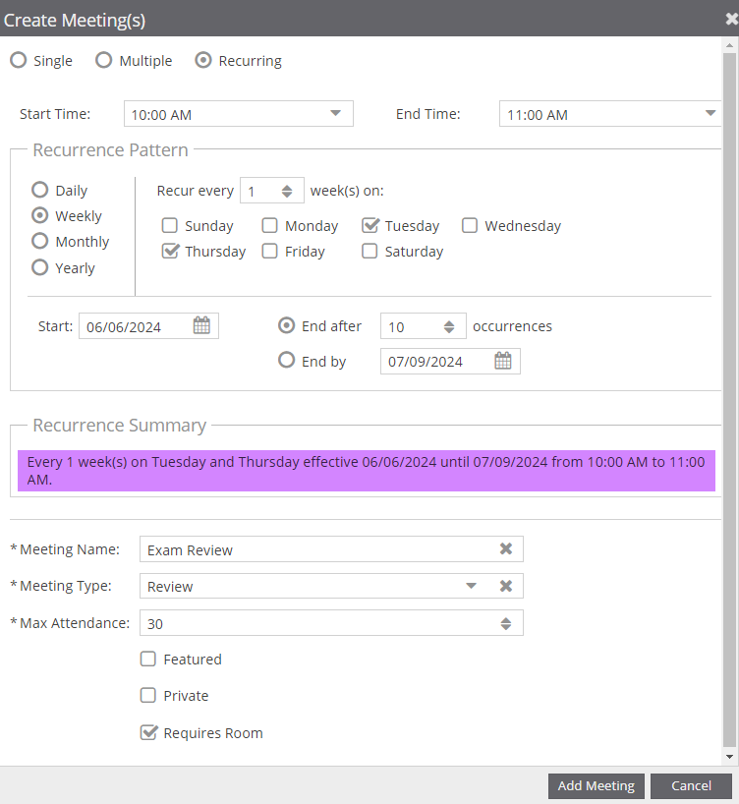

- Select Meeting Type. Specific categorization for the type of event.

- Banquet | - Exam | - Luncheon | - Rehearsal
- Camp | - Exhibit | - Maintenance | - Review
- Campus Event | - Fair | - Meeting | - Social Gathering
- Campus Tour | - Fundraiser | - Orientation | - Training
- Ceremony | - Graduation | - Performance | - Tutoring
- Conference | - Interview | - Presentation | - Workshop
- Dance | - Lecture | - Recruitment

- Click on Assign Rooms. The meeting will populate underneath.

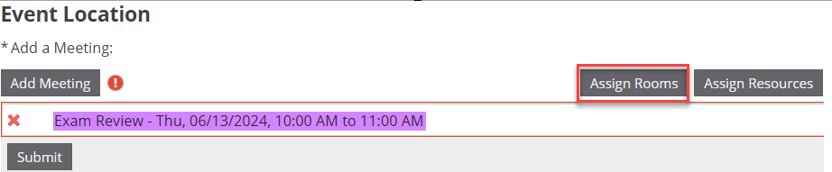

- Filter by Campus and Search. Select room(s) and click OK.
Note: Moving cursor to the circle will show a picture of the room.
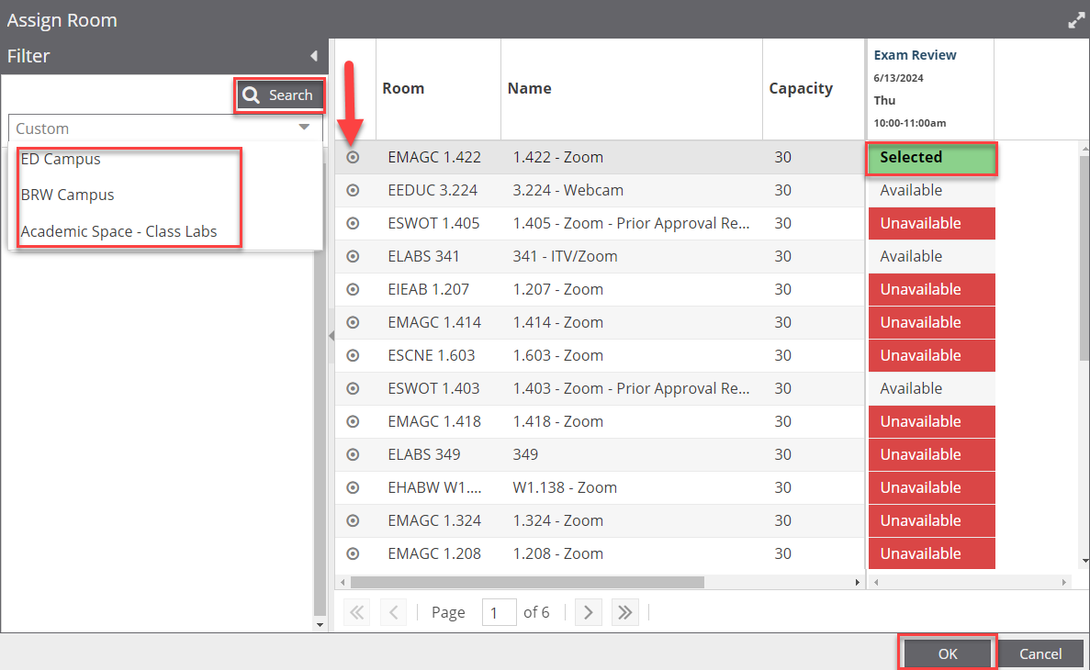

- Click on Assign Resources. The room will populate next to the meeting.

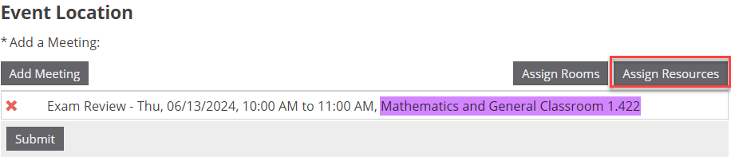

- Police Resources are preselected. Enter 1 to Lock & Unlock Door and click OK.

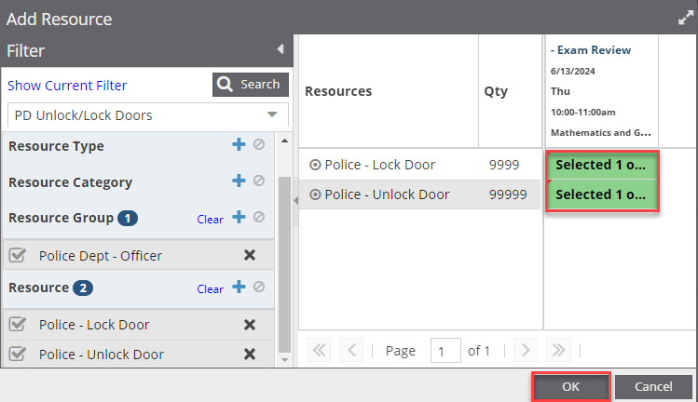
- Review your event information for accuracy and click Submit.

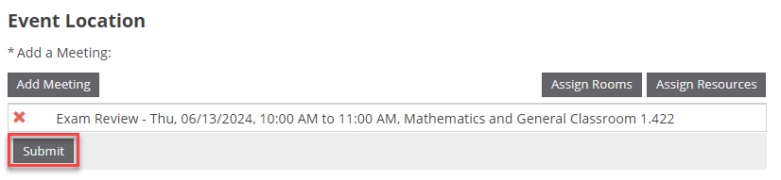

- Once your request is submitted, the requestor will see the message below.

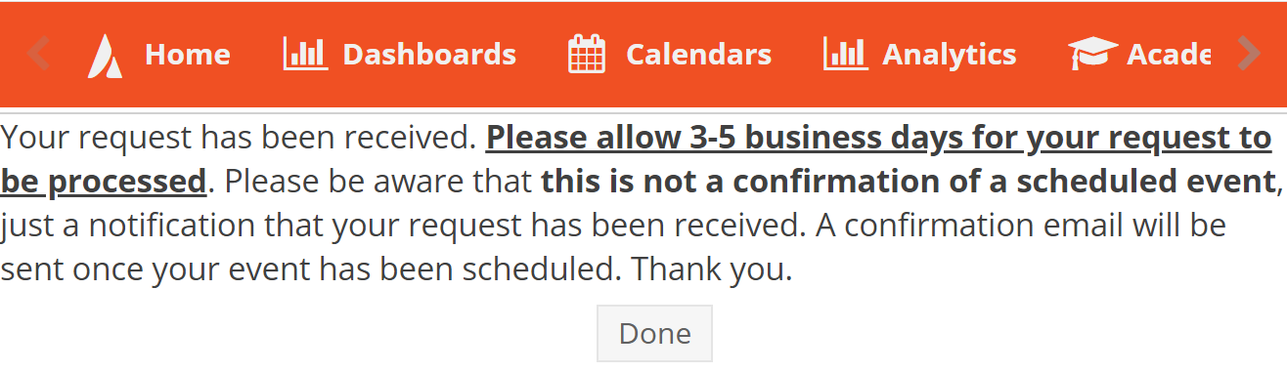

- The requestor will receive an email notification, please note that is not confirmation of a scheduled event. Once your request is processed and scheduled, the requestor will receive an event summary confirming a scheduled event.

