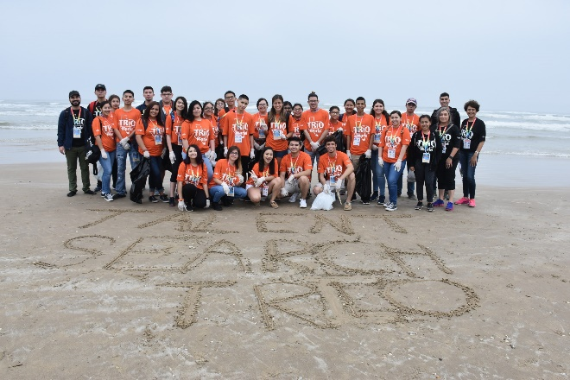
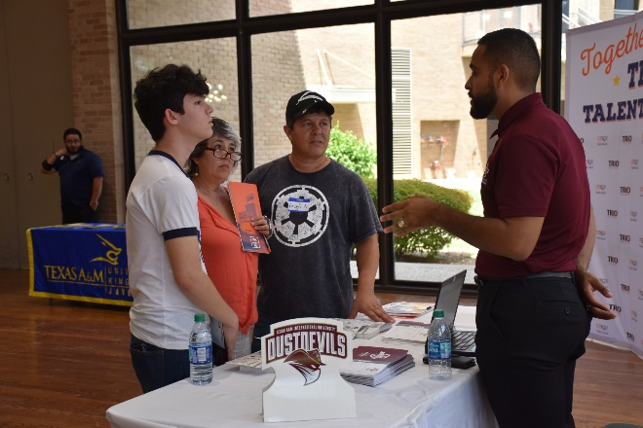
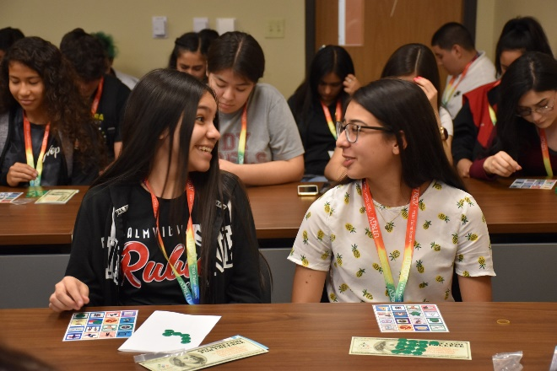
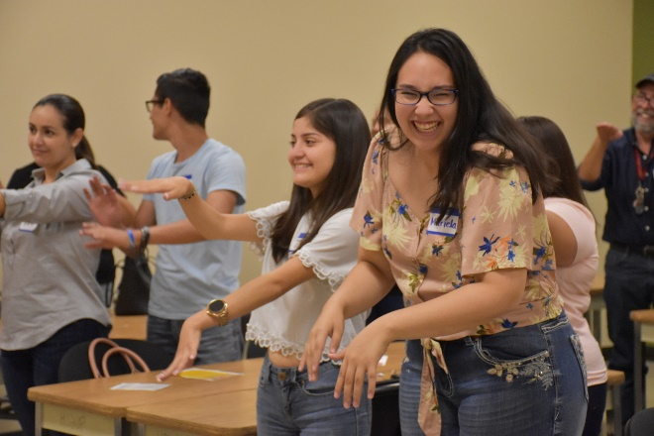
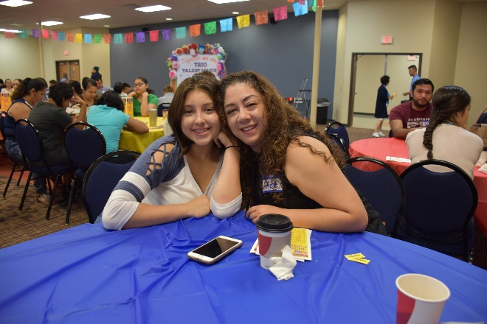
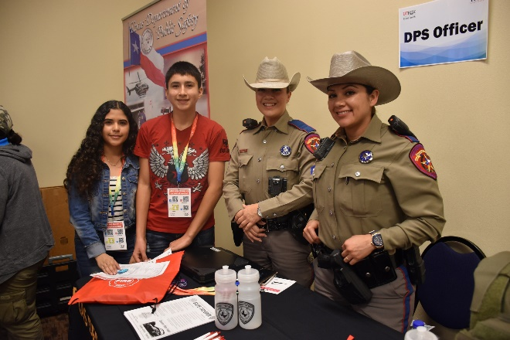

2018 – 2019
TS-Edinburg Annual Report
Sonia del Angel, Director, Talent Search-Edinburg
Terrie Salinas, Sr. College Readiness Specialist
Elias Garcia, College Readiness Specialist
Karina Nava, College Readiness Specialist
Elijah Jones, College Readiness Specialist
Sara Olivarez, Administrative Assistant

Updated: October 25, 2019

A Federally Funded Program

TABLE OF CONTENTS
Executive Summary 3
Mission 3
Talent Search-Edinburg Highlights 4
Participant Profile 5
TS -Edinburg Program Characteristics 6
Eligibility of Participants 6
Participant Status 6
Participant by Gender 7
Grade Level of Participants 8
Project Services and Academic Progress 9
Academic Services 10
Participant Secondary School Performance 10
Competitive Preference Priority Participants 11
Post-Secondary Status 12
Post-Secondary Completion 12
Talent Search Edinburg Objectives 13

- TALENT SEARCH EDINBURG-EXECUTIVE SUMMARY
The Talent Search-Edinburg Program (TS-Edinburg) is one of three TRIO Talent Search pre-college access grants from the U.S. Department of Education awarded to The University of Texas Rio Grande Valley (UTRGV). TS-Edinburg received its initial award notification in 1981 and has been renewed every subsequent funding cycle. The program is funded to serve 905 students each year at five target high schools in Hidalgo County. The primary goal of the program is work with students of limited financial resources to prepare for successful entry into college and the completion of a program of study. The key to the success of the program lies not only with its participants but, their parents as well. TS works diligently to be sensitive to the needs of limited income and first-generation college bound students and their families.
This report provides an overview of the project services delivered in 2018-2019, the demographic and characteristics of TS participants and performance outcomes. The major findings of this report indicate that the project met or exceeded all objectives set forth by the U.S. Department of Education. TS-Edinburg participants are graduating college ready, enrolling at post-secondary institutions and persisting in college. More than half of the participants are completing a higher education program of study within six years of graduation from high school.
The U.S. Department of Education offered competitive preference priority points for those programs who provided additional mentoring and tutoring services for program participants. TS-Edinburg initiated these services for targeted students at their respective high schools. Those services will be addressed as well.

MISSION
The mission of the Talent Search grants at UTRGV is to promote higher education opportunities for low-income, first-generation college bound students. TS is committed to a comprehensive plan of college readiness services, which foster graduation from secondary school, facilitate enrollment into and completion of a post-secondary education.

TALENT SEARCH-EDINBURG HIGHLIGHTS
This report provides a profile of the Talent Search Program using performance report data and data requested from the Edcouch-Elsa, Mission and La Joya Independent School Districts for the 2018 – 2019 academic year.

Unique Project Characteristics
  - The Talent Search-Edinburg program served 908 participants. Seventy percent (636) continued from the previous year and thirty percent (272) are new to the program.
  - Seventy-five percent (682) of TS participants are in grades 9 – 11.

  - Twenty-five percent (226) of TS participants are high school seniors.

  - Forty-three percent (392) of TS participants are in dual enrollment programs.

  - Fifty percent (216) of TS Junior and Senior participants are enrolled in AP courses.

Participants Characteristics
  - Thirty-seven percent (339) of TS-Edinburg participants are male and sixty-three percent (569) of TS-Edinburg participants are female.
  - Ninety-eight percent (888) of participants are Hispanic, one percent (8) two or more races, non-Hispanic/Latino and one percent were White, Black or African American, non-Hispanic/Latino (8 and 2)

  - Eighty-two percent (746) of the participants met both the low-income and first-generation college eligibility requirements. The federal program requirement is two-thirds.

Project Services and Activities
  - TS-Edinburg high school participants (908 throughout 5 target high schools) were offered an array of services which included, study skills, college preparation, career exploration, college transition, field trips, a college tour and UTRGV enrichment days. Additionally, they received ACT/SAT and TSI assistance. Seniors received sessions dealing with all facets of the admissions and financial aid process. TS-Edinburg provided for a total of 14,571 small group contact sessions and 2,653 individual session contacts throughout AY 2018-2019
  - College Readiness Specialists provided 144 ACT/SAT Fee Waivers to participants in AY 2018-2019
  - College Readiness Specialists provided 108 admissions fee waivers for participants in AY 2018-2019
  - College Readiness Specialists provided FAFSA Verification Assistance for 72 TS Seniors in AY 2018-2019

IV. PARTICIPANT PROFILE
Total Program Participants | 908
Educational Status
High School non-senior (9th – 11th grade) | 682 | 75%
High School senior (12th grade only) | 226 | 25%
Gender
Male | 339 | 37%
Female | 569 | 63%
Ethnicity
White (non-Hispanic) | 10 | 1%
Hispanic or Latino | 888 | 98%
Black or African-American | 1 | *%
Asian | 0 | 0%
Two or more races, non-Hispanic/Latino | 8 | 1%
Age
11 – 13 | 0 | 0%
14 – 18 | 908 | 100%
19-27 | 0 | 0%
Participant Eligibility
Low Income & First Generation | 746 | 82%
Low Income Only | 20 | 2%
First Generation Only | 107 | 12%
Other | 35 | 4%

DEPARTMENT CHARACTERISTICS
This section summarizes the demographic information on current project participants. Data was compiled from information found in the Compansol Blumen database.

Eligibility of Participants:
Eighty-two percent (746 participants) are both low-income and first-generation, 2 percent (20 participants) are low-income only, 12 percent (107 participants) are first generation only, and 4 percent (35 participants) are “other” (neither low income or first generation) with extenuating circumstances that warrant inclusion.

Participant Status:
The following chart (figure 2) shows the number of students that have continued in the program and 70% (636) and the new students recruited 30% (272).

Participant by Gender:
Participants in the TS-Edinburg program are more likely to be female than male, 63% (569 participants) versus 37% (339 participants) (Figure 3). The gender distribution remains relatively stable throughout the four years of high school.

Race and Ethnicity of Participants:
The following chart shows distribution of races and ethnicities:

Hispanic 98% (888 participants); White 1% (10 participants); 1% Two races or more (8 participants) (Figure 4)

The University of Texas Rio Grande Valley Talent Search Edinburg Page 7

Target School Participant Grade Level Distribution:
The Talent Search-Edinburg program provided delivery of services at 5 five target high schools. The grant is funded to serve 905 participants. In the 2018-2019 academic year, TS-Edinburg served 908 participants. The bar graph (Figure 5) illustrates participant grade distribution at each of the target high schools.

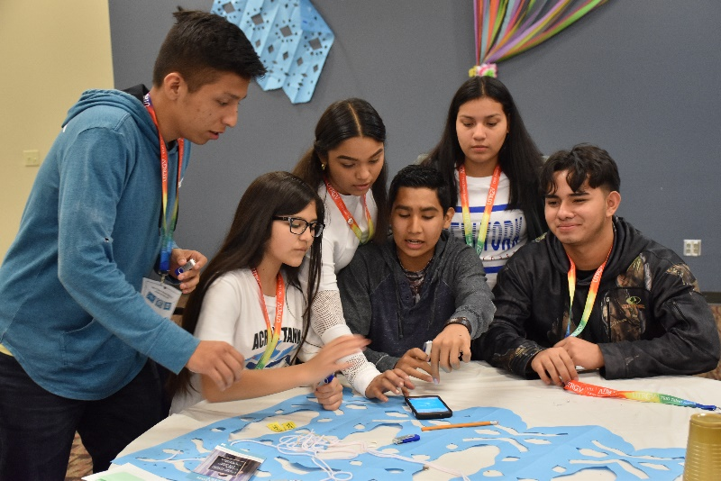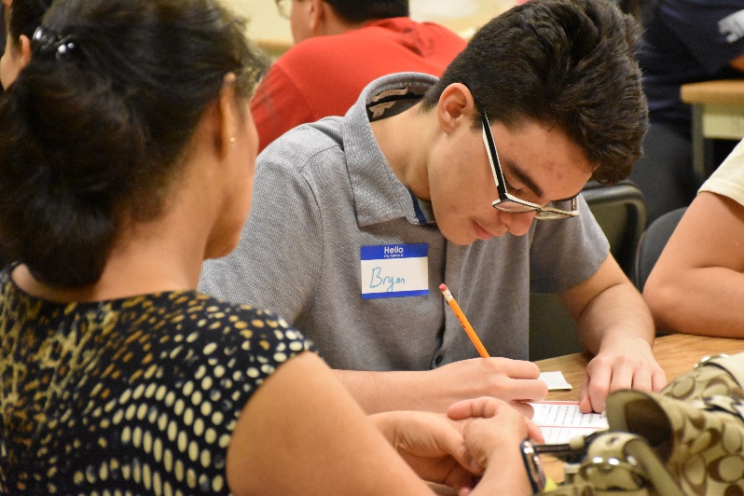

The University of Texas Rio Grande Valley Talent Search Edinburg Page 8

PROJECT SERVICES AND ACADEMIC PROGRESS
Talent Search-Edinburg College Readiness Specialists generated contacts for the 2018 – 2019 school sessions and parent meeting. The following is a snapshot of selected services provided:

(Figure 6)
The University of Texas Rio Grande Valley Talent Search Edinburg Page 9

Activity / Service Rendered # Students # Sessions Activity Time

22. Tutoring-Connections 79 79 333 minutes = 5:33 hrs
23. Academic Advising 521 790 24519 minutes = 408:39 hrs
28. Career Exploration 183 227 35738 minutes = 595:38 hrs
29. Career Interest Inventory 161 161 3185 minutes = 53:05 hrs
30. College Field Trip 56 57 1155 minutes = 19:15 hrs
33. Parent/Family Workshop 70 82 1510 minutes = 25:10 hrs
34. College Readiness 769 1,576 72500 minutes = 1208:20 hrs
35. SR-Assistance with College Application 196 309 5660 minutes = 94:20 hrs
36. SR-Submitted College Application 222 267 1555 minutes = 25:55 hrs
37. SR-Financial Aid Information 264 532 9629 minutes = 160:29 hrs
38. SR-Assistance with FAFSA 145 197 4460 minutes = 74:20 hrs
39. SR-Submitted FAFSA Completed 216 227 480 minutes = 8:00 hrs
40. SR-Scholarship Assistance 81 102 1625 minutes = 27:05 hrs
41. SR-Postsecondary Degree Plan Review 107 110 3315 minutes = 55:15 hrs
42. SR-College Orientation 56 58 980 minutes = 16:20 hrs
43. College Transition (9th-12th) 760 1,737 51796 minutes = 863:16 hrs
44. SR-Admissions Fee Waiver 108 117 775 minutes = 12:55 hrs
45. SR-Admissions Information 452 791 13864 minutes = 231:04 hrs
46. SR-FAFSA Verification Assitance 72 87 1045 minutes = 17:25 hrs
47. SR-College Acceptance Notification 20 20 105 minutes = 1:45 hrs
48. SR-Financial Aid Award Notification 90 113 1204 minutes = 20:04 hrs
49. ACT/SAT Test Preparation 53 63 825 minutes = 13:45 hrs
50. ACT/SAT Information 496 923 9858 minutes = 164:18 hrs
51. ACT/SAT Registration 151 167 5795 minutes = 96:35 hrs
52. ACT/SAT Fee Waivers 144 144 422 minutes = 7:02 hrs
53. Took ACT/SAT 279 279 1325 minutes = 22:05 hrs
54. TSI Exam Information 598 1,015 8274 minutes = 137:54 hrs
56. TSI Exam Test Prep 99 102 1255 minutes = 20:55 hrs
59. Financial Aid Information (9th-11th) 597 966 14118 minutes = 235:18 hrs
60. Financial Literacy Information 134 134 3370 minutes = 56:10 hrs
61. Scholarship Information (9th-11th) 255 292 8203 minutes = 136:43 hrs
62. College Awareness (9th-11th) 691 1,261 25580 minutes = 426:20 hrs
63. New/Continuing Student Parent Meeting 65 65 1300 minutes = 21:40 hrs
74. Community Service 204 211 2650 minutes = 44:10 hrs
77. Institutional Mentoring 455 593 23810 minutes = 396:50 hrs
78. Community Mentoring 242 273 6700 minutes = 111:40 hrs
79. Peer Mentoring 865 2,140 43796 minutes = 729:56 hrs

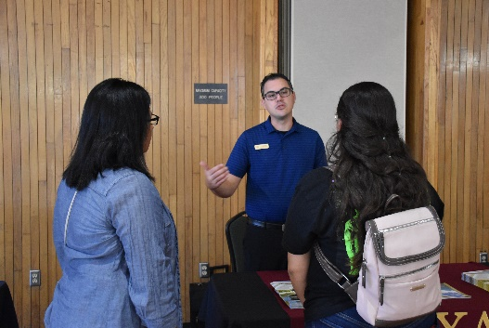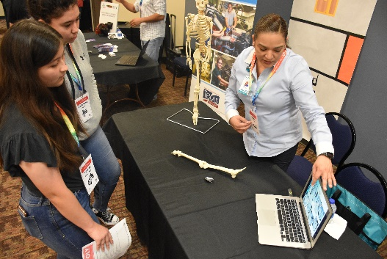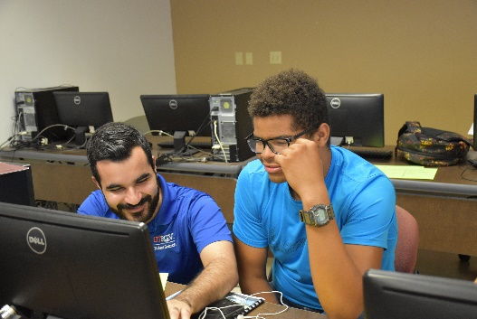

Academic services:
Services offered to students on their respective campuses are:

- College Readiness and Awareness
- Talent Search participants are given information regarding postsecondary education and institution to prepare them at a young age.

- Dual Enrollment, Advanced Placement (AP) Coursework and Transition Services
- Talent Search participants and their parents receive information on the advantages and responsibilities involved when they undertake rigorous academic coursework. Participants focus on connecting their existing high school career pathway endorsements to future college majors.

- Participants and parents receive information on the two primary options to earn college credit while in high school: dual enrollment and advanced placement courses. Both challenge the student academically and provide rigor. Each avenue presents its own unique advantages and challenges.

- Career Awareness
- Participants explored their career choices and opportunities through a variety of resources and opportunities. TS Juniors experienced a day with over 25 different professionals who provided informational mentoring sessions on their chosen careers.

- Senior Sessions
- College Readiness specialists provide multiple small group and individual senior sessions throughout the school year to assist TS graduates and their parents with the admissions, testing, and financial aid application processes.

Participant School Performance:
Student transcripts are gathered from all five target schools, the following outcomes are based on reported grades and testing information to the TS program at the time of this report. TS participant transcripts indicate promotion rates from one grade to the next at a rate of almost 100%. The bar graphs (Figure 7 and 8) further reflect the number of TS participants who are enrolled in dual enrollment and AP courses by target school and by grade level.
The University of Texas Rio Grande Valley Talent Search Edinburg Page 10

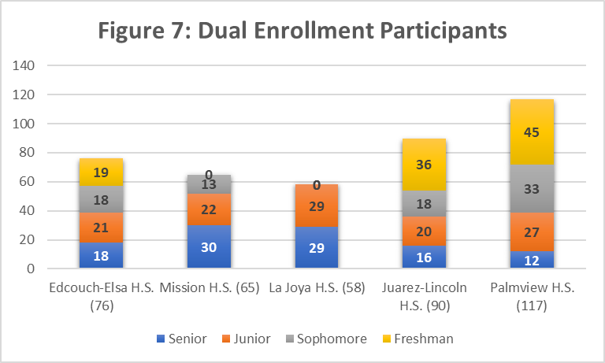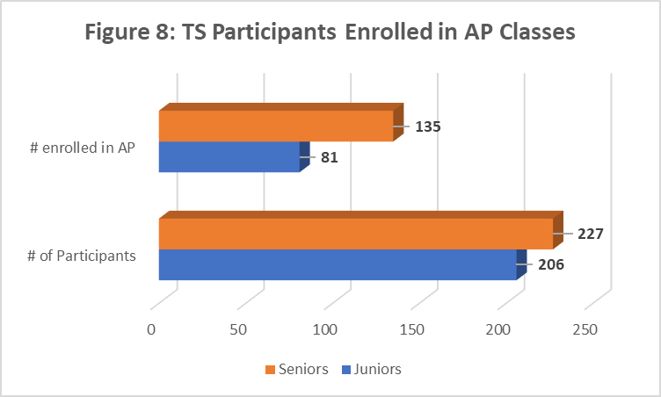

Competitive Preference Priority Participants:
TS Edinburg addressed U.S. Department of Education recommended competitive preference priorities. TS- Edinburg response is shown below (Figure 9.) The program incorporated additional mentoring and tutorial assistance for groups of select TS participants. Mentoring services were targeted to participants at risk for non-entry into college. TS Edinburg focused on TSI online test prep assistance for tutorial services.

The University of Texas Rio Grande Valley Talent Search Edinburg Page 11

Post-Secondary Status:
The following data collected on TS Class of 2019 graduates shows the number of seniors served, number and percentage of students that applied for admission and financial aid at a post-secondary institution after graduation. Figure 10 also illustrates the number of senior participants that enrolled in post-secondary institution. Finally, it indicates the number TS Class of 2019 participants enrolled at the UTRGV.

Figure 10

169 (75%)
59 (26%)
216 (96%)
226 (100%)
222 (98%)

Post-Secondary Completion:
The U.S. Department of Education instituted several new priorities for Talent Search grants. An objective addressing TS participant degree attainment was also implemented. UTRGV TS had an approved objective of 20% completion of a program of study within 6 years of entry into post-secondary institution. Pre-existing grants were asked to report on attainment for the TS 2012-2013 Cohort.

Six-year completion rates are unavailable until December 2019. The 2012-2013 TS-Edinburg cohort had 204 graduates who enrolled in post-secondary school. As of Fall 2019, the six year-point, 122 (60%) had completed a post-secondary program of study. Additionally, 21 or 10% of the Class of 2013 are still enrolled working toward a degree. The following is a breakdown of credentials earned:
- Certificates 3
- Associate degrees 13
- Bachelor’s degrees 86
- Associate & bachelor’s degrees 10
- Bachelors and master’s 4
- With other combinations 6

The University of Texas Rio Grande Valley Talent Search Edinburg Page 12

- TALENT SEARCH-EDINBURG OBJECTIVES
*This is the six-year completion rate as of November 2019.
The University of Texas Rio Grande Valley Talent Search Edinburg Page 13

OBJECTIVE NO. 1: SECONDARY SCHOOL PERSISTENCE: 85% of non-senior TS participants served each project year will complete the current academic year and continue in school for the next academic year, at the next grade level.

Objective was exceeded: 677 of 682 or 99.26% of non- senior TS participants served during the project year complete the current academic year and continue in school for the next academic year, at the next grade level.
OBJECTIVE NO. 2a: SECONDARY SCHOOL GRADUATION (Regular Secondary School Diploma: 80% Talent Search Seniors served during the project year will graduate during the project year with a regular secondary school program diploma within the standard number of years

Objective was exceeded: 226 of 226 or 100% of TS seniors served during the project year graduated during the project year with a regular secondary school diploma within the standard number of years
OBJECTIVE NO. 2b: SECONDARY SCHOOL GRADUATION (Rigorous Secondary School Diploma): 42% of TS project senior participants served during the project year will complete a rigorous secondary school program of study and will graduate from secondary school with a regular secondary school diploma within the standard number of years.

Objective was exceeded: 223 of 226 or 97% of project TS senior participants served during the project year completed a rigorous secondary school program of study and graduated from secondary school with a regular secondary school diploma within the standard number of years.
OBJECTIVE NO. 3: POSTSECONDARY ENROLLMENT: 60% of TS participants, who have graduated with a regular secondary school diploma, during the project year, will enroll in an institution of higher education, by the fall term immediately following high school graduation.

Objective was exceeded: 194 of 226 or 86% of TS participants, who graduated with a regular secondary school diploma, during the project year, enrolled in an institution of higher education, by the fall term immediately following high school graduation
OBJECTIVE NO. 4: POSTSECONDARY ATTAINMENT: 20% of TS participants served during the project year who enrolled in an institution of higher education, by the fall term immediately following high school graduation will complete a program of postsecondary education within six years.

OBJECTIVE NO. 4: 20 % POSTSECONDARY ATTAINMENT for new grants is not available until TS cohort 2021-2022.

TS GRANT OBJECTIVE NO. 4 : POSTSECONDARY ATTAINMENT for pre-existing TS grants was met: 122 of 204 or 60% of TS Seniors from the 2012-2013 cohort* who were served during the project year, enrolled in an institution of higher education, by the fall term immediately following high school graduation completed a program of postsecondary education within six years.

