Faculty Mentoring Toolkit

UTRGV School of Medicine Faculty Mentoring Program

Table of Contents

Page
Introduction…………………………………………………. 2
Documents to Complete…………………………………..13
Mentoring Best Practices……………………………….…19
Mentee Resources…………………………………...…….34
Mentor Resources………………………………………….39
Appendix…………………………………………………….48

Adapted with permission from Mitchell D. Feldman, MD, MPhil, UCSF Faculty Mentoring Program (2012).

Introduction
The Introduction section includes:

- Purpose
- UTRGV School of Medicine Objectives
- Mission
- Program Core Components
- Faculty Mentoring Yearly Timeline
- Mentoring Program Advisory Committee

Purpose

The purpose of the Faculty Mentoring Toolkit is to:

- Provide an overview of the UTRGV-SOM Faculty Mentoring Program
- Describe the concepts and benefits of mentoring
- Define the role of the mentor and mentee
- Provide strategies for being an effective mentor
- Describe the phases of the mentoring relationship
- Provide tools to help the mentoring facilitator manage the mentoring pairs

UTRGV School of Medicine

Mentoring Program Objectives

To promote UTRGV School of Medicine faculty success and advancement, this program will help participating faculty members to:

- Identify and develop an area of academic expertise.

- Form professional networks inside UTRGV-SOM and the larger community of scholars

- Become familiar with UTRGV-SOM infrastructure and services supporting scholarship

- Harness the power of interdependent relationships with mentors, colleagues, and peers

- Mitigate factors that disproportionately hamper the advancement of women and underrepresented minority faculty members

- Receive guidance about the essential elements and specific factors required for advancement in the division, department, medical school, and university

To promote UTRGV School of Medicine faculty success and advancement, this program will help the organization to:

- Recruit and retain a diverse and inclusive group of talented faculty members

- Develop a “culture of mentorship” that promotes faculty scholarship and advancement, and that builds social equity for faculty

- Develop and retain mentors that are skilled at helping women advocate for equity in salary and resources

- Promote leadership among traditionally under- represented groups – this includes providing unconscious bias training for search committees

- Provide mentorship that addresses interpersonal communication skills and expectations for professionalism including education about appropriate workplace behavior, reporting unprofessional behavior, and advocating for the elimination of sexual and gender harassment

- Build a cadre of skilled mentors

- Create a mentoring program that is viewed as a national model for medical schools that do not own a clinical enterprise and must partner with hospitals and health systems

To promote the success and advancement of UTRGV School of Medicine Kleberg Scholars, this program will help participating Kleberg Scholars to:

  - Identify and develop an area of academic expertise

  - Identify health disparities that can be targeted to improve healthcare access and delivery across the Rio Grande Valley

  - Serve as health care advocates for Rio Grande Valley

Mission

The Office of Faculty Affairs implements a life-cycle of learning experiences to establish and sustain a culture that promotes faculty vitality toward integrating medical education, community research and patient care throughout the Rio Grande Valley to foster an academic climate that strives for excellence.

Faculty Development facilitates the success of faculty by providing comprehensive support services and professional development opportunities to assist in navigating the academic environment, support professional achievement and academic excellence.

The University of Texas Rio Grande Valley School of Medicine’s Office of Faculty Affairs and Faculty Development is committed to facilitating the success and academic advancement of our faculty.

Program Core Components

Senior Associate Dean of Faculty Affairs, Assistant Dean of Faculty Development , and Program Manager
Establish and oversee program for faculty at UTRGV

Mentoring Facilitators, Mentoring Program Advisory Committee
Responsible for advising the mentoring program

Core Curriculum
Workshops and seminars, invited speakers, retreats.

Topics to be covered include:

    - Emotional Intelligence
    - Evidence Based Medicine Review
    - Biosketch Development
    - Grant Writing
    - Communication
    - Familiarization with the Promotion &Tenure Process
    - Management Skills
    - How to Succeed in Academic Medicine
    - Other relevant topics

Evaluation
Continuing evaluation of the Program and individual mentors

Mentoring Program Web Site
      - Links to other local and international mentoring activities
      - Mentoring Resources
      - Mentor Development

Recognition for Mentors
      - Mentoring awards
      - Advancement and promotion

Faculty Mentoring Program
Yearly Timeline

Mentoring Model

Engage 6-8 junior faculty paired with trained mentors to complete a focused project over a 6-9 month-long period.

Typically, junior faculty will be in the first three years of appointment and hold the rank of assistant professor or be incoming Kleberg Scholar. Each mentee will have 10% protected time for this program.
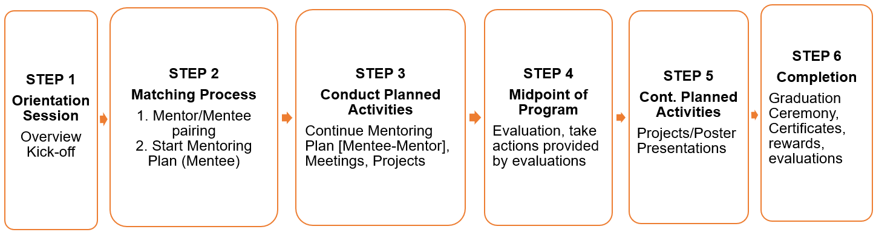

Mentoring Program
Advisory Committee

A mentoring program advisory committee has been established to set up mentoring pairs and to lead mentoring activities in their respective groups.

Attributes and Skills
- Associate or higher rank

- Dedicated time (0.10 FTE per 10-15 mentor/mentee pairs)

- Outstanding communication skills

- Knowledge/experience with all aspects of advancement and promotion at UTRGV SOM

Responsibilities
- Overall responsibility for faculty mentoring in their department or division

- Set up mentee/mentor pairs (main target mentees are junior faculty up to associate professor rank; new faculty who have been at UTRGV SOM for 3 years or less should also be offered a mentor)

- Establish local system for documenting and tracking these pairs

- Responsible for oversight of mentoring program— including yearly review of pairs

- Provide guidance and support for reassignment of mentees as needed

Work with the Faculty Mentoring, to:

- Conduct qualitative and quantitative evaluation of the program
- Disseminate findings and recommendations
- Attend mentoring workshops and organize mentoring events for their faculty
- Attend yearly mentoring facilitator meetings

Documents to Complete
The Documents to Complete section includes:

- Mentoring Partnership Agreement
- Mentoring Meeting Journal
- Individual Development Plan (IDP)

Mentoring Partnership Agreement
As a mentor and mentee in the UTRGV Faculty Mentoring Program, we agree to abide by the following set of guidelines:

- Commit to making the time to meet on a regular basis, no less than
2-3 times per year.

- Keep the content of our conversations confidential.

- Practice active listening.

- Provide each other with honest, direct, and respectful feedback.

- Other:

Mentee Signature
Mentor Signature

Date

Mentoring Meeting Journal

Use this page to record the discussion points in each of your mentoring meetings.
Check-In (e.g. urgent issues, work-life balance, personal issues):

Goal Discussion :

Action Items :

Next Meeting Date:

Individual Development Plan (IDP)
UTRGV SOM Faculty Mentoring Program

Instructions to Mentees:
Please complete this form and give a copy to your mentor before your
Mentoring session.

Instructions to Mentors:
Please review the mentee’s CV and this form prior to meeting your mentee.

Date:

Mentee Name:

Mentor Name:

Time Allocation in Mentee MOA:

% Teaching/Training/Providing Mentoring
% Research
% Patient Care
% Administration/Other Services

How (if at all) would you like to change this time distribution?

- things you’re doing now that you want to quit
- things you’ve just been asked to do that you want to refuse to do
- things that you’re doing that you want to continue
- things that you’re not doing that you want to start
- strategies for improving the balance within the above 4 categories

Academic Appointment
Do you understand the series to which you are appointed and the expectations
for advancement in this series?

___Yes
___No

Explain:

Current Professional Responsibilities
List your major professional responsibilities and if you anticipate significant
changes in the coming year:

1.
2.
3.
4.
5.

Future Professional Goals
Short Term Goals
List your professional goals for the coming year. Be as specific as possible, and
indicate how you will assess if the goal was accomplished (expected outcome).

- Goal:

Expected outcome:

- Goal:

Expected outcome:

- Goal:

Expected Outcome:

Long Term Goals
List your professional goals for the next 3-5 years. Again, be specific,
and indicate how you will assess if the goal was accomplished.

- Goal:

Expected Outcome:

- Goal:

Expected Outcome:

- Goal:

Expected Outcome:

Mentoring

Best Practices
The Mentoring Best Practices section includes:

- What is Mentoring?
- Hierarchy of Supportive Work Relationships
- Why Mentoring Matters
- Benefits of Mentoring for University
- Phases of the Mentoring Relationship
- Selecting Mentors
- Initiation: First Meeting Checklist
- Initiation: Structuring Meeting Time
- Initiation: Expectations
- Cultivating the Relationship: Building Trust
- Cultivating the Relationship: Giving and Receiving Feedback
- Separation and Redefinition
- Consequences of Negative Mentoring Relationships

What is Mentoring?

. . . a process where mentor and mentee work together to discover and develop the mentee’s abilities.

. . . a long-term relationship with a responsibility to provide the support, knowledge and impetus that can facilitate professional success.

. . . a personal process that combines role modeling, apprenticeship, and nurturing.

The mentor will act as a teacher, sponsor, guide, exemplar, counselor, moral support—but most importantly will assist and facilitate the realization of the dream.

. . . process whereby an experienced, highly regarded, empathic person (the mentor) guides another individual (the mentee) in the development and examination of their own ideas, learning and personal and professional development. The mentor, who often, but not necessarily, works in the same organization or field as the mentee, achieves this by listening and talking in confidence to the mentee.

Hierarchy of Supportive

Work Relationships

Career Functions

“Those aspects of a relationship that enhance advancement in the organization.”
- Coaching, protecting, networking, sponsorship

Psychosocial Functions

“Those aspects of a relationship that enhance an individual’s sense of competence, identity and effectiveness.”
- Role modeling, counseling, confirmation, acceptance

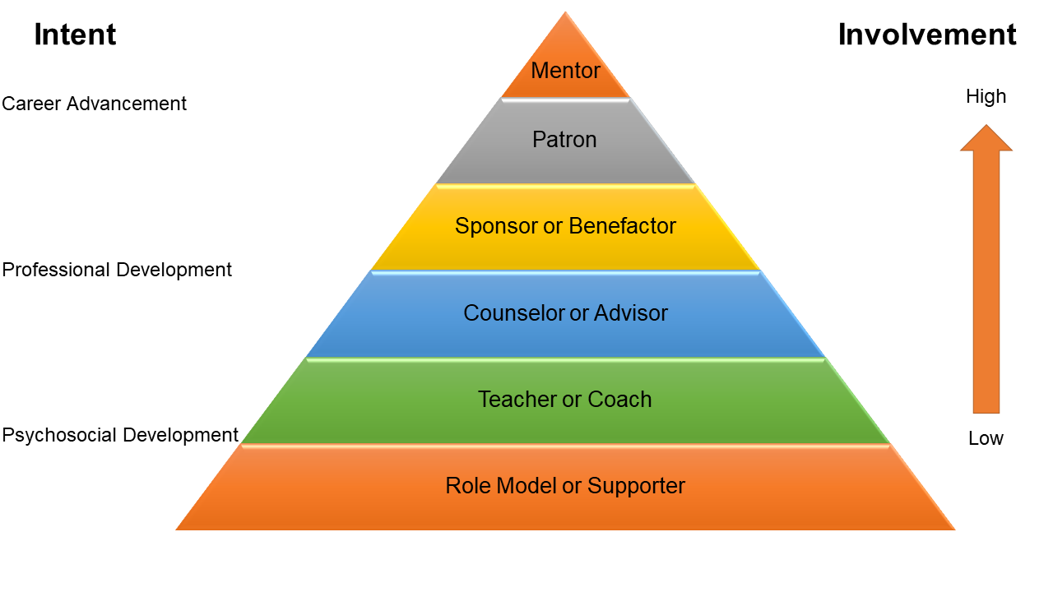
Metz, 2004

Why Mentoring Matters

- Promotes career development and satisfaction

- Improves success of women and underrepresented minorities in academic health careers

- Enhances faculty productivity (mentoring is linked to increased funding and publications)

- Increases interest in academic careers

- Predicts promotion in academia

- Improves self-efficacy in teaching, research, and professional development

- Increases the time that clinician educators spend in scholarly activities

- Leads to less work-family conflict

Benefits of Mentoring

Benefits for Mentees
  - Compensation
  - Promotion in career / job
  - Satisfaction outcomes

Benefits for Mentors
  - Develop personal support network
  - Information and feedback from protégés
  - Satisfaction from helping others
  - Recognition
  - Improved career satisfaction

Benefits of Mentoring

for the University

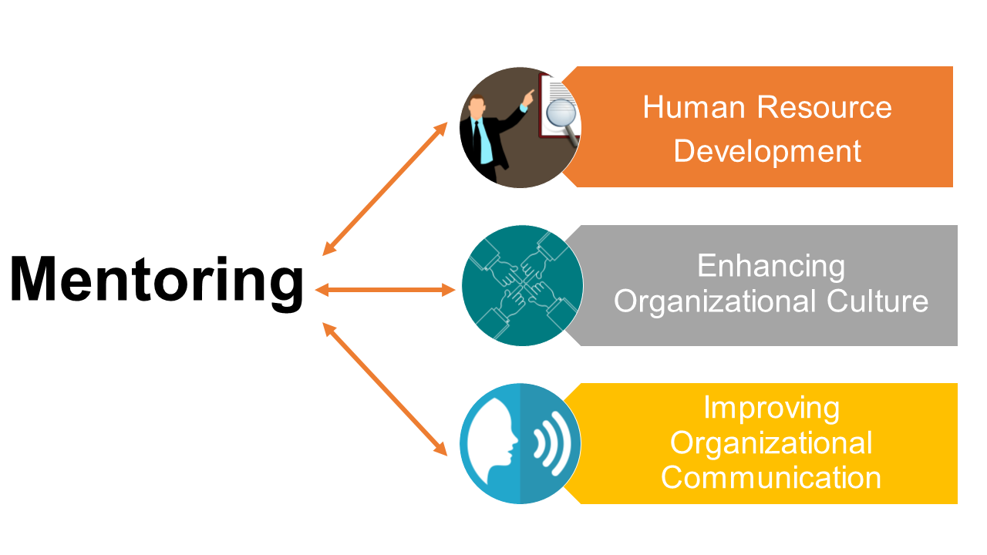

Phases of the Mentoring Relationship

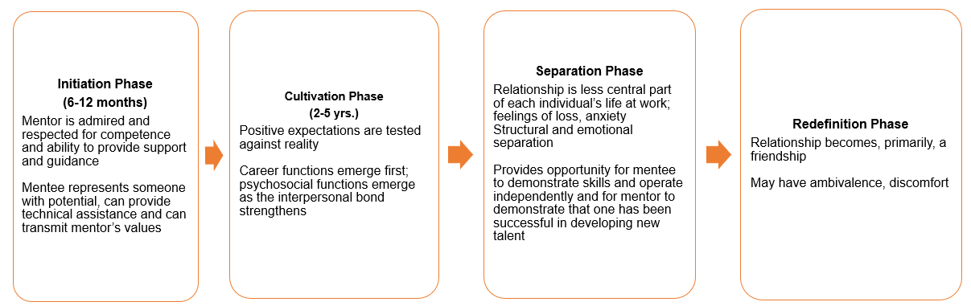

Kram,1983

Selecting Mentors

In matching mentors and mentees consider the following:

    - All senior faculty members (associate professor rank or higher) are eligible to be mentors
    - Mentors should have a limit of two to three ‘career’ mentees
    - Research shows that mentees who have more input into the match are more satisfied with their mentors
    - Mentor/Mentee characteristics
      - Career interests
      - Gender (gender matching has been shown to be helpful for female mentees)
      - Race/ethnicity
      - Age
      - Personal chemistry (important but hard to predict)

Initiation:

First Meeting Checklist

Get to Know Each Other
- Share information about your professional and personal life
- Learn something new about your mentee/mentor

Establish Guidelines
- When and where will we meet?
- How will we schedule meetings?
- How will we communicate between meetings?
- What agenda format will we use?
- Will there be any fixed agenda items to be discussed at every meeting?
- How will we exchange feedback?
- How will we measure success?

Partnership Agreement
- Review partnership agreement, modify if desired, sign and exchange
- Review goals for the mentoring relationship

Confirm Next Steps
- Schedule date, time, and place of future meetings

Initiation:

Structuring Meeting Time

Determine how to use your time together. One suggestion is the “10/20/60 Rule” that will help you to establish a solid partnership and address mentoring goals and everyday issues. For a meeting of about 1½ hours split the time roughly as follows:

First 10 Minutes
Engage in personal/professional “check-in”

Next 20 Minutes
Focus on ‘front burner’ issues (upcoming presentation, manuscript revision, etc.)

Next 60 Minutes
Discuss current and long-term goals and priorities Summarize discussion, clarify tasks, schedule follow-up meeting

Initiation: Expectations

A critical component of a successful mentoring relationship is clarity of commitment and expectations.

Mentors and mentees need to agree on:
- Scheduling and logistics of meeting
- Frequency and mode of communicating between meetings
- Responsibility for rescheduling any missed meetings
- Confidentiality
- “Off-limits” conversations
- Giving and receiving feedback
- Working with formalized mentee goals

Cultivating the Relationship:

Building Trust

When people trust each other, they allow their most authentic self to emerge. They feel free to share concerns, insecurities, and doubts. Listening to each other builds trust. Sharing reservations and uncertainties builds trust. Most importantly, demonstrating by our acts that we are trustworthy builds trust.

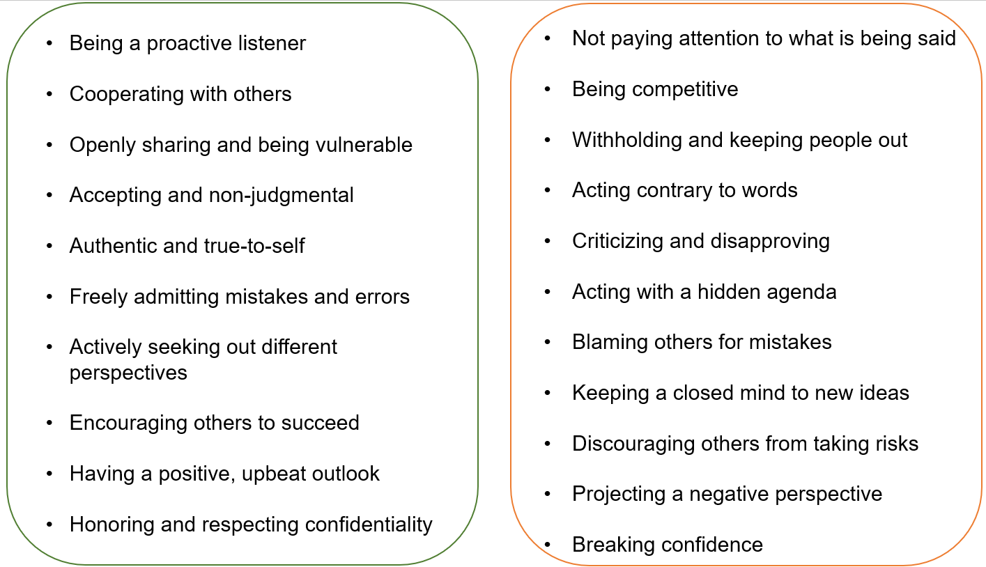
Behaviors That Build Trust Behaviors That Destroy Trust

Cultivating the Relationship: Giving and Receiving Feedback
Mentees want to receive honest, candid feedback from their mentor. Equally important is the feedback mentees can offer to mentors. Engaging in reciprocal and on-going feedback is a vital component of the partnership.

Effective feedback:
- Is offered in a timely manner
- Focuses on specific behaviors
- Acknowledges outside factors that may contribute
- Emphasizes actions, solutions, or strategies

Effective Feedback from Mentee:
- Whether the advice or guidance you offered was beneficial and solved an issue
- Whether the mentor communication style and/or actions facilitate a positive mentoring experience
- Whether the mentor communication style and/or actions create challenges to a positive mentoring experience

Effective Feedback to Mentee:
- Mentee strengths and assets
- Areas for growth, development, and enhancement
- Harmful behaviors or attitudes
- Observations on how your mentee may be perceived by others

Separation and Redefinition

Participating in a mentoring program brings the opportunity for planning and implementing closure that is unlike most other types of relationships. Whether you determine to continue meeting on a regular basis or not, it is essential to discuss and plan the process by which your formal partnership will end.

If appropriate, you will want to think about how you would like to transition from a formal to an informal mentoring partnership or to more of a peer relationship. It is recommended to instill some structure to even an informal partnership to yield the most benefit from the time you spend together.

Closure Checklist:
- Discuss how to use the remaining time together.
- Make sure an important goal has not been overlooked.
- Plan a formal acknowledgement or celebration of the mentoring relationship.

Questions to Discuss:
- Have the goals been achieved?
- Have the important issues been discussed?
- How should the separation/redefinition be acknowledged?
- What will the agenda be for the last meeting?
- What would be the ideal interaction going forward?

Consequences of Negative Mentoring Relationships

For Mentees
- Higher levels of work stress
- Lower self esteem
- More likely to leave

For Mentors
- Less likely to mentor others
- Less likely to invest in other work activities

For Organizations
- Culture of mistrust and lack of voluntarism

Mentee Resources

The Mentee Resources section includes:

- Choosing a Mentor
- Being a Proactive Mentee
- Mentee’s Dos and Don’ts
- Mentee Strategies to Achieve Mentoring Objectives

Choosing a Mentor

Choose a mentor who has the following qualities:

- Interested in developing your career
- Commitment to mentoring

- Match your emotional needs
Do you need more support and praise or more challenge?

- Match with your professional needs
Help with writing? Methodological skills?
Research/scholarly/clinical interests

- A successful track record
- Good communication skills
- Will provide networking opportunities
- Is institutionally savvy
- Expresses interest in you as a person
- There is potential for reciprocity

Being a Proactive Mentee

The most successful mentoring partnerships are those in which the mentee takes the initiative and truly drives the partnership. In a mentee-driven partnership, the mentee determines the pace, route, and destination. The mentor is then able to offer insights and counsel that is focused on the mentee’s objectives.

Consider the following questions:

  - Are my objectives clear and well defined?
  - Am I comfortable asking for what I want?
  - Am I open to hearing new ideas and perspectives?
  - Do I allow myself to be open and vulnerable?
  - Am I receptive to constructive feedback?
  - Am I able to show I value and appreciate feedback?
  - Am I willing to change or modify my behaviors?
  - Do I consistently follow through on commitments?
  - Do I try to instill trust?
  - Do I openly show appreciation and gratitude?

Mentee Dos and Don’ts

Do’s Don’ts
Mentee Strategies to
Achieve Mentoring Objectives

Whether your objectives focus on broad issues or more specific developmental areas, your mentor’s ability to help you attain those objectives will be enhanced when you have clearly defined where you want to go and how you want to get there. It is important to think carefully about your objectives and the challenges to achieving them.

Use the questions below to appraise your objectives:

Specificity
    - Have you identified a specific objective for the partnership?
    - Are your objectives definite and precise?

Measurability
    - Are your objectives quantifiable in nature?
    - Have you decided how to measure success?

Work Plan
    - Do you have an action plan to achieve your objectives?
    - Have you considered the outcome of achieving your objectives?

Reality Check
    - Are your objectives realistic given the circumstances?
    - Have you determined a completion date?
    - Is your timeline realistic?
    - Will you need additional resources or tools to be successful?

The Mentor’s Role
    - Will your objectives require your mentor to provide you something other than guidance?
    - How can your mentor be most helpful to you?

The Mentor Resources section includes:

- Characteristics of an Effective Mentor: The Three C’s
- Mentor Roles and Functions
- Negative Mentoring Experiences Chart
- Mentor Do’s and Don’ts
- Mentors Role in Mentee Development
- Mentoring Program Advisory Committee Checklist
- Mentor’s Meeting Checklist
- Cultivating Your Mentee’s Goals

Mentor Resources
Characteristics of an Effective Mentor: The Three C’s

Competence
Professional knowledge and experience Respect Interpersonal skills and good judgment

Confidence
Shares network of contacts and resources
Allows protégé to develop his/her own terms Demonstrates initiative, takes risks
Shares credit

Commitment
Invests time, energy, and effort to mentoring Shares personal experience

Mentor Roles and Functions

Role
Responsibility
Relationship with Individual
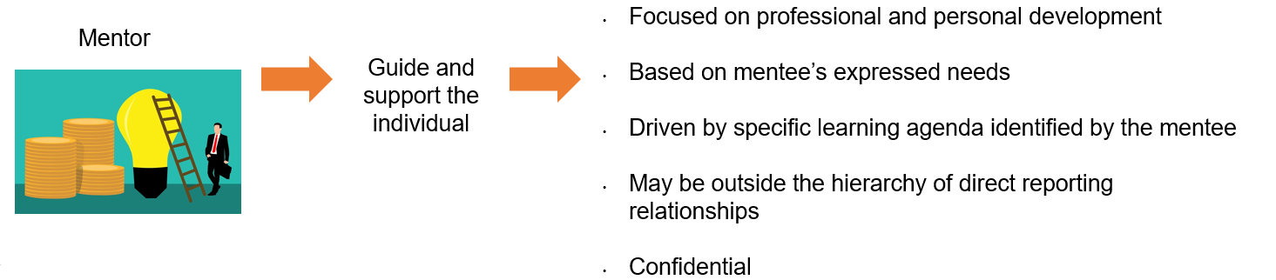

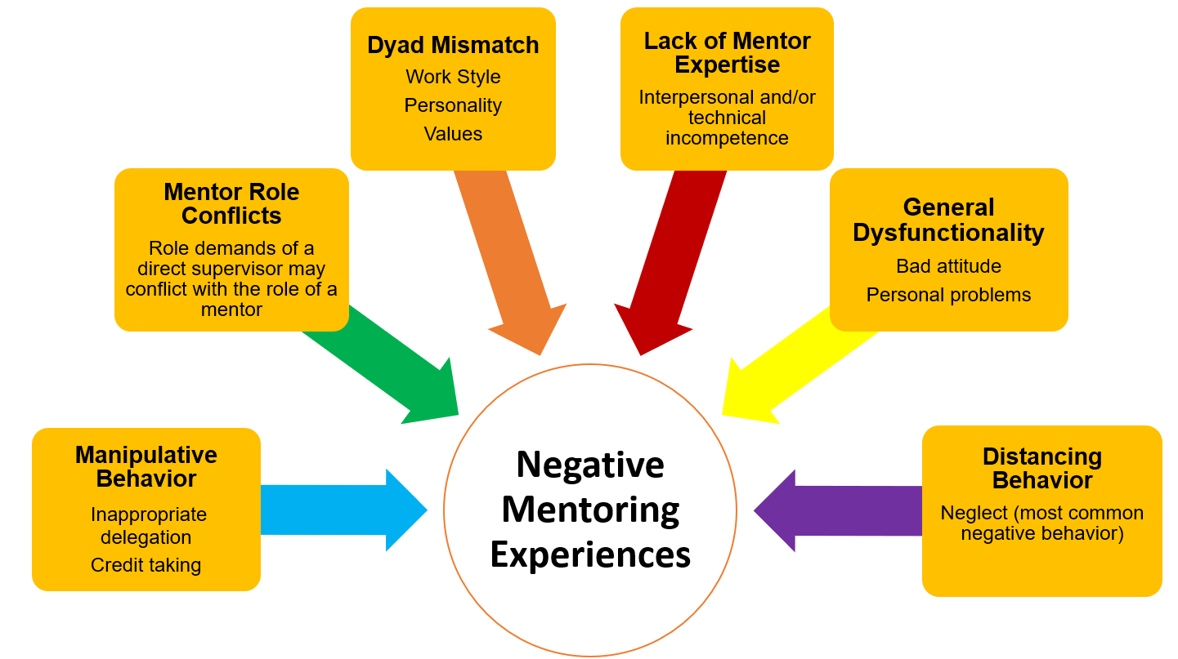

(Eby, 2000)

Mentor Do’s and Don’ts

Do’s Don’ts
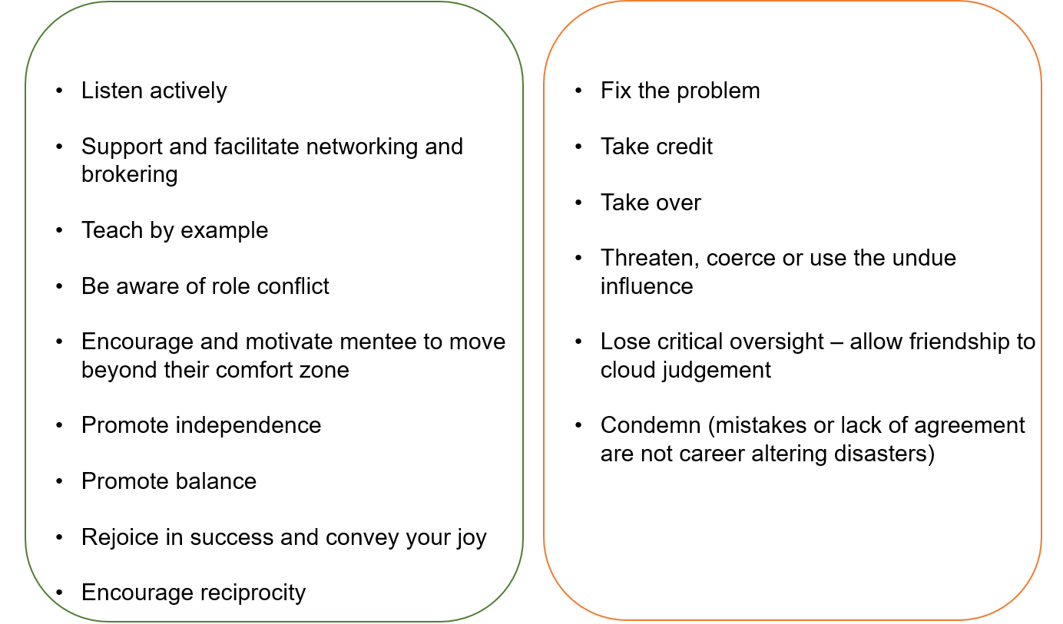
Mentors Role in
Mentee Development

Support
  - Listening—actively (empathically)
  - Expressing positive expectations
(Mentors) balance both a present sense of where their students are and a dream of what they can become.
  - Serving as advocate
  - Self-disclosure as appropriate

Challenge
    - Setting tasks
    - Setting high standards
    - Modeling
    - Providing a mirror

Vision
    - Provide a vision for a satisfying and successful career
(Daloz, 1999)

Mentoring Program
Advisory Committee Checklist

- Finalize list of eligible mentees’ (junior/new faculty) current mentoring needs and relationships

- Assemble list of eligible mentors
    - Limit 2-3 ‘career’ mentees per mentor

- Assist in mentor/mentee pairings, confirm existing pairs, and make assignments as needed

- Create database of mentor-mentee pairs
- Distribute mentoring contract, IDP, meeting guide and other materials

- Periodic check-in: meet with mentors/mentees as needed

- Organize faculty development mentoring activities: faculty meetings, grand rounds, retreats

- Annual meeting or survey of mentors and mentees
- Assist in program evaluation

Mentor’s Meeting Checklist

- Set aside adequate time for meetings
- Obtain and review mentee’s CV and IDP prior to meeting
- Be sure to review contact information and other meeting arrangements
- Clarify what mentee expects from you--and what you expect from mentee

- Review mentee’s short/long term goals
- Be sure that you have accurate, up-to-date information on advancement and promotion policies for your mentee’s series and rank (see the UTRGV SOM P&T Guidelines posted on Blackboard).

- Ask mentee to help you with writing, research, teaching, curriculum development etc. that is consistent with their career goals

- Be aware of potential conflicts of interest if you are both a supervisor and mentor for the mentee

- Be sure that mentee has joined committees and professional organizations helpful for career development

- Assist your mentee to find other mentors within and outside UTRGV- SOM

Evaluating Your Mentee’s Goals

Use the checklist below to appraise your mentee’s goals: Specificity
  - Has your mentee identified specific short- and long-term goals?
  - Are the goals definite and precise?

Measurability
  - Are your mentee’s goals quantifiable in nature?
  - Has your mentee determined how to measure success?

Work Plan
  - Does your mentee have an action plan to achieve their goals?
  - Has your mentee considered the outcome of achieving these goals?

Reality Check
  - Are your mentee's goals realistic given the circumstances?
  - Has your mentee determined a completion date?
  - Can success be achieved within the time allocated?
  - Will additional resources or tools be needed to achieve success?

Your Role
  - Is your role to advise, suggest or listen?
  - Will your mentee’s goals require you to provide something other than guidance?
  - How can you be most helpful to your mentee?

Appendix
The Appendix section includes:

- Mentoring Resources
- Miscellaneous Mentoring Resources
- University-Wide Resources
- Selected Articles

Mentoring Resources

Johns Hopkins School of Public Heath, Center for Mind-Body Research
http://www.jhsph.edu/mindbodyresearch/mentoring_program/

Medical College of Virginia Campus Office of Faculty and Instructional Development School of Medicine
https://faculty.med.virginia.edu/facultyaffairs/faculty-life-cycle/mentoring-program/

Northeast Ohio Medical University
https://www.neomed.edu/facultyrelations/development/master-teacher-guild/

University of Arkansas Medical Sciences
https://faculty.uams.edu/faculty-mentoring-program/

University of California San Diego, National Center of Leadership in Academic Medicine
http://nclam.ucsd.edu/

University of Wisconsin - Madison
https://ictr.wisc.edu/mentoring/

University of Massachusetts Medical School
http://www.umassmed.edu/Macy/index.aspx?linkidentifier=id&itemid=7722

University of Miami School of Medicine
http://cfar.med.miami.edu/developmental-core/mentoring-program

University of North Carolina at Chapel Hill
https://www.med.unc.edu/pediatrics/about/faculty-development/faculty-mentoring-1/

Miscellaneous Mentoring Resources

A guide to Training and Mentoring in the Intramural Research Program at NIH

https://oir.nih.gov/sourcebook/mentoring-training/guide-training-mentoring

American Heart Association Mentoring Handbook

http://my.americanheart.org/idc/groups/ahamah- public/@wcm/@sop/documents/downloadable/ucm_319794.pdf

Association for Women in Science

https://www.awis.org/getting-the-most-out-of-your-mentoring-relationships/

MentorNet

http://www.mentornet.net/

University-Wide Resources

Mentor Support Program
https://www.utrgv.edu/facultysuccess/programs-training/mentors-support-program/index.htm

New Faculty Support Program
https://www.utrgv.edu/facultysuccess/programs-training/new-faculty-support/index.htm

Academic Affairs Leadership Program
https://www.utrgv.edu/facultysuccess/programs-training/academic-affairs-academic-program/index.htm

Second Year Faculty
https://www.utrgv.edu/facultysuccess/programs-training/second-year-faculty/index.htm

General Faculty Development
https://www.utrgv.edu/facultysuccess/programs-training/general-faculty-development/index.htm

Summer Writing Program
https://www.utrgv.edu/facultysuccess/programs-training/summer-writing-program/index.htm

Associate to Full Professor Program
https://www.utrgv.edu/facultysuccess/programs-training/associate-full-professor-program/index.htm

Department Leaders Workshop
https://www.utrgv.edu/facultysuccess/programs-training/department-leaders-workshop/index.htm

Distinguished Faculty Colloquium
https://www.utrgv.edu/facultysuccess/programs-training/distinguished-faculty-colloquium/index.htm

Department Profile
https://www.utrgv.edu/facultysuccess/programs-training/department-profile/index.htm

Selected Articles
Abedin, Z., Biskup, E., Silet, K., Garbutt, J. M., Kroenke, K., Feldman, M. D., . . . Pincus, H. A. (2012). Deriving Competencies for Mentors of Clinical and Translational Scholars. Clinical and Translational Science, 5(3), 273-280. doi:10.1111/j.1752-8062.2011.00366.x; 10.1111/j.1752-8062.2011.00366.x
Berk, R. A. P., Berg, Janet, MS, RN, Mortimer, Rosemary, MS, MSEd, RN, Walton-Moss, Benita, DNS, RN, & Yeo, Theresa P., MSN, MPH, RN. (2005). Measuring the Effectiveness of Faculty Mentoring Relationships. Academic Medicine, 80(1), 66-71.
Cho, C. S., Ramanan, R. A., & Feldman, M. D. (2011). Defining the ideal qualities of mentorship: a qualitative analysis of the characteristics of outstanding mentors. The American Journal of Medicine, 124(5), 453-458. doi:10.1016/j.amjmed.2010.12.007
Daloz, L. (1999). Mentor: Guiding the journey of adult learners. San Francisco, CA: Jossey-Bass
Eby, L. T., & Lockwood, A. (2005). Protégés’ and mentors’ reactions to participating in formal mentoring programs: A qualitative investigation. Journal of Vocational Behavior, 67(3), 441-458. doi:10.1016/j.jvb.2004.08.002
Feldman, M. D. (2012). From the editors' desk: realizing the dream: mentorship in academic medicine. Journal of General Internal Medicine, 27(1), 1-2. doi:10.1007/s11606-011-1923-2
Feldman, M. D., Arean, P. A., Marshall, S. J., Lovett, M., & O'Sullivan, P. (2010). Does mentoring matter: results from a survey of faculty mentees at a large health sciences university Medical Education Online, 15(0) doi:10.3402/meo.v15i0.5063
Feldman, M. D., Huang, L., Guglielmo, B. J., Jordan, R., Kahn, J., Creasman, J. M., . . . Brown, J. S. (2009). Training the Next Generation of Research Mentors: The University of California, San Francisco, Clinical & Translational Science Institute Mentor Development Program Clinical and Translational Science, 2(3), 216-221. doi:10.1111/j.1752- 8062.2009.00120.x
Feldman, M. D., Steinauer, J. E., Khalili, M., Huang, L., Kahn, J. S., Lee, K. A., . . . Brown, J. S. (2012). A Mentor Development Program for Clinical Translational Science Faculty Leads to Sustained, Improved Confidence in Mentoring Skills Clinical and Translational Science, doi:10.1111/j.1752-8062.2012.00419.x
Jackson, V. A., Palepu, A., Szalacha, L., Caswell, C., Carr, P. L., & Inui, T. (2003). "Having the right chemistry": a qualitative study of mentoring in academic medicine. Academic Medicine : Journal of the Association of American Medical Colleges, 78(3), 328-334.
Johnson, J. C., Williams, B., & Jayadevappa, R. (1999). Mentoring program for minority faculty at the University of Pennsylvania School of Medicine. Academic Medicine : Journal of the Association of American Medical Colleges, 74(4), 376-379.
Johnson, M. O., Subak, L. L., Brown, J. S., Lee, K. A., & Feldman, M. D. (2010). An innovative program to train health sciences researchers to be effective clinical and translational research mentors. Academic Medicine : Journal of the Association of American Medical Colleges, 85(3), 484-489. doi:10.1097/ACM.0b013e3181cccd12

Kram, K. E. (1983). Phases of the Mentor Relationship. Academy of Management Journal, 26(4), 608-625. doi:10.2307/255910
Kram, K. E. (1985). Improving the Mentoring Process. Training & Development Journal, 39(4), 40.
Luckhaupt, S. E., Chin, M. H., Mangione, C. M., Phillips, R. S., Bell, D., Leonard, A. C., & Tsevat, J. (2005). Mentorship in academic general internal medicine. Results of a survey of mentors. Journal of General Internal Medicine, 20(11), 1014-1018. doi:10.1111/j.1525-1497.2005.215.x
Shea, J. A., Stern, D. T., Klotman, P. E., Clayton, C. P., O'Hara, J. L., Feldman, M. D., . . . Jagsi, R. (2011). Career development of physician scientists: a survey of leaders in academic medicine. The American Journal of Medicine, 124(8), 779-787. doi:10.1016/j.amjmed.2011.04.004
Straus, S. E., Johnson, M. O., Marquez, C., & Feldman, M. D. (2013). Characteristics of successful and failed mentoring relationships: A qualitative study across two academic health centers. Academic Medicine : Journal of the Association of American Medical Colleges, 88(1), 82-89. doi: 10.1097/ACM.0b013e318276

