**Community Historical Archaeology Project with Schools (CHAPS) Program**

What we are:

The Community Historical Archaeology Project with Schools (CHAPS) Program is a consortium of UTRGV faculty, lecturers, and staff have embraced the teacher/scholar model in academe wherein scholarly enquiry is intertwined with K-17 education and community engagement. Our focus is on local cultural and natural history.

While the CHAPS is not a degree-granting program, it provides students with interdisciplinary methodological experience in locally-focused cultural and natural history research projects which engage K-17 students, the general public, and visitors to Rio Grande Valley through hands-on interactive curriculum, web pages, exhibitions, and heritage tourism. The CHAPS Program has, since 2011, conducted an annual study of Edinburg-based farming families, which provides baseline-information on local archaeology, biology, geology, and history. These have been compiles into reports. It also oversaw the creation of the 200 mile-long ***Rio Grande Valley Civil War Trail*** ([www.utrgv.edu/civilwar-trail](http://www.utrgv.edu/civilwar-trail) ) and associated films, exhibits, books, and K-16 curriculum. Students created an exhibit titled “***Discovering Fort Brown***,” which is currently traveling the region ([www.utrgv.edu/rgv-militaryhistory](http://www.utrgv.edu/rgv-militaryhistory)).

Student Enrichment and Careers:

Students who have been part of the CHAPS Program team have entered graduate programs in Anthropology, History, and Museum Studies at East Carolina University, George Washington University, Texas A&M University, the University of Texas El Paso, and the University of Texas San Antonio. Some have held internships or are currently employed with the National Park Service and at the Smithsonian Institution in Washington, D.C.

Who we are:

The CHAPS Program team has expertise and experience in anthropology, archaeology, biology, education, film/communication, geology, and history. It has won grants from the National Endowment for the Humanities, Humanities Texas, the Summerlee Foundation, the Summerfield G. Roberts Foundation, the Texas Historical Commission, and the Texas Historical Foundation.

The CHAPS Program has been honored in Texas. In 2015 the Texas Archaeological Society gave its *Distinguished Service Award for Outstanding Contributions of Service to Texas Archaeology-CHAPS Program.* In 2016 the Texas Historical Commission recognized the program twice with the “*Chairman’s Award for Community Engagement*,” and with the *Award of Merit*. And, in 2017 the 85th Texas State Legislature recognized the CHAPS Program “as a true community engagement entity (House Resolution 479). And, in 2017 by the Society for Historical Archaeology honored us with the *Daniel G. Roberts Award for Excellence in Public Historical Archaeology.*

Web address: [www.utrgv.edu/chaps](http://www.utrgv.edu/chaps)

Program Manager: Roseann Bacha-Garza; Office: ELAMR

Email: [Roseann.bachagarza@utrgv.edu](mailto:Roseann.bachagarza@utrgv.edu) Phone: 956-665-3231

Director: Russell K. Skowronek Office: 317 ELABN

[Russell.skowronek@utrgv.edu](mailto:Russell.skowronek@utrgv.edu) 956-665-8085

Donations to the CHAPS Program will provide support to students for travel to conferences and field schools, as well as for research or internships. It will also help support the purchase of equipment, travel to conferences and for research, and to help with the publication of reports and other materials for teachers and the general public.

Farming series of reports

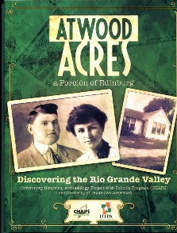 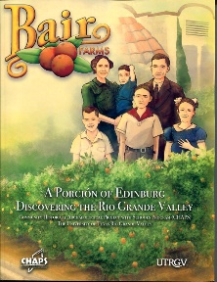 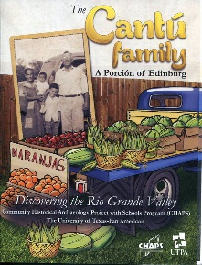  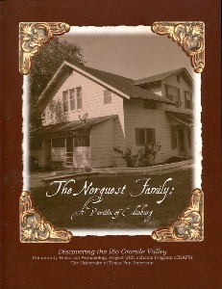 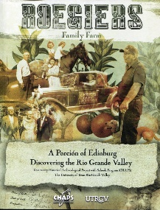

Other Publications

