 Reference Guide to Time and Effort Certification – Supporting Individual (SI)
ACCESS ECRT SYSTEM
To access the ECRT system:
- Open any web browser:
  - Go to: https://utss-ecrt.utsystem.edu/ecrt/
LOGIN SCREENS

- Choose “The University of Texas Rio Grande Valley” from the institution drop-down list and click <Select>.
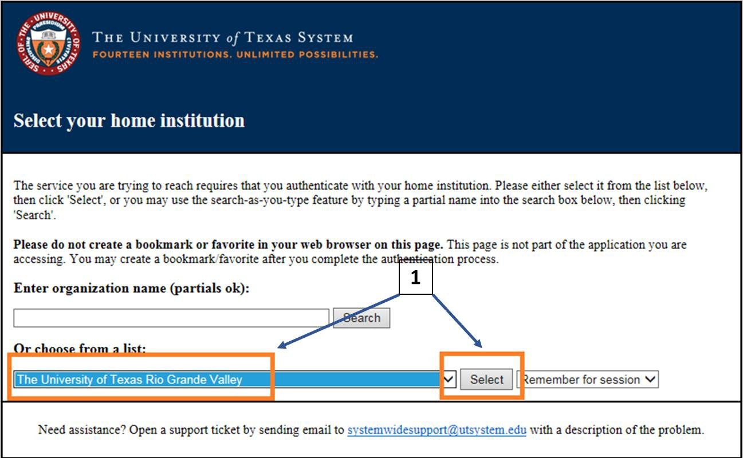

- Enter your UTRGV <Username> and <Password>.
  - Username: Same as your Network Username
  - Password: Same as your Network Password
- Click on the <Sign in> button.
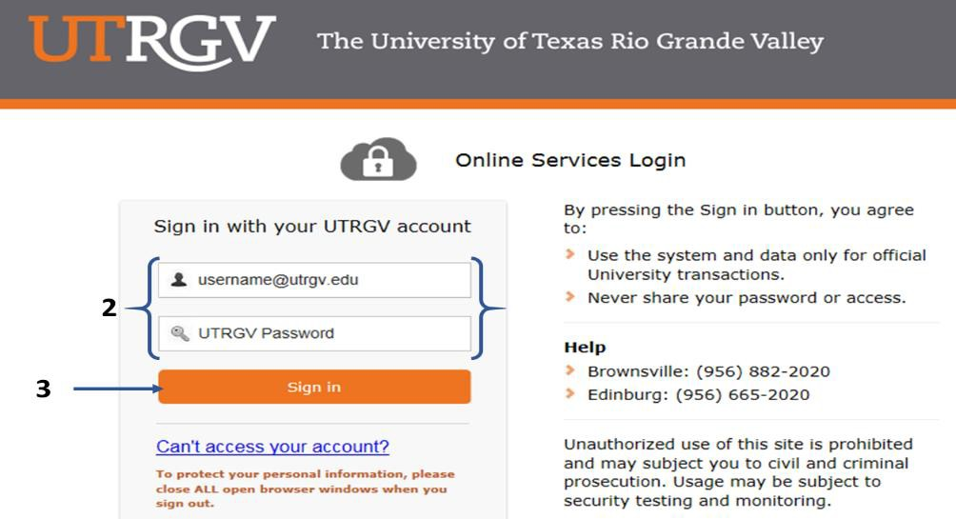

WELCOME TO THE ECRT SYSTEM

After the username and password are accepted, you will be taken to the “Welcome to the Effort Certification and Reporting Technology (ECRT) System” screen. This screen contains a statement about the certification process.

At the bottom of the message, click on the <Continue> button which will take you to the Home Page.
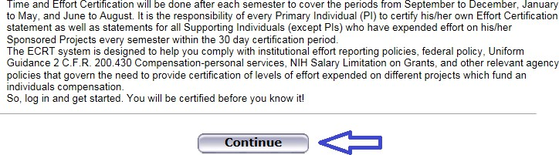

The Home Page displays after a user has successfully logged into ECRT. This screen functions as an entry point to all system functions, provides an overview of the Time and Effort Certification (Effort Reporting) process for administrators, and offers links to a variety of resources to assist users with the certification.
HOME PAGE
Your effort statement link will be listed under the “Statements Awaiting Certification” tab. The Status will show as “Not Open for Certification” during the semester data uploads and “Open for Certification” when your effort statement is ready for your PI(s) to certify.
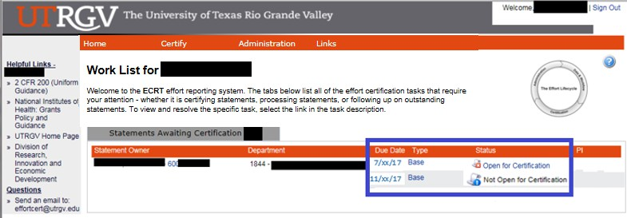
DROP DOWN MENUS

Across the top of the page is a menu bar. The left most option <Home> will return you to the home page containing the link(s) of your effort statement(s). Hover over the <Certify> tab of the menu bar and select “My Statements” to view your effort statement. Links highlighted in the blue boxes are specific to the SI’s. Helpful links are available on the left side of the home screen and from the <Links> drop down box. To log off of the system, simply click at the top right corner option
<Sign Out>.
The links contained in the drop-downs give you access to the menu options from any screen within the system.
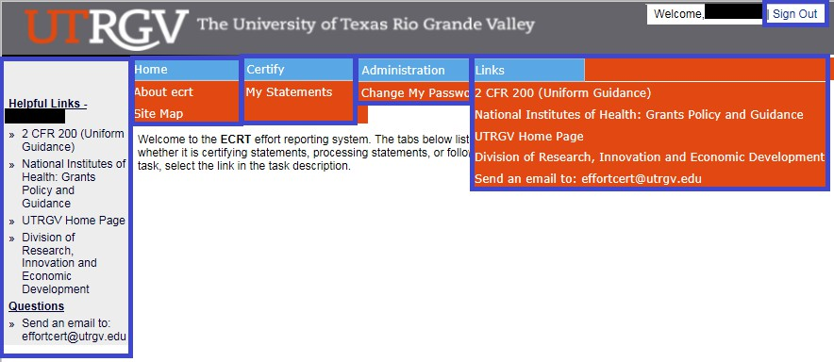

VIEW EFFORT STATEMENT

To view your Effort Statement, hover over the <Certify> tab of the menu bar and select “My Statements” or from the
<Home Page>, click on any link under the <Status> column depending on which cycle you would like to select.
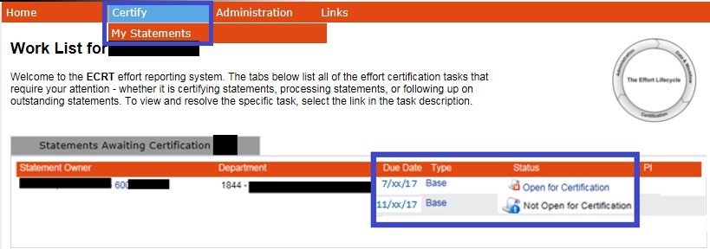
EFFORT STATEMENT INSTRUCTIONS

This is the main view of the effort statement:

The top right section of this screen shows the different categories of your effort statement.

- Needing certification: “Open for Certification” – effort statement is ready for your PI to certify during the certification period.
- In progress: “Not Open for Certification” - payroll data has been uploaded for the next cycle. Please log in to ECRT on a monthly basis to review your “Transactions” so your name can be recorded on the “Activity Log”.
- Historical: “Certified, Processed” – effort statement has been certified by your PI and Processed by the Central Effort Coordinator.
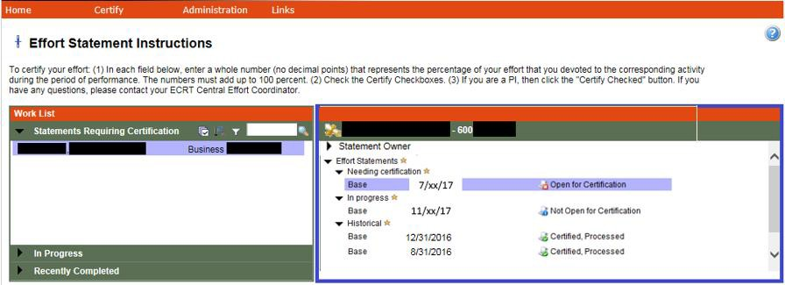

The middle section of your effort statement shows: Name, the Base Effort Period, and Status. Then, it shows the Projects (Sponsored and Non-Sponsored), Payroll, Cost Sharing (if any), and Computed Effort associated with the projects depending on the payroll data that has been uploaded to your effort statement.

If you place the cursor over the project name, an extra screen will pop up with the PI contact information. That PI will be certifying your effort statement. If you have multiple sponsored projects, then each PI will certify their own projects.
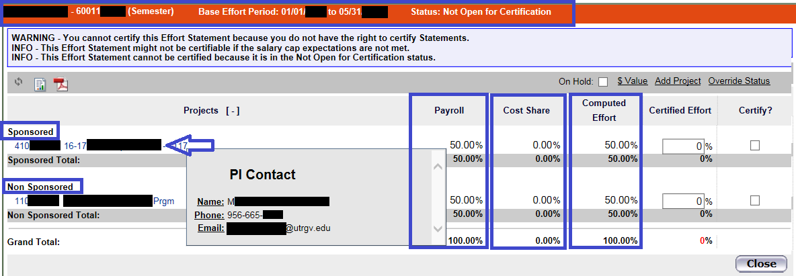

On the bottom section of your effort statement, you will see the following:

- “Notes” – Will allow users to add effort notes to active effort statements.


  - Example #1, for workshops attended: Project #XXXXXXXXX was for a stipend at 0% effort.

  - Example #2, for summer effort statements only: Project #XXXXXXXXX was for my 9 month appointment
/ 12 month distribution only at 0% effort.

- “Attachments” – Will allow users to attach a file to the effort statements if needed. Acceptable file formats include PDF, TIF, JPEG, and GIF.
- “Transactions” – Will show the payroll data that has been uploaded to your effort statement. Please review it on a monthly basis and make sure that it is correct. Report any discrepancies: through email at effortcert@utrgv.edu or contact your ECRT Central Effort Coordinator at (956) 882-7024.
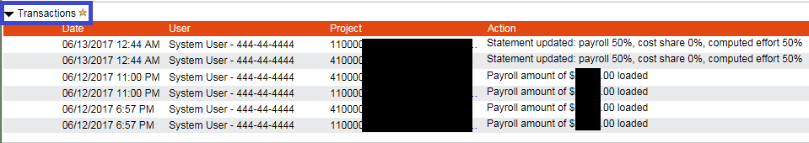

- “Activity Log” – Will record your name after you log in to view your effort statement. Please log in to ECRT after you receive monthly notifications informing you that “Payroll for a specific cycle has been uploaded to ECRT for your review”.

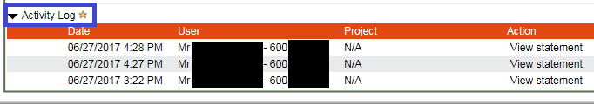

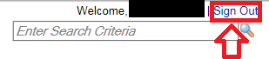
Finally, click the <Sign Out> link on the top right to log out.
T&E BLACKBOARD TRAINING

- Time and Effort Certification Training in Blackboard will occur at least once every two years or more frequently if determined by the requirements of sponsoring agencies. You have to pass 80% (8 out of 10) of the questions in order to meet training requirements. To access this training, go to:
  - myUTRGV
  - Blackboard
  - Click on “UTRGV Employee Education”
  - Then “Time and Effort Certification”

- Completion of this training will be required for:

New PIs receiving an award before an account is setup
  - All Supporting Individuals (SIs): Expend effort and cost sharing on sponsored projects
  - Primary Individuals (PIs): Certify their own effort and the effort of their SIs
  - Department Effort Coordinators (DECs): Involved with the effort certification process

Global View Only (GVO): Office of Research Compliance (ORC), Office of Sponsored Programs (OSP), Grants & Contracts (G&C), and Internal Auditing.

REMINDERS
- Please log in to ECRT to review your effort statement and “Transaction Log”.

- By logging in to ECRT at the end of each month, the “Activity Log” will record your name for tracking purposes.

- It is the responsibility of every PI in ECRT to certify his/her own effort statement as well as statements for all SIs (except PI’s) who have expended effort on his/her sponsored projects every semester.

- Three certification cycles per year:
  - Fall (September-December)

  - Spring (January-May)
  - Summer (June-August)

- UTRGV has a 30 day Certification Period.

- If your effort statement is pending certification by your PI, you will receive email reminders:
  - 14 days before the deadline
  - 7 days before the deadline
  - On the due date
RELEVANT INFORMATION

- Uniform Guidance 2 CFR 200.430, Compensation-personal services.

- The University of Texas Rio Grande Valley (UTRGV) Policy ADM 07-103, Managing and Certifying Effort on Sponsored Projects.
QUESTIONS/ASSISTANCE

- If you have any questions regarding Time and Effort Certification or the Effort Certification and Reporting Technology (ECRT) system, please send an email to effortcert@utrgv.edu or contact your ECRT Central Effort Coordinator at (956) 882-7024.
- Visit the Time and Effort Certification (T&E) website at:
http://www.utrgv.edu/research/for-researchers/time-effort/index.htm for “Services” and “Resources”.

