 Reference Guide to Time and Effort Certification – Primary Individual (PI)
ACCESS ECRT SYSTEM
To access the ECRT system:
- Open any web browser:
  - Go to: https://utss-ecrt.utsystem.edu/ecrt/
LOGIN SCREENS

- Choose “The University of Texas Rio Grande Valley” from the institution drop-down list and click <Select>.
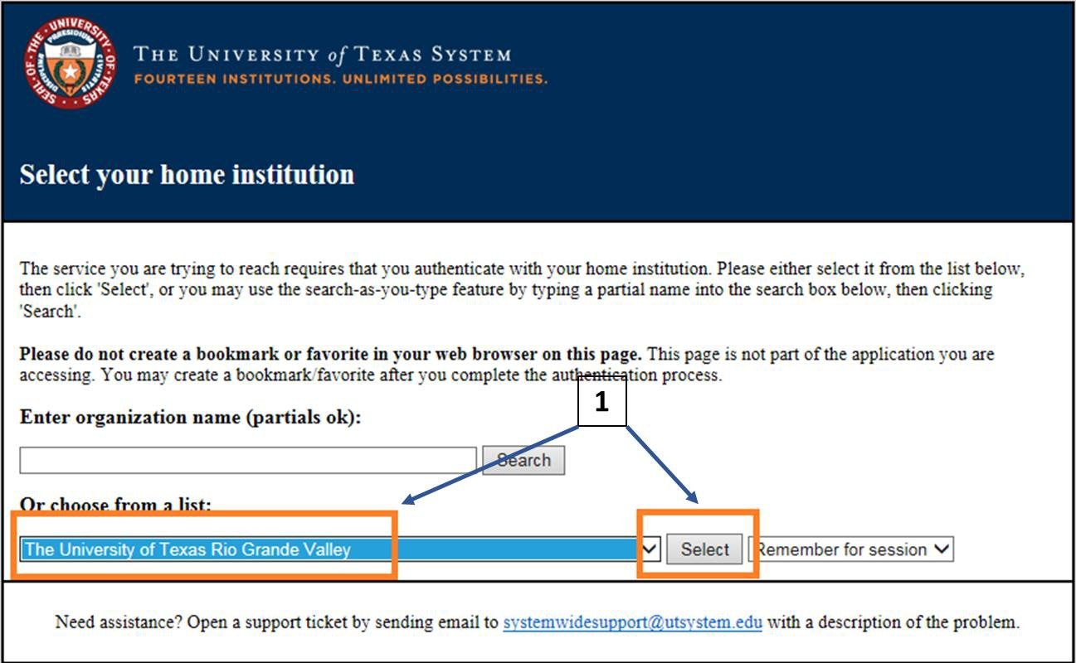

- Enter your UTRGV <Username> and <Password>.
  - Username: Same as your Network Username
  - Password: Same as your Network Password
- Click on the <Sign in> button.
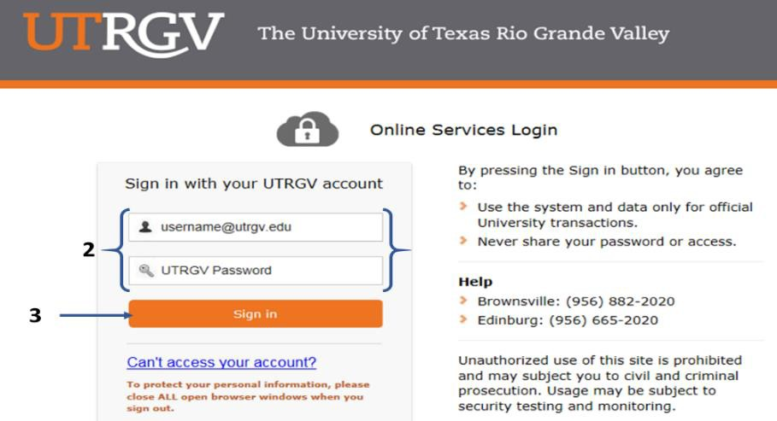
WELCOME TO THE ECRT SYSTEM

After the username and password are accepted, you will be taken to the “Welcome to the Effort Certification and Reporting Technology (ECRT) System” screen. This screen contains a statement about the certification process.

At the bottom of the message, click on the <Continue> button which will take you to the Home Page.
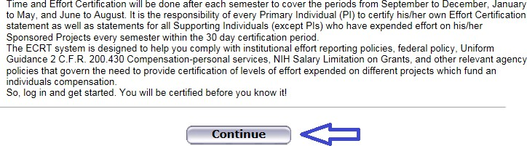

HOME PAGE

The Home Page displays after a user has successfully logged into ECRT. This screen functions as an entry point to all system functions, provides an overview of the Time and Effort Certification (Effort Reporting) process for administrators, and offers links to a variety of resources to assist users with the certification.
A list of effort statements appear under the “Statements Awaiting Certification” tab.

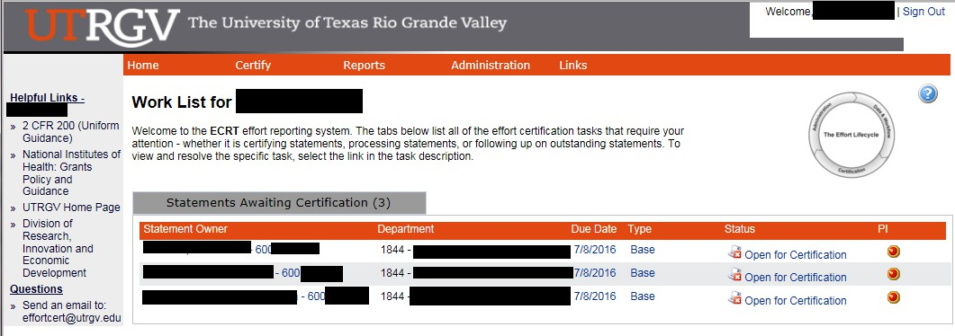
DROP DOWN MENUS

Across the top of the page is a menu bar. The left most option <Home> will return you to the home page containing statements awaiting certification. Hover over the <Certify> tab of the menu bar and select “My Statements” to certify your effort statements. Links highlighted in the blue boxes are specific to the PI’s. Helpful links are available on the left side of the home screen and from the <Links> drop down box. To log off of the system, simply click at the top right corner option
<Sign Out>.
The links contained in the drop-downs give you access to the menu options from any screen within the system.
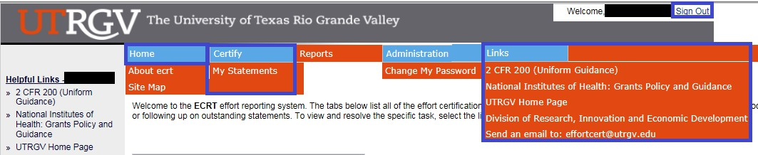
CERTIFY MY EFFORT AND SUPPORTING INDIVIDUALS

To certify your effort and the effort of your SI’s (that are not PI’s), hover over the <Certify> tab of the menu bar and select
“My Statements”.
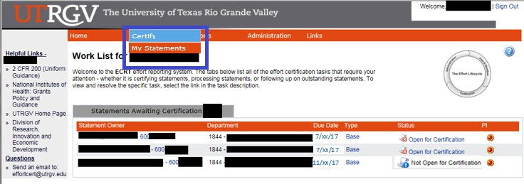

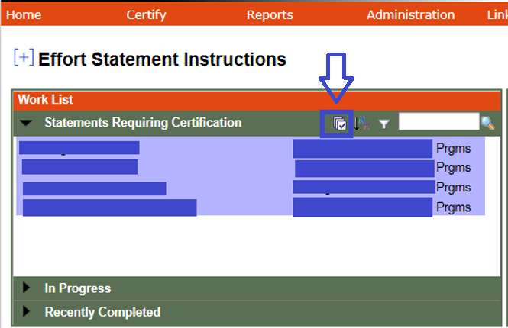
Your work list contains all of the effort statements. Select all of the effort statements at once by clicking the “Select everyone in the work list” icon from the “Work List box” or by holding “CTRL” and clicking each of the names in the list one by one.

All of the uncertified effort statements for every user in the list will be populated below. This is the main view of the effort statements for the PI and the Supporting Individuals (SI’s) if everyone was selected in the work list. The effort statements will contain the Sponsored and Non-Sponsored projects, you may view payroll, cost sharing (if any), and computed effort associated with those projects for the semester.

To certify effort:

- Review the projects, payroll/cost sharing, and the pre-populated percentages on the <Certified Effort> column.
  - The <Save All> button will save all changes and you can certify later. Effort statements that have not been certified will remain on your <Home Page> and <Effort Statement Instructions Page>.
  - The <Certify> or <Certify Checked> will appear once you have clicked on one of the <Certify?> check boxes.
  - If an effort statement has several Sponsored PI’s, then the PI that certifies first will certify all of the Non Sponsored <Certified Effort> percentages as well.

- Check the <Certify?> check boxes for your sponsored projects only and all of the non-sponsored projects.

- To certify all of the effort statements at once, click <Certify Checked> at the top/bottom right of the list, then
<OK>.

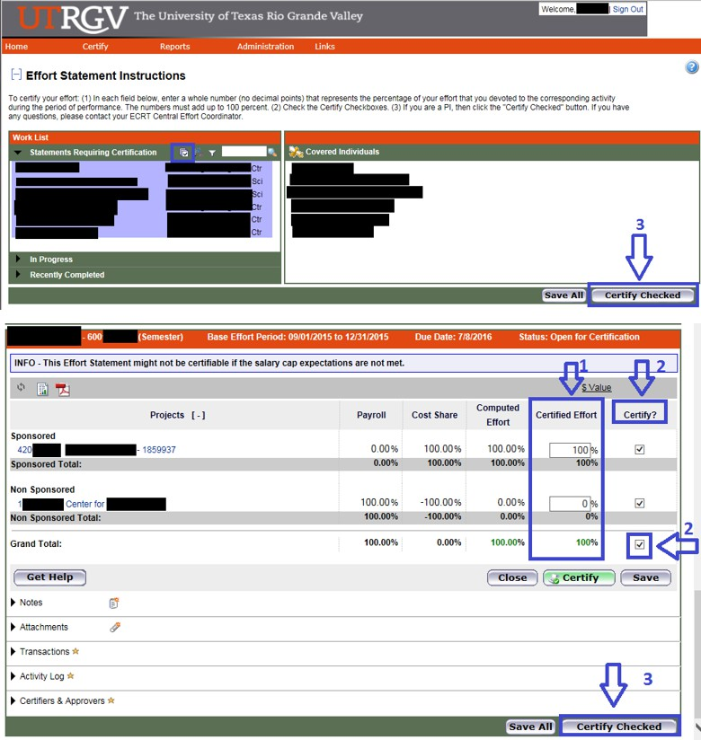

CERTIFICATION ATTESTATION PAGE

Attestation Page
  - I certify that I have used a reasonable means of verification and that the effort percentages shown for the stated period are a reasonable estimate of activity performed, allocable to the respective projects and activities as shown.

  - Verify list of certified effort statement(s).

  - Click on “I Agree” and “OK”.

After certification
  - The <Home Page> removes all of the effort statements that have been certified and the message “There are no effort statements associated to you” will appear.

  - The <Effort Statement Instructions Page> will only leave behind the PI’s effort statement to verify status and be able to see the historical statements.

  - Status will change to: “Certified, Not Processed”.


Finally, click the <Sign Out> link (on the top right) to log out.
T&E BLACKBOARD TRAINING

  - Time and Effort Certification Training in Blackboard will occur at least once every two years or more frequently if determined by the requirements of sponsoring agencies. You have to pass 80% (8 out of 10) of the questions in order to meet training requirements. To access this training, go to:
    - myUTRGV
    - Blackboard
    - Click on “UTRGV Employee Education”
    - Then “Time and Effort Certification”

  - Completion of this training will be required for:

New PIs receiving an award before an account is setup
    - All Supporting Individuals (SIs): Expend effort and cost sharing on sponsored projects
    - Primary Individuals (PIs): Certify their own effort and the effort of their SIs
    - Department Effort Coordinators (DECs): Involved with the effort certification process

Global View Only (GVO): Office of Research Compliance (ORC), Office of Sponsored Programs (OSP), Grants & Contracts (G&C), and Internal Auditing.

REMINDERS

  - It is the responsibility of every Primary Individual (PI) in ECRT to certify his/her own effort statement as well as statements for all Supporting Individuals (except PI’s) who have expended effort on his/her sponsored projects every semester. .

  - Three certification cycles per year:
    - Fall (September-December)
    - Spring (January-May)
    - Summer (June-August)

  - UTRGV has a 30 day Certification Period. Failure to certify during the certification period will result in placing your grant account(s) on hold until the certification is complete.

  - If your effort statements are pending certification, you will receive email reminders:
    - 14 days before the deadline
    - 7 days before the deadline
    - On the due date
RELEVANT INFORMATION

  - Uniform Guidance 2 CFR 200.430, Compensation-personal services.

  - The University of Texas Rio Grande Valley (UTRGV) Policy ADM 07-103, Managing and Certifying Effort on Sponsored Projects.
QUESTIONS/ASSISTANCE

  - If you have any questions regarding Time and Effort Certification or the Effort Certification and Reporting Technology (ECRT) system, please send an email to effortcert@utrgv.edu or contact your ECRT Central Effort Coordinator at (956) 882-7024.
  - Visit the Time and Effort Certification (T&E) website at:
http://www.utrgv.edu/research/for-researchers/time-effort/index.htm for “Services” and “Resources”.

