 Reference Guide to Time and Effort Certification –
Department Effort Coordinator (DEC)
ACCESS ECRT SYSTEM
To access the ECRT system:
- Open any web browser:
  - Go to: https://utss-ecrt.utsystem.edu/ecrt/
LOGIN SCREENS

- Choose “The University of Texas Rio Grande Valley” from the institution drop-down list and click <Select>.
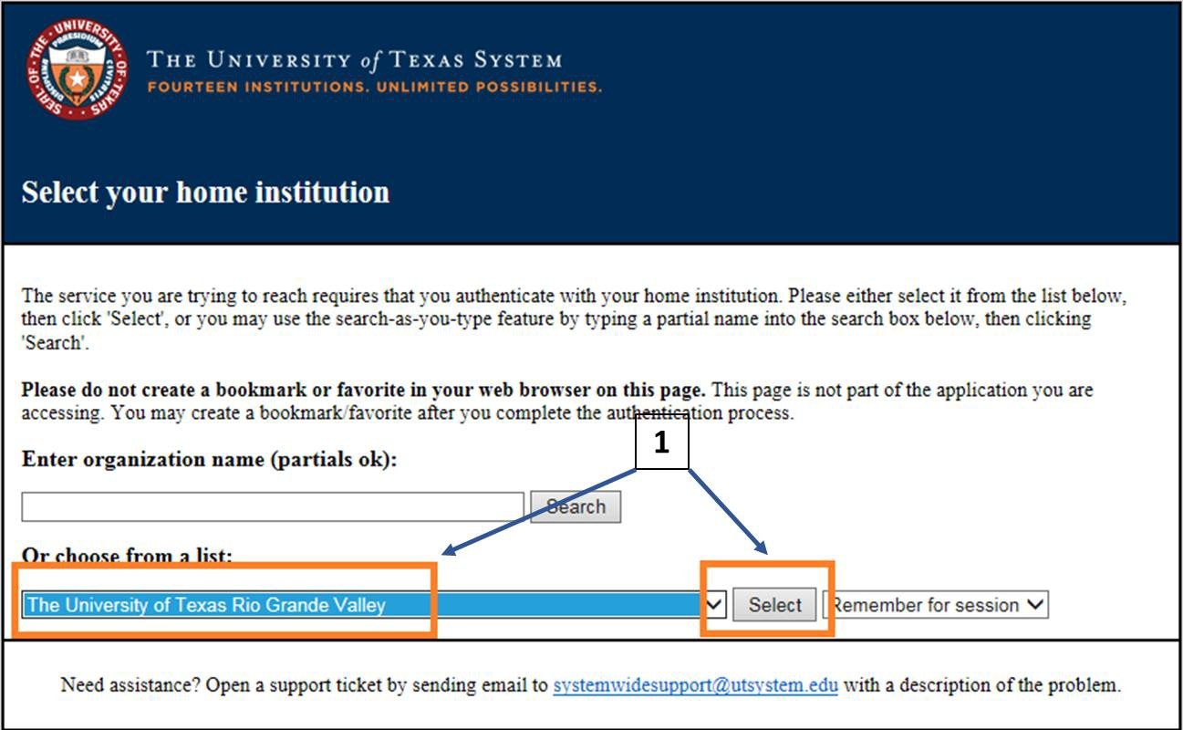

- Enter your UTRGV <Username> and <Password>.
  - Username: Same as your Network Username
  - Password: Same as your Network Password
- Click on the <Sign in> button.
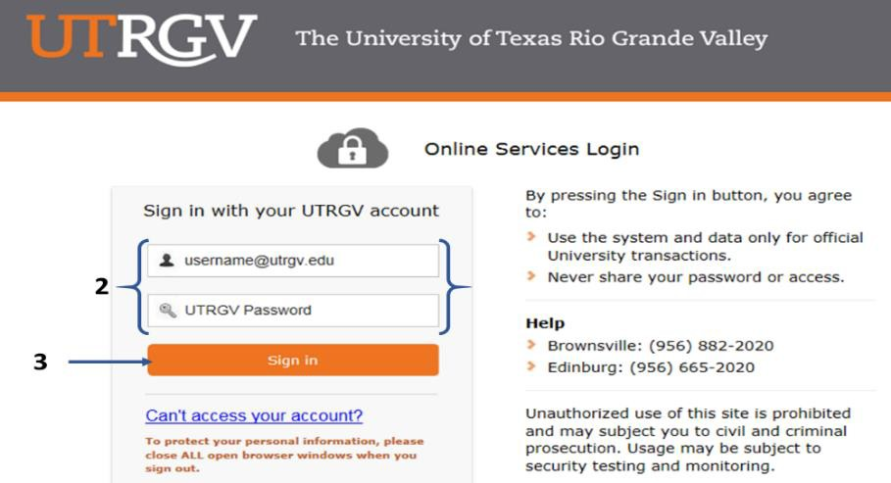
WELCOME TO THE ECRT SYSTEM

After the username and password are accepted, you will be taken to the “Welcome to the Effort Certification and Reporting Technology (ECRT) System” screen. This screen contains a statement about the certification process.

At the bottom of the message, click on the <Continue> button which will take you to the Home Page.
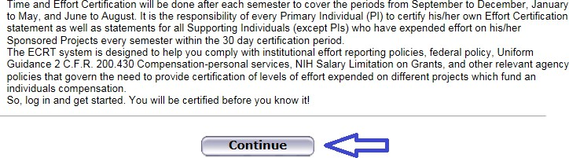

HOME PAGE

The Home Page displays after a user has successfully logged into ECRT. This screen functions as an entry point to all system functions, provides an overview of the Time and Effort Certification (Effort Reporting) process for administrators, and offers links to a variety of resources to assist users with the certification.
A list of effort statements appear under the “Statements Awaiting Certification” tab. The Status will show as “Not Open for Certification” during the semester data uploads and “Open for Certification” when they are ready for PI(s) to certify.
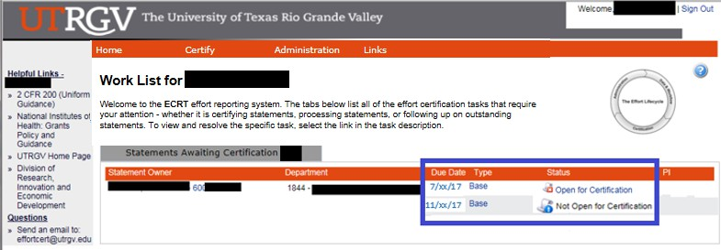

DROP DOWN MENUS
Across the top of the page is a navigation menu bar. The navigation menu bar is on every screen of the application, allowing users to move from one page to another quickly. The left most option <Home> returns users to the Work List from anywhere in the application. Hover over the <Certify> tab of the menu bar and select “My Statements” to view your effort statement. The <Manage> Look-up page allows users to search for Employees, Department(s), and Active/Inactive Projects. The <Manage> Department Dashboard page allows users to view information related to a department, sub-department, or division, including the Employees, Awards and Projects, and Department Information.
Links highlighted in the blue boxes are specific to the individuals with the Department Effort Coordinator (DEC) role. Helpful links are available on the left side of the home screen and from the <Links> drop down box. To log off of the system, simply click at the top right corner option <Sign Out>.
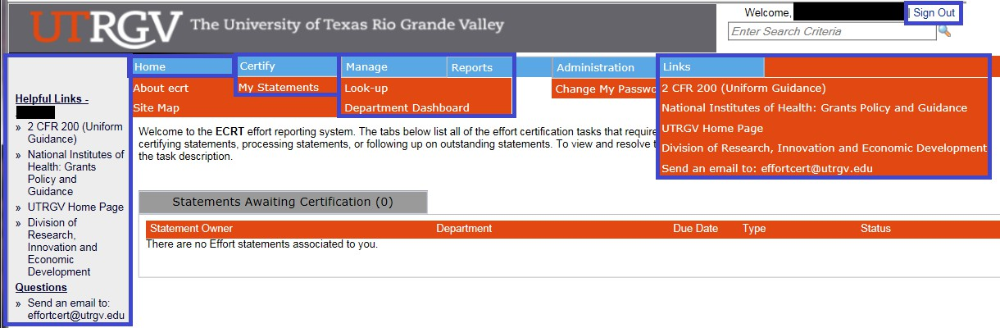
3
jlt: 3/2/2018
Office of Grants & Contracts
The University of Texas Rio Grande Valley

REVIEW CERTIFIED EFFORT PERCENTAGES

To review the effort statements for all of the Supporting Individuals (SIs) of your Primary Individuals (PIs), hover over the
<Certify> tab of the menu bar and select “My Statements”.
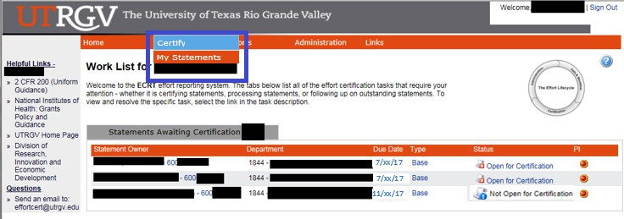

Your work list contains all of the effort statements. Select all of the effort statements at once by clicking the “Select everyone in the work list” icon from the “Work List box” or by holding “CTRL” and clicking each of the names in the list one by one.
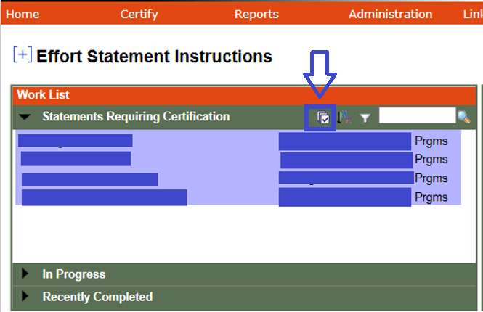

All of the uncertified effort statements for every user in the list will be populated below. This is the main view of the effort statements if everyone was selected in the work list. The effort statements will contain the Sponsored and Non-Sponsored projects, you may view payroll, cost sharing (if any), and computed effort associated with those projects for the semester.

From the <Process Base Effort Statement> page, the DECs review effort statements for PIs to certify by following the steps below:

- Review the projects, payroll/cost sharing, and the pre-populated percentages on the <Certified Effort>
column. The numbers must add up to 100 percent.
- Review <Notes and Attachments> if any.
- If there are any changes to the pre-populated Certified Effort, make sure you click on the <Save All> button to save all of the effort statements so the PI can certify within the 30 day certification period. Then, saving is complete. Press <OK> to continue.
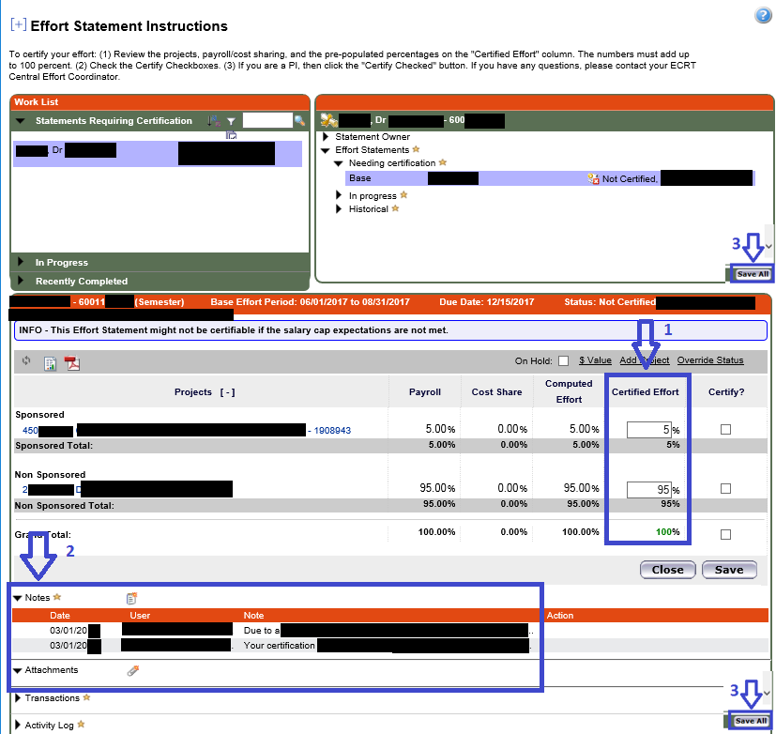

MANAGE

Look-Ups
Users can enter employee name, employee ID, department name, department number, account name, or account number to see results for your area(s) only.
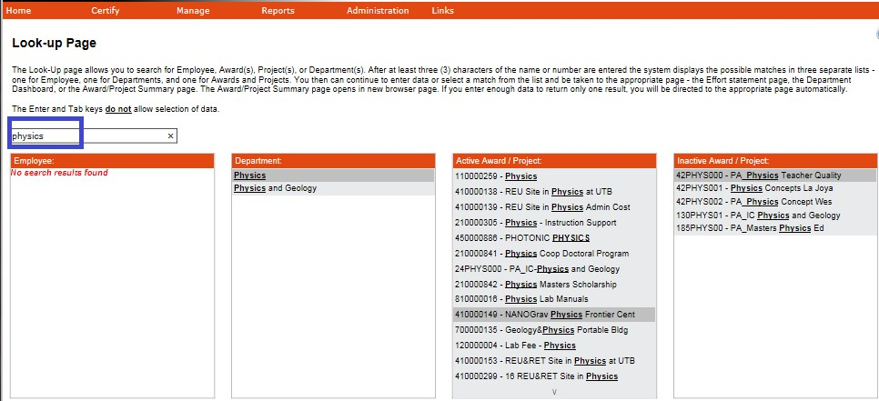

Department Dashboard
You have been given the role of “Department Effort Coordinator” in ECRT and can select any department(s) for your area(s) only from the Manage / Department Dashboard.
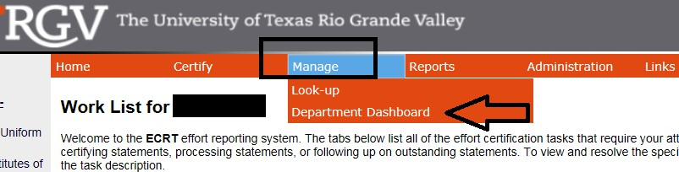

Like always, start by typing the name of the department and select from the database.
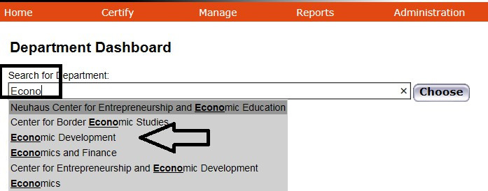

This Department Dashboard will give you a quick summary of any department(s) in your area(s) only:
From the People tab, select “Semester” as the Employee Type, for any particular Period, and then click on the (+) sign in front of the word Sponsored to expand the selection. Anything with (X) has not been certified.
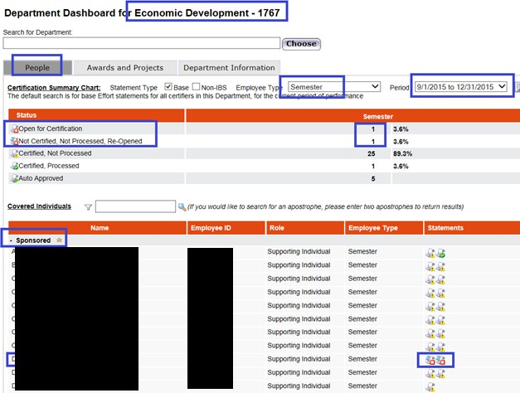

REPORTS

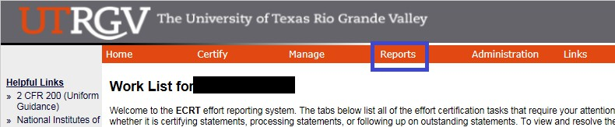

The Reports page contains three window panes across the top that show the report category, the list of reports associated to the selected category, and a description of the selected report.

Category - Management:
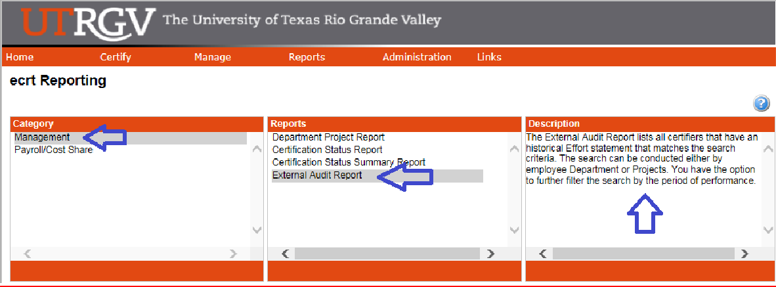

External Audit Report:
Description: The External Audit Report lists all certifiers that have an historical Effort statement that matches the search criteria. The search can be conducted either by employee Department or Projects. You have the option to further filter the search by the period of performance.

Parameters:
This report depends on the status, in this case I selected “Certified, Processed”. Incase an effort statement has been certified, but is not processed yet, then select “Certified, Not Processed”.
You can search by: Employee, Department, Account, or PI. (Make sure you select from their database, start typing and the list should come up for you to make your selection). Select “Yes” to Show Effort Notes and Show Transaction History. Select: Employee Type, Semester basis, and a particular Period. Then, click on “Run Report”.
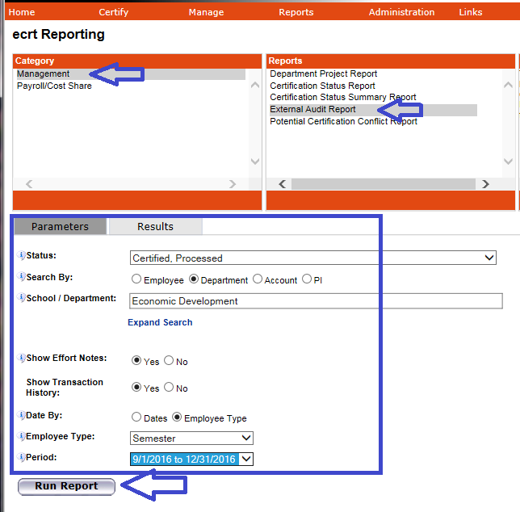

    - Results: Are shown below for the entire department selected and Period.
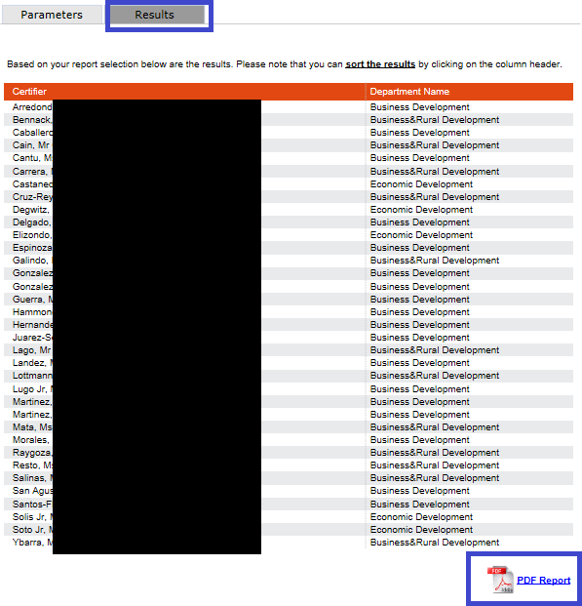
Then, click on the “PDF Report” icon to open the effort statements.
For Example: This is usually the report given for Internal/External requests on T&E. The top section contains the employee information, status of effort statement, certification period, and name of PI that certified statement and date.
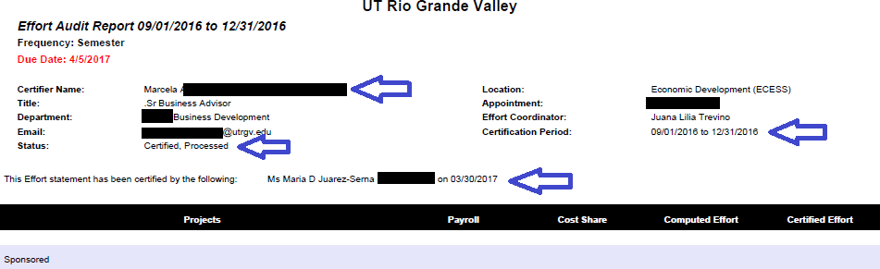
In case there are notes attached, if selected on parameters, they will show on this External Audit Report as well.
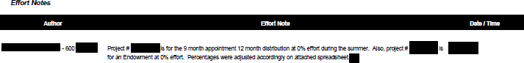

Category - Payroll/Cost Share:
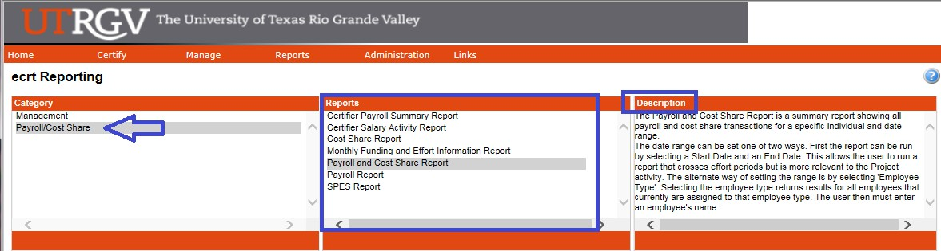
Several reports have all of the information. In case you don’t want to sort the data, just select a particular report depending on what you are looking for (Reports for certain PIs, Departments, Account/Project #).
- Certifier Salary Activity Report: Can be run for a certain PI.
Description: The Certifier Salary Activity Report contains a list of all individuals charging a certifier's Projects and their activities. You must enter a PI and a starting month. The report will show the certifiers associated to the PI along with 12 months of payroll activity starting with the month that you selected.

Parameters:
You must enter a PI and a starting month. The report will show the certifiers associated to the PI along with 12 months of payroll activity. Then, click on “Run Report”.
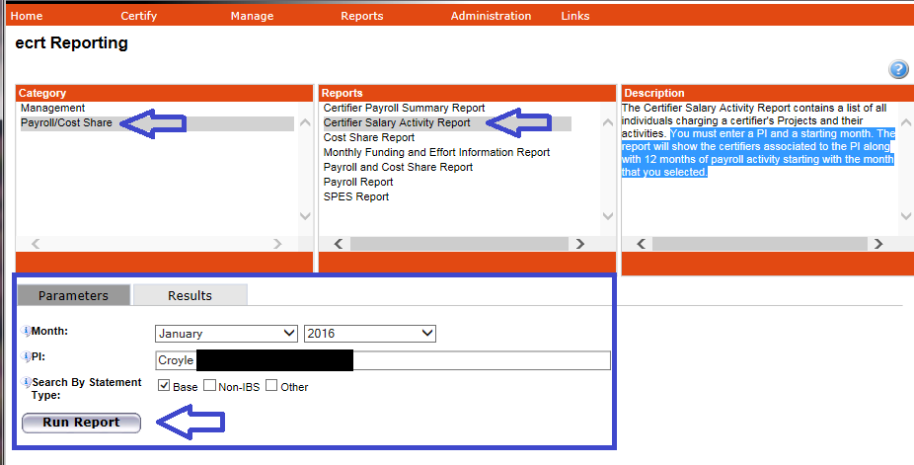

  - Results: List of individuals associated to the PI selected.
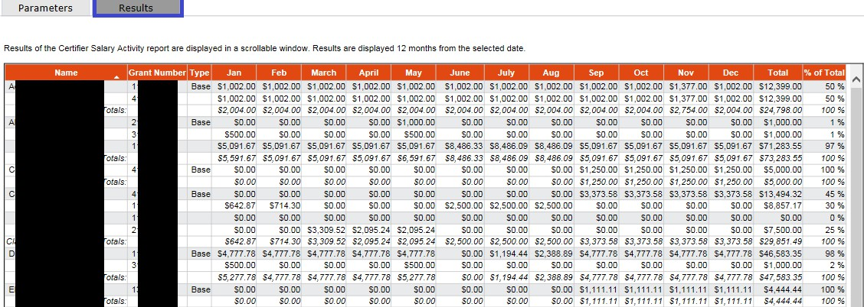

The data can always be exported to Excel, XML, PDF, and RTF (See bottom right of Results).
- Payroll Report: Can be run for a particular Employee or Department.

Description: The Payroll Report is a payroll summary report for a specific individual or Department and date range. The date range for this can be set one of two ways. First the report can be run by selecting a date range. This allows the user to run a report that crosses reporting periods but is more relevant to the Project activity. The alternate way of setting the range is by selecting 'Employee Type'. Selecting the employee type returns results for all employees that currently are assigned to that employee type. The user then must enter either an employee's name or the desired Department.
The Account View shows the breakdown by Project. The Pay Period View shows the breakdown by pay period.

Parameters:
This selection can be done for an Employee or Department, Employee Type: Semester, and per Period. Then, click on “Run Report”.
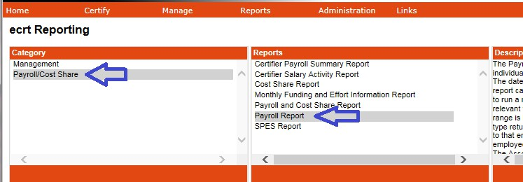

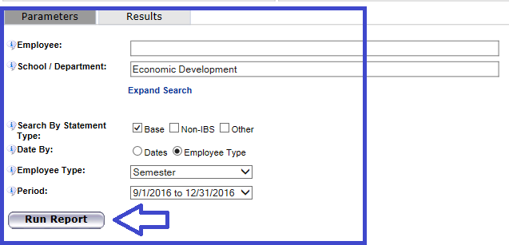

  - Results: Can be viewed by “Pay Period View” (sorted per month), or “Account View” (sorted by account/project).
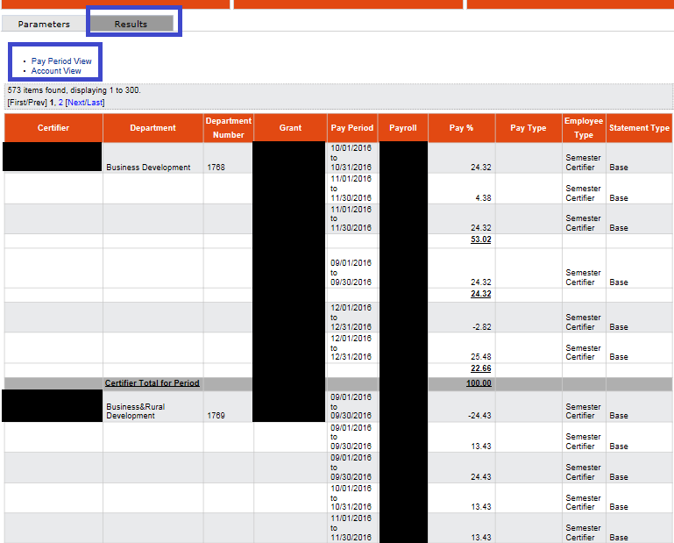

- Sponsored Project Employee Summary (SPES) Report: Can be run a report for a particular Active/Inactive
Account/Project #.

Description: The SPES (Sponsored Project Employee Summary) Report lists all employees that had salary charged to a specific Project. This report allows certifiers and Effort Coordinators to review the employees that were paid from the grant, verify the accuracy of the charges, and make changes if necessary. You must enter the Project name in the quick search field and select 'Active' or 'Inactive'. You also may enter a date range either by month or employee type, which will search by period of performance.

Parameters:
Select Employee Type. For Account/Project #: start by typing the first or last 3 digits and then select from the database. For Employee type, we are Semester basis and then select a particular Period. Finally, click on “Run Report”.
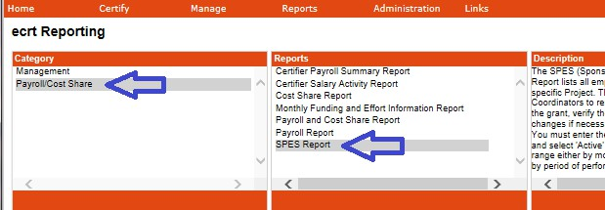
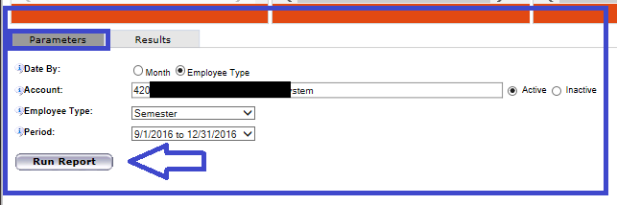

Results:
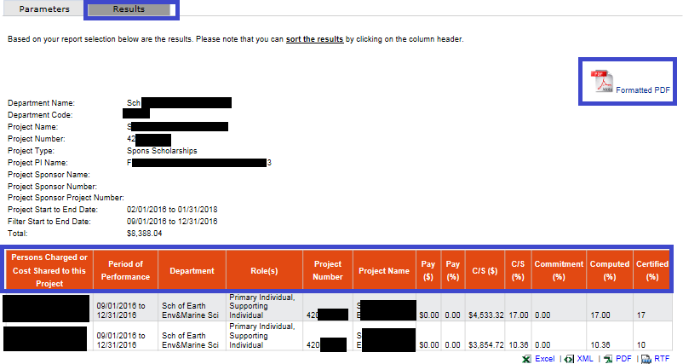

This is a full report that will also give you the Cost Share $ and % (if any) as well as the Computed and Certified Effort
%’s. This can be printed on a Formatted PDF and the data can always be exported to Excel, XML, PDF, and RTF (See bottom right of Results).
T&E BLACKBOARD TRAINING
    - Time and Effort Certification Training in Blackboard will occur at least once every two years or more frequently if determined by the requirements of sponsoring agencies. You have to pass 80% (8 out of 10) of the questions in order to meet training requirements. To access this training, go to:
      - myUTRGV
      - Blackboard
      - Click on “UTRGV Employee Education”
      - Then “Time and Effort Certification”

    - Completion of this training will be required for:

New PIs receiving an award before an account is setup
      - All Supporting Individuals (SIs): Expend effort and cost sharing on sponsored projects
      - Primary Individuals (PIs): Certify their own effort and the effort of their SIs
      - Department Effort Coordinators (DECs): Involved with the effort certification process

Global View Only (GVO): Office of Research Compliance (ORC), Office of Sponsored Programs (OSP), Grants & Contracts (G&C), and Internal Auditing.

REMINDERS

    - It is the responsibility of every Primary Individual (PI) in ECRT to certify his/her own effort statement as well as statements for all Supporting Individuals (except PI’s) who have expended effort on his/her sponsored projects every semester.

    - Three certification cycles per year:
      - Fall (September-December)
      - Spring (January-May)
      - Summer (June-August)

    - UTRGV has a 30 day Certification Period. Failure to certify during the certification period will result in placing your grant account(s) on hold until the certification is complete.

    - If effort statements are pending certification, email reminders will go out:
      - 14 days before the deadline
      - 7 days before the deadline
      - On the due date

RELEVANT INFORMATION

    - Uniform Guidance 2 CFR 200.430, Compensation-personal services.

    - The University of Texas Rio Grande Valley (UTRGV) Policy ADM 07-103, Managing and Certifying Effort on Sponsored Projects.
QUESTIONS/ASSISTANCE

    - If you have any questions regarding Time and Effort Certification or the Effort Certification and Reporting Technology (ECRT) system, please send an email to effortcert@utrgv.edu or contact your ECRT Central Effort Coordinator at (956) 882-7024.

    - Visit the Time and Effort Certification (T&E) website at:
https://www.utrgv.edu/research/departments/research-administration/grants-and-contracts/time-effort/index.htm
for “Services” and “Resources”.

