UTRGV IRB TRAINING REQUIREMENTS:
CITI training is required for all studies.
For Expedited and Full Review studies, all research team members must complete or have a current training course for Human Subjects Protection and Responsible Conduct of Research. Both of these courses are good for 4 years.
If you are conducting clinical research or a clinical trial, you must complete a Good Clinical Practice training course in addition to the above-mentioned courses.

Human Subjects Protection, Basic Course
- Social Behavioral Research Investigators and Key Personnel
- Biomedical Research Investigators and Key Personnel
Responsible Conduct of Research Course
-Social and Behavioral Responsible Conduct of Research
- Biomedical Responsible Conduct of Research
- Physical Science Responsible Conduct of Research
- Humanities Responsible Conduct of Research
Good Clinical Practice Training
-Social and Behavioral Research Best Practices for Clinical Research
- Clinical Investigations of Devices
- Clinical Trials with Investigational Drugs and Biologics
- Clinical Trials with Investigational Drugs and Medical Devices (U.S. FDA Focus)

Detailed instructions (with screenshots) are located on the following pages
- Section 1: How to register and access the basic course
- Section 2: How to add an additional course
- Section 3: How to access completed course certificates and/or reports
- Section 4: How to affiliate with a new institution (UTRGV)

Section 1:
How to Register and Access the CITI Basic Course

Instructions for Completing the UTRGV IRB Human Subjects Protection Training: Online CITI Course

- Go to the CITI website at www.citiprogram.org
- Click on “Register”

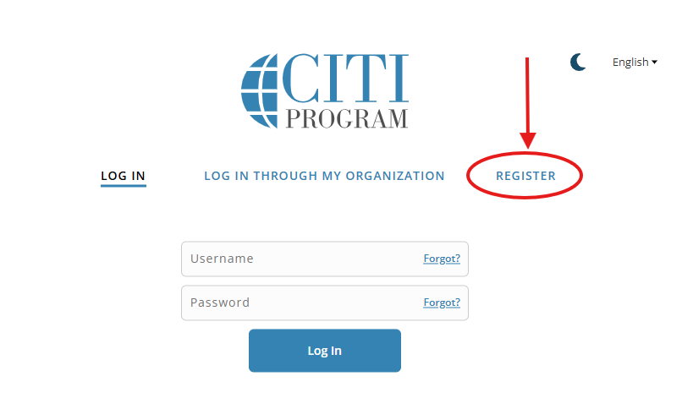
- Complete the four registration steps.
- In the first step, type “Rio Grande Valley” and select University of Texas – Rio Grande Valley” from the drop-down box.
- After all sections have been completed, click “Continue Registration”.
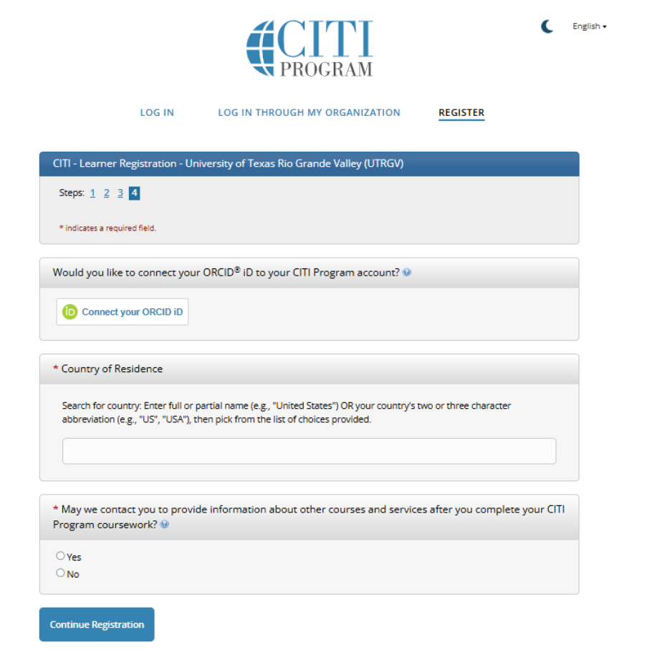
NOTE: You are NOT required to register/pay for CME/CEU credits for UTRGV IRB approval. This is optional.
- Indicate whether you are continuing education. If you select no, select “submit”. If you select yes, the following information will need to be filled out:
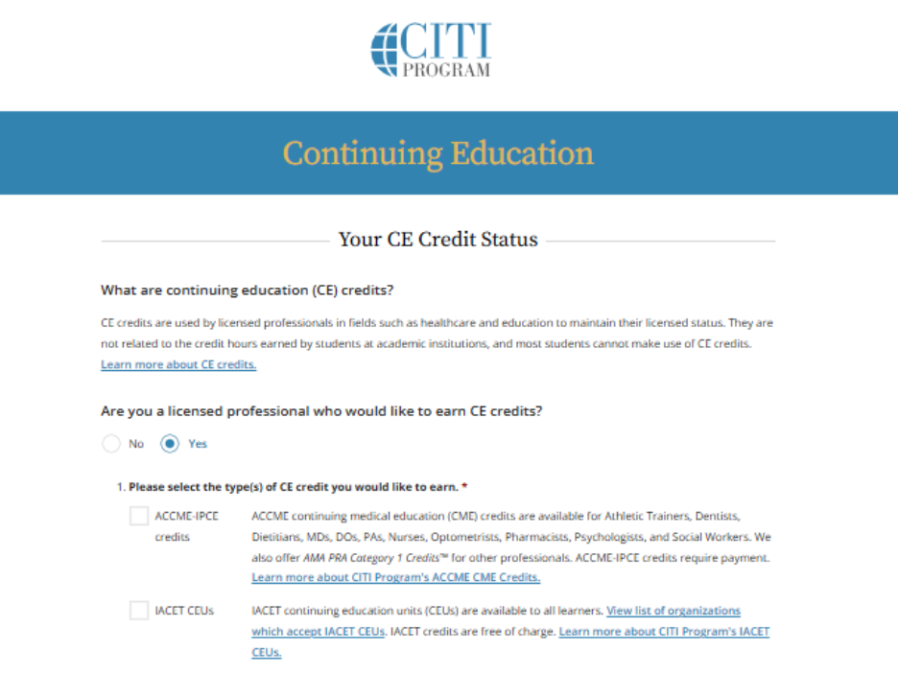

- Complete the section titled “affiliate with an institution” and submit to have your account created:
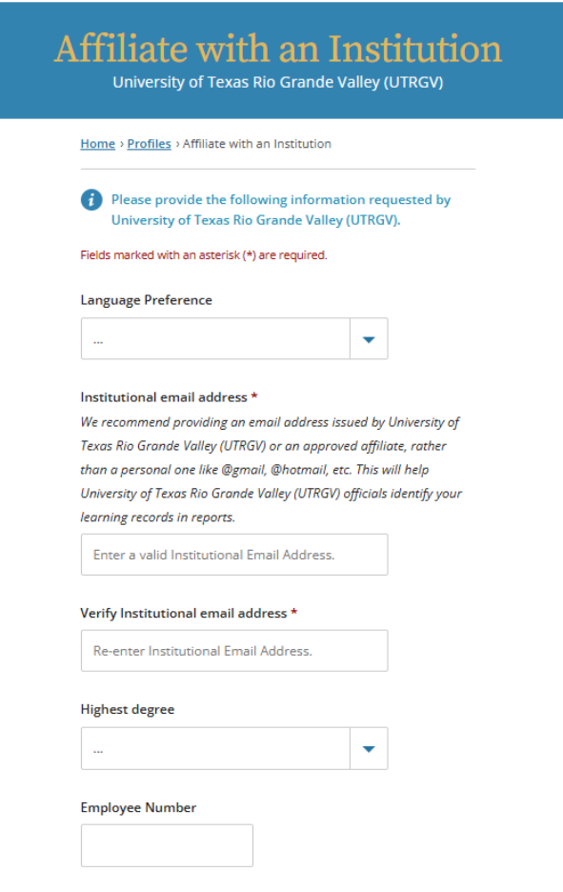

- You will now see the CITI homepage. Please make sure to verify your email address to ensure the completion of CITI website registration.
- Select “View courses” under institutional courses and scroll down to Learner Tools for University of Texas Rio Grande Valley (UTRGV). Indicate “Add a Course”.
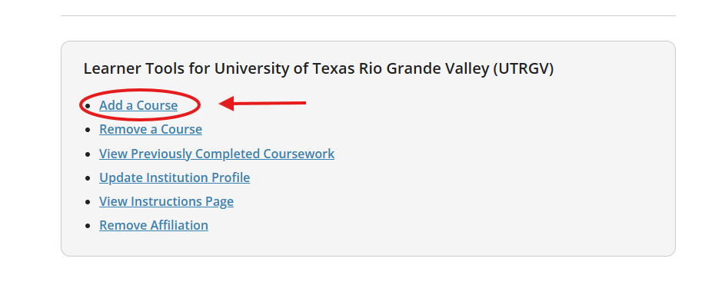
- Indicate which courses you wish to complete and select “Next”:
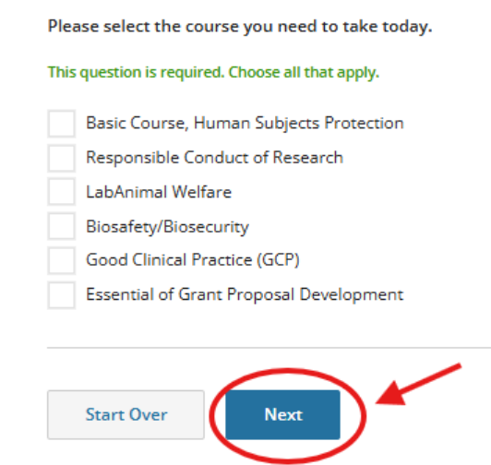
- Select Curriculum:
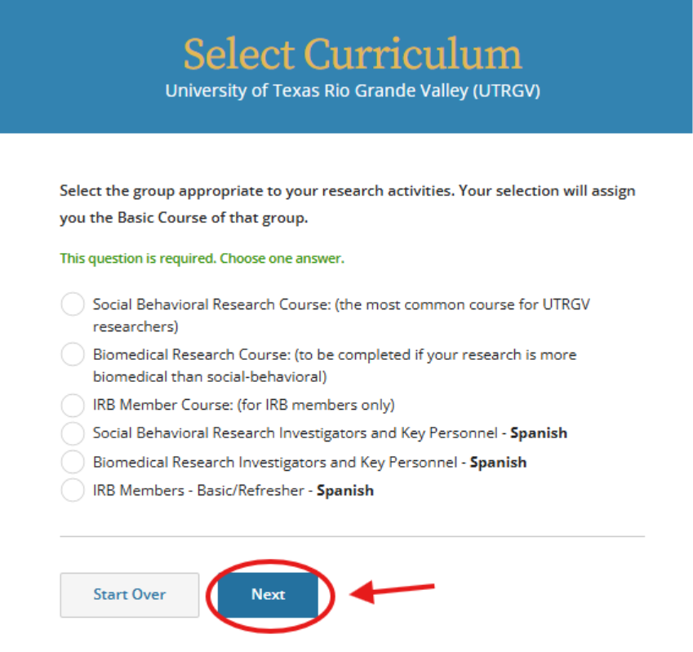
- You will now be able to view your courses on CITI under “Courses Ready to Begin” under “Required Models”. To start the training course, click on each module.

- The required modules must be completed in the order listed. Each time you complete a module, you may move on to the next module (most modules will have short quizzes at the end). For example:
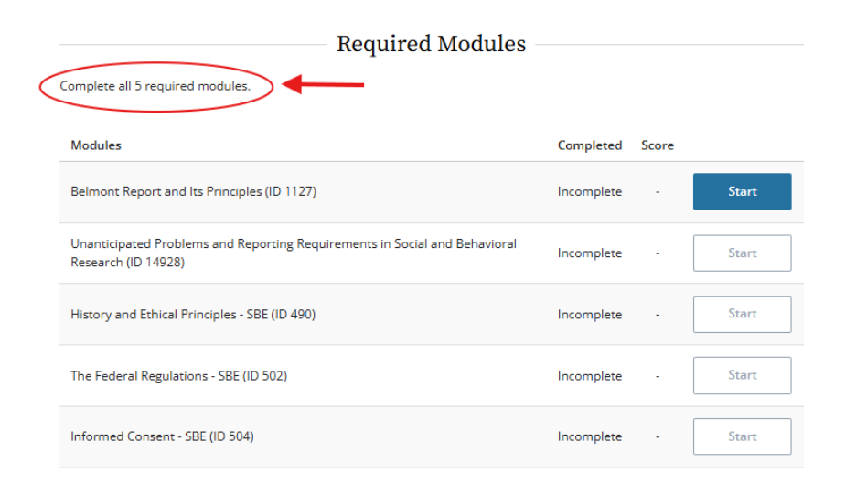
- You will need at least an 80% average on quizzes to print the Basic Course completion certificate. If you score poorly on any quizzes, you may retake them.
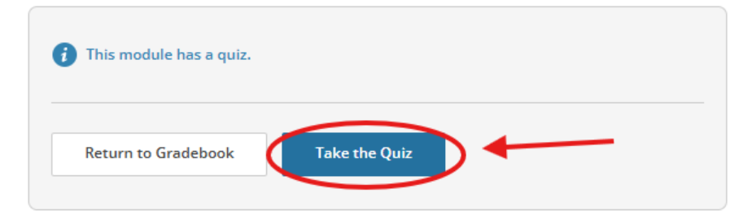
- You do not have to complete your modules all in one sitting. You can log off and on again. When you log onto CITI again, select view courses, and you will be able to view active, completed, and courses ready to begin:
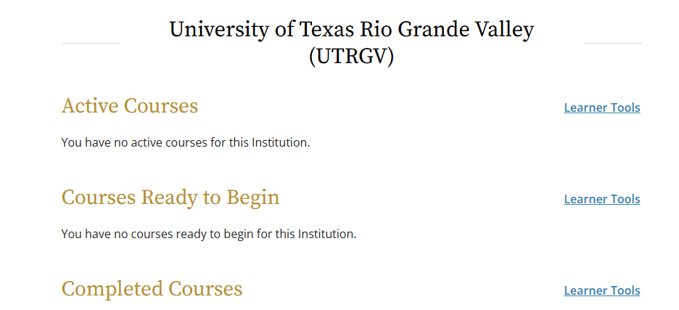

Section 2:
How to Add an Additional Course

- Click on Add a Course at the bottom of the menu, under My Learner tools for UTRGV:
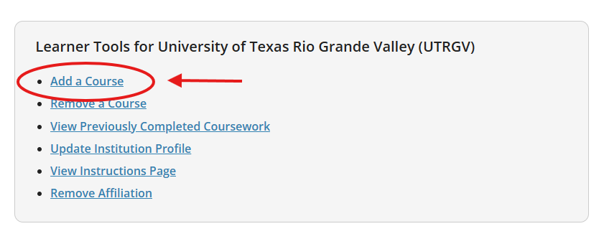
- Indicate the course you would like to take.
- For example, select Responsible Conduct of Research and select “Next”
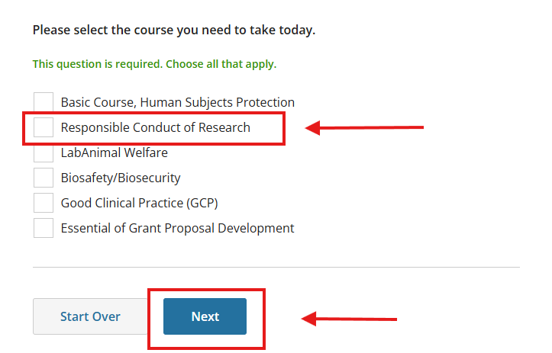
- Indicate the group and language you’d like to take the course in.
- Then, the course will be added to the main menu under the “courses ready to begin.”
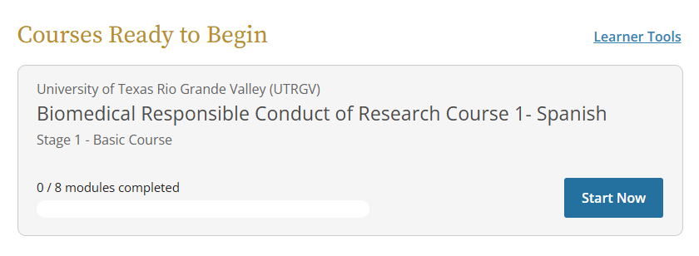Note: This screenshot shows the Spanish Biomedical Responsible Conduct of Research Course 1, but you may choose whichever group and language best fits your research.

Section 3:
How to Access CITI Certifications and/or Reports for Previously Completed Courses

- From the “Main Menu”,
- If you need to access previous completion reports (e.g., Basic Course completion certificate or a refresher course completion certificate), you can click on “My Records” at the top of the Main Menu. You also have the option to scroll to the bottom of the page and click on “View Previous Completed Coursework”:

OR

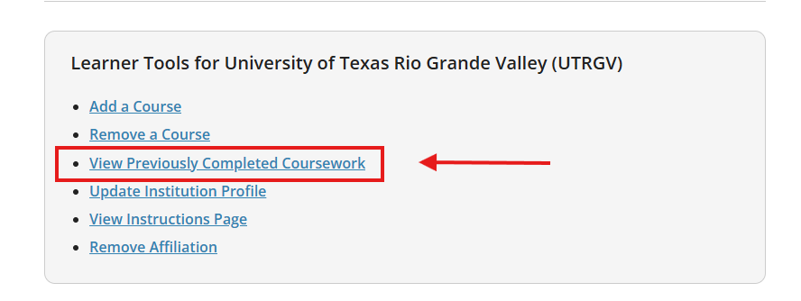

- Select View-Print-Share, under Completion Record:
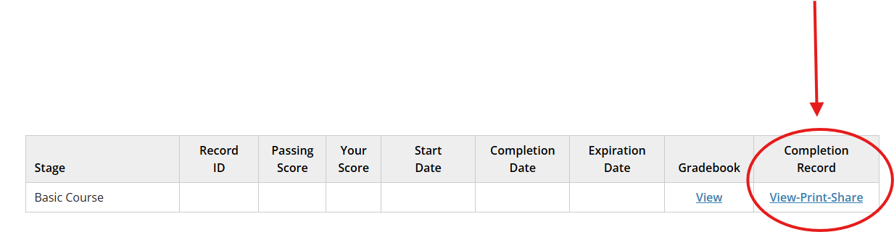
- You may use the first link to obtain your Completion report with scores and dates listed.
- You may use the second link to obtain a certification which is a summarized proof of completion.
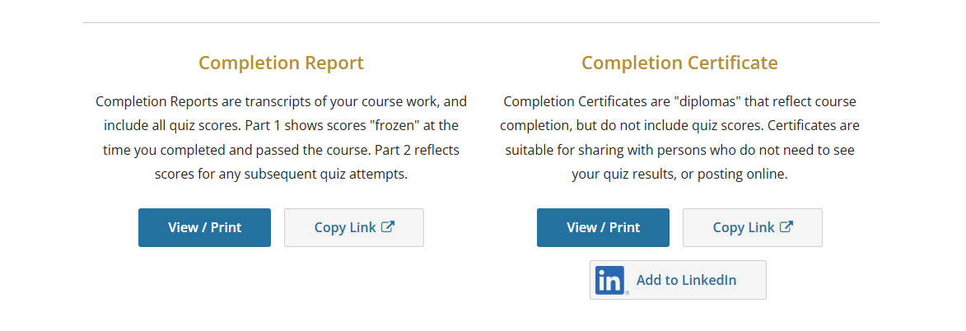

Section 4:
How to Affiliate with a New Institution (UTRGV)

You may have a CITI account already. If you are registered under another institution and are now with UTRGV, you may change your account by affiliating with another institution.
Please do not create a new account.
To set up your affiliation with The University of Texas Rio Grande Valley, please follow these steps:
- Log in
- Next to the “Welcome, [Your Name]” in the main menu, select “Add institutional affiliation”
- Search “University of Texas Rio Grande Valley (UTRGV)” and our institution should pop up directly below the search box. Click on continue.
- Enter all required information for your profile.

To Add the Human Subjects Protection, Basic Course
- Select "Basic Course, Human Subjects Protection"
- Select "Group 1: Social Behavioral Research Course" or “Group 2: Biomedical Research Course”

To Add the Responsible Conduct of Research Course
- Select “Responsible Conduct of Research”
- Select “Biomedical Responsible Conduct of Research Course” or “Social and Behavioral Responsible Conduct of Research Course”

The CITI course will be added to your main menu.

