Please use the following steps to request access:
- Log in to https://my.utrgv.edu/home
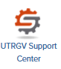
- Under the Application module, select UTRGV Support Center, as shown below.

- Click on Information Technology, as shown below.
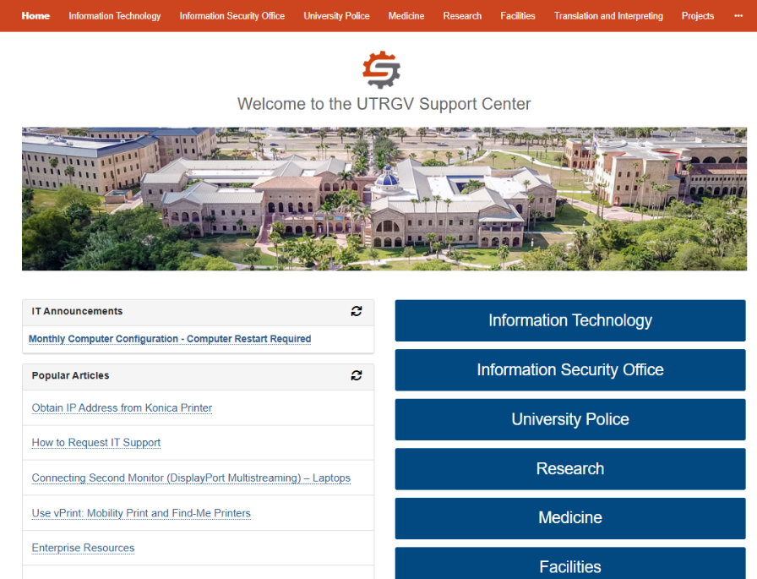

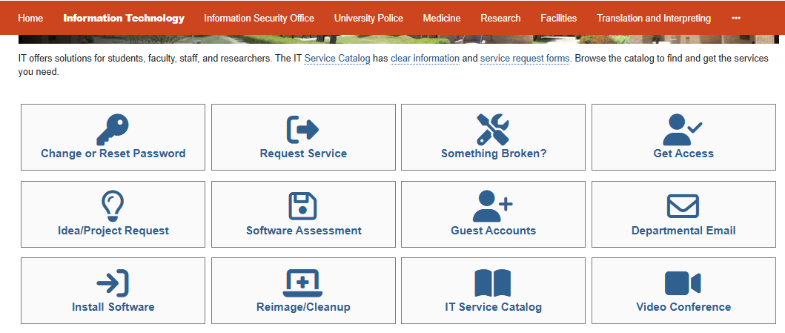
- Then click on Get Access

- Next, fill out the form with the following information:
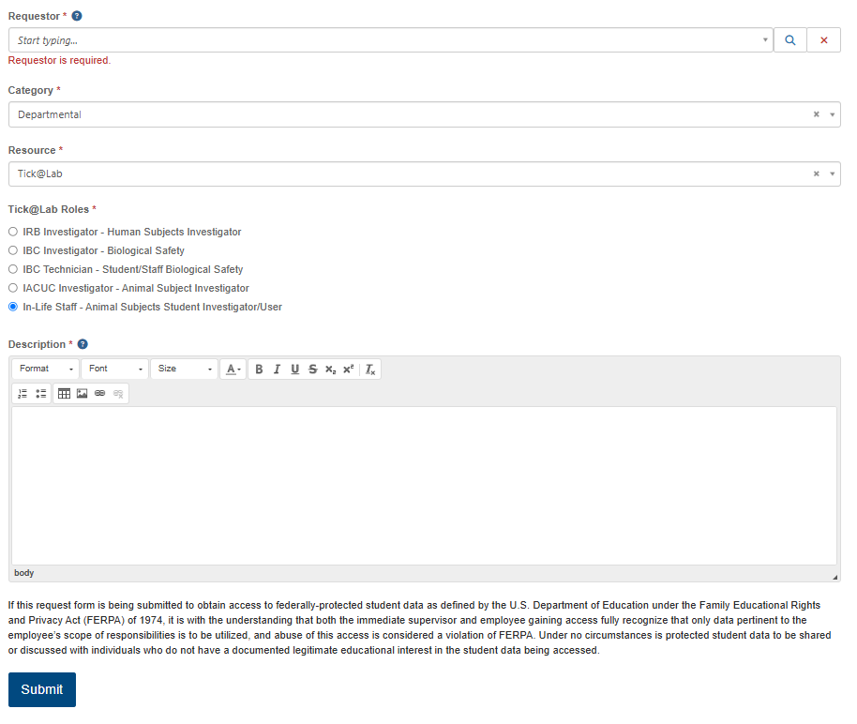
- Please indicate who the requestor for access is.
- For Category: Departmental
- For Resource: Tick@Lab
- For Application Role: Indicate what type of access you need.
- For Description: If you are a student, please indicate who your faculty advisor is for the research project you will be conducting.
- Click ‘Submit’ for acceptance of the privacy policy

