Laboratory Animal Resources (LAR) has orientations every Monday starting June 1, 2026, between 1:30 pm and 4 pm.
To register for an orientation, please see below.
- Click on the UTRGV Training Services Portal link, The hyperlink will search for Laboratory ANimal Resources (LAR) Orientation or scan the QR code. 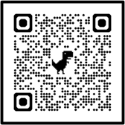

- Sign in with your UTRGV credentials.

- You can search for the Laboratory Animal Resources (LAR) Orientation in the search bar or look for the session by date.
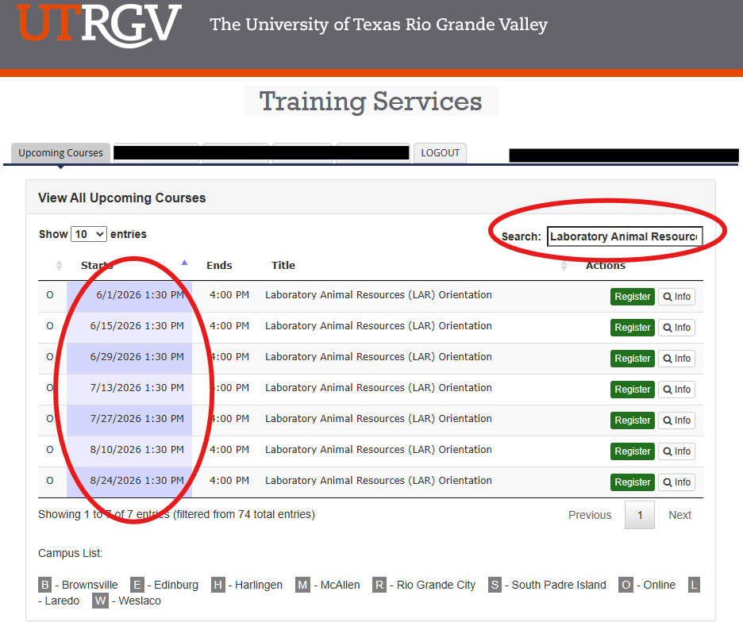

- Click on “Register” for your selected date. After clicking on Register, you will shortly receive an email.

- Once you receive the email, please “Add” the session to your calendar.
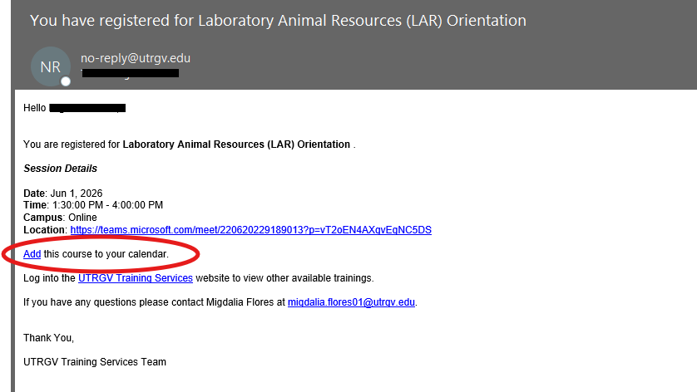

- After adding the course, the session invitation will be downloaded to your default web browser. Click on “keep” and click on the “newAppointment” download.
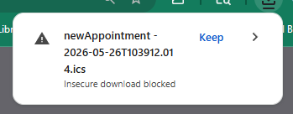

- After clicking on the calendar download, the session should now appear in your UTRGV Outlook calendar.

If there are any questions, please contact animalresources@utrgv.edu or call 956-665-2067.

