iShop UTRGV allows users to Change Account Number for PO’s that have not been paid. Users can check on payments by looking at the “Invoice tab” on the PO record in iShop. Please review the invoice tab and make changes only if no invoice is included. If invoices are included, the PO change should not be submitted because the system will place the PO in error. Questions can be emailed to: esmeralda.rios@utrgv.edu or to iShop@utrgv.edu.

- Set the Document Search to show “ALL”. Enter the PO# in the Quick Search Bar and select the PO number. See sample below.
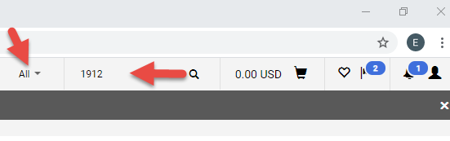
- Please review the invoice tab and make changes only if no invoice is included. If invoices are included, the PO change should not be submitted because the system will place the PO in error.
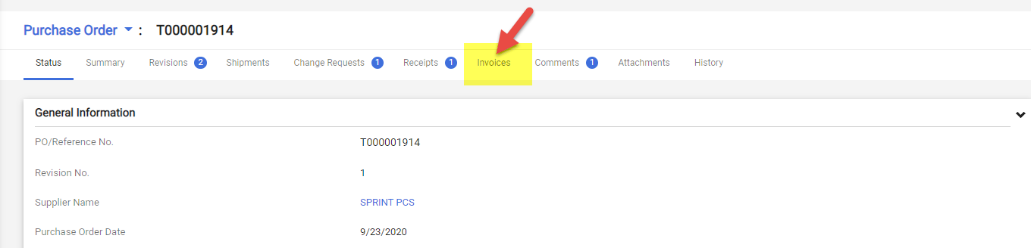
- Click on Purchase Order and Select Create Change Request.
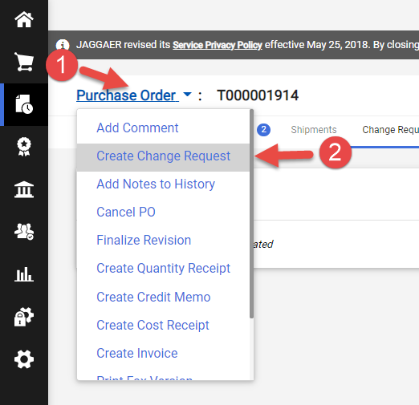

- Select the employee that you would like to notify about this change. Enter description for the change. See sample below. Click on Create Change Request.
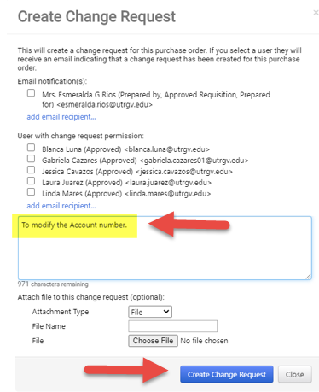
- Click on the pencil image.
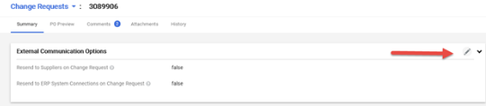
- The Resend to ERP System should indicate “True” at all times. Select PO export. Scroll down to the line detail to enter the change.
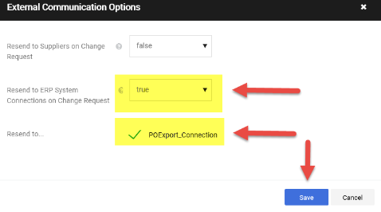

- Scroll down until you get to the Accounting Codes section. Click on the pencil image.
Note: Orders made using our showcased suppliers cannot be changed. Click on the Account field.
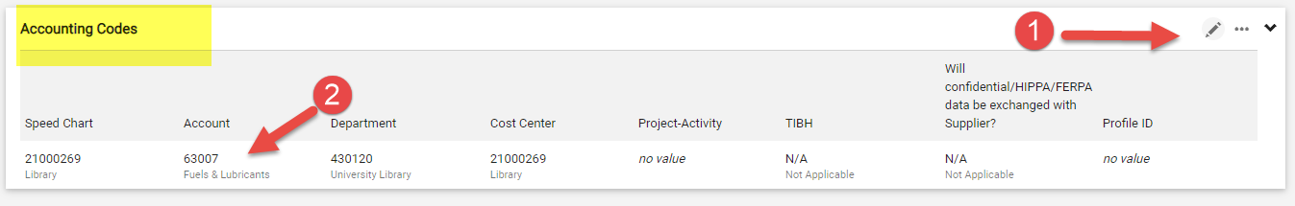
- Enter a description of the item to be searched and Click on “Filter” to reduce the number of items listed. Click on the plus sign to select the item. See sample below.
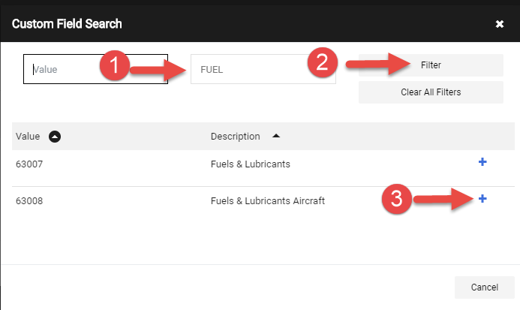
- Save the changes and Scroll up to the top of the page.
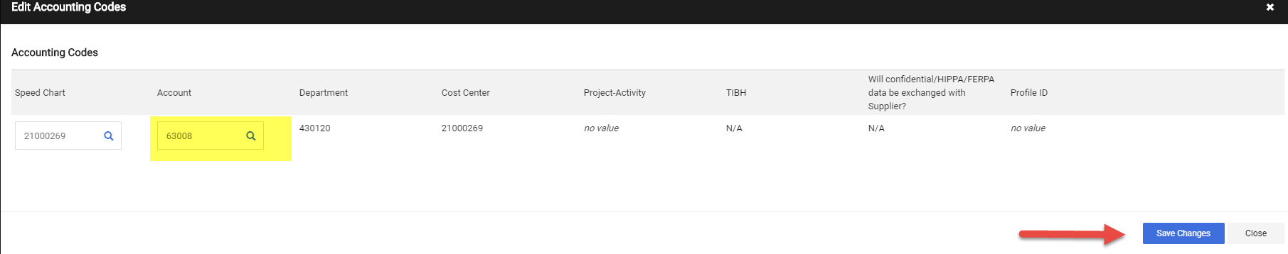
- Scroll up to the top of the page. Click Submit Request.
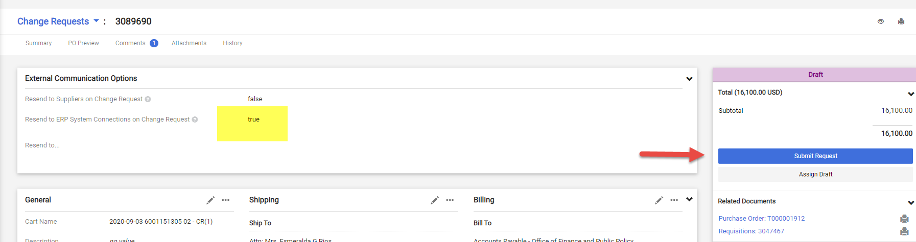

- Change request submitted notification will be displayed. Note this shows the Change Request number. Click on Approval Status to see who needs to approve. You can send an e-mail to the approver to expedite the approval process.
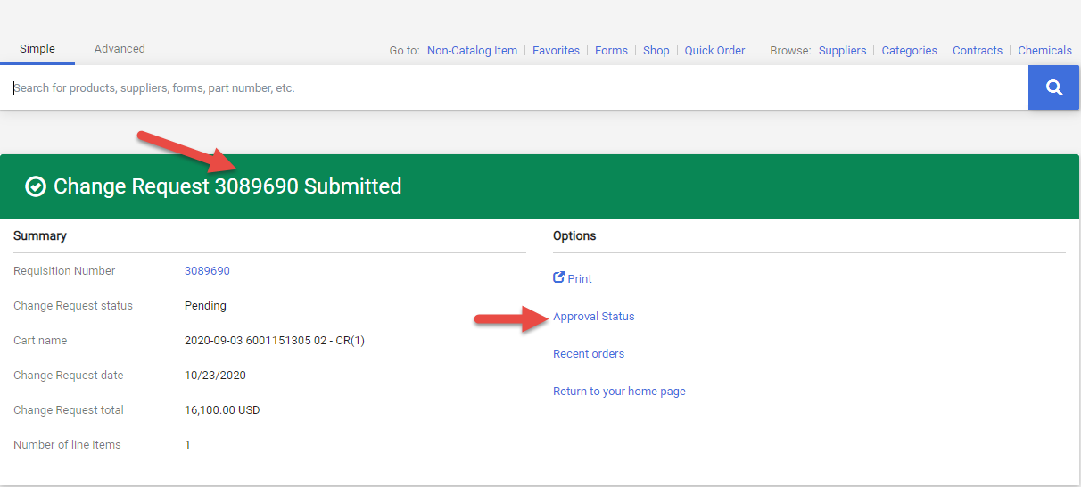
- This is the workflow. The Cost Center/Project manager’s approval is required for this type of change orders. Click on “View approvers” to see who needs to approve. If the PO is higher than $15K, it will route to Procurement for buyer’s approval. The system will update the PO with the requested changes when the workflow approval is completed.
