iShop UTRGV allows users to cancel lines that have never been paid on PO’s.

Common reasons for cancelling PO lines include incorrect items not received or needed. Once a PO line is cancelled, it cannot be re-instated. Please review the invoice tab and make changes only if **no** invoice is included. If invoices are included, the PO change should not be submitted because the system will place the PO in error. Questions can be emailed to: [ishop@utrgv.edu](mailto:ishop@utrgv.edu)

1. Set the Document Search to show “ALL”. Enter the PO# in the Quick Search Bar and select the PO number. See sample below.

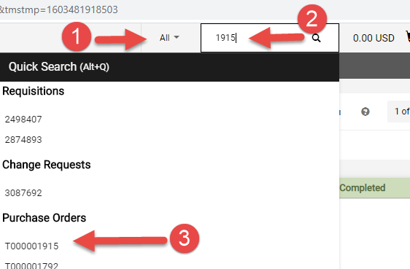

1. Please review the invoice tab and make changes only if **no** invoice is included. If invoices are included, the PO change should not be submitted because the system will place the PO in error.

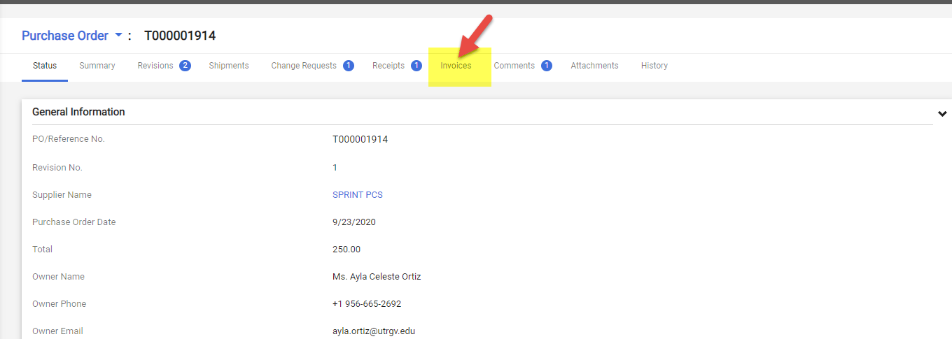

1. Click on Purchase Order and Select Create Change Request.

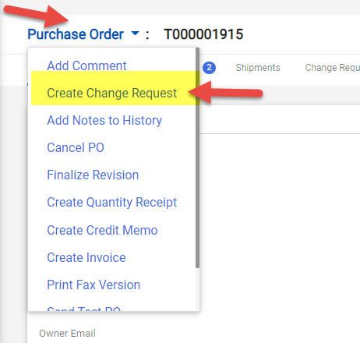

1. Select the employee that you would like to notify about this change. Enter the description for the change. See sample below. Click on Create Change Request.

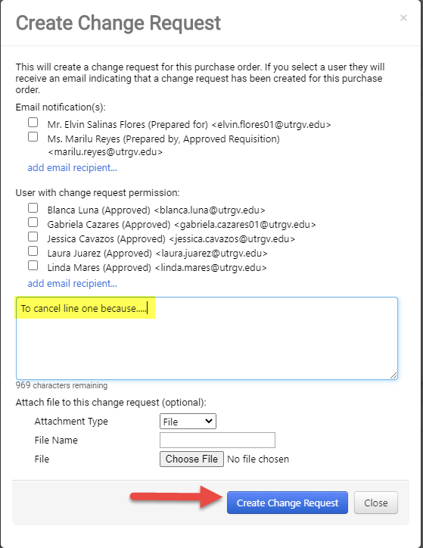

1. Click on the pencil image.

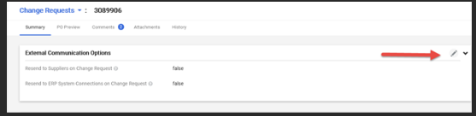

1. The Resend to ERP System should indicate “True” at all times.  Select PO export.   Scroll down to the line detail to enter the change.

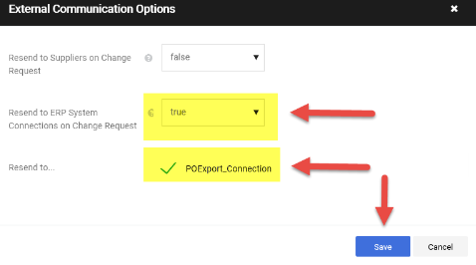

1. Scroll down to the lines section. Select the line you want to cancel. Click on the arrow above and select on Cancel Selected Items. See sample below.

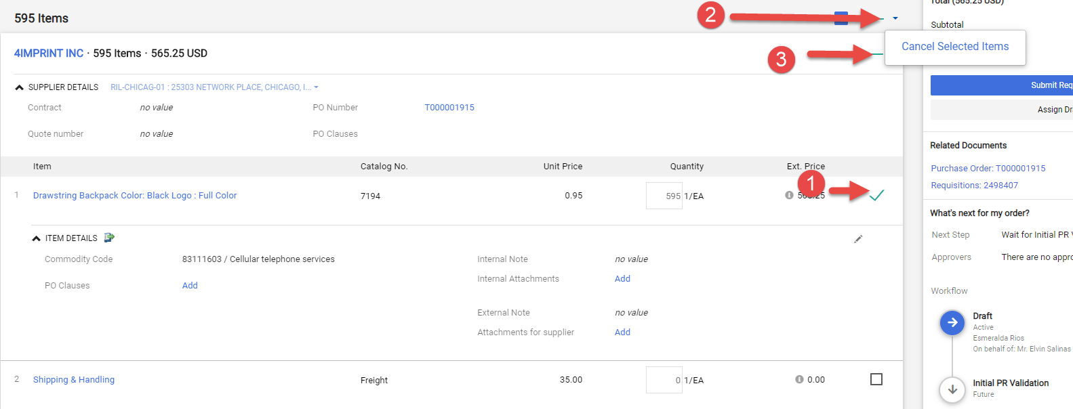

1. Enter the note or reason to cancel the line. Click OK.

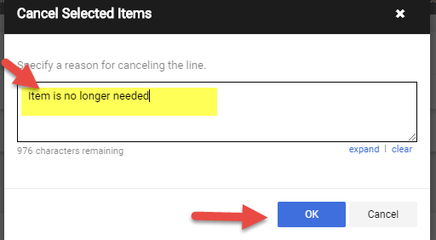

1. The icon is displayed on canceled lines.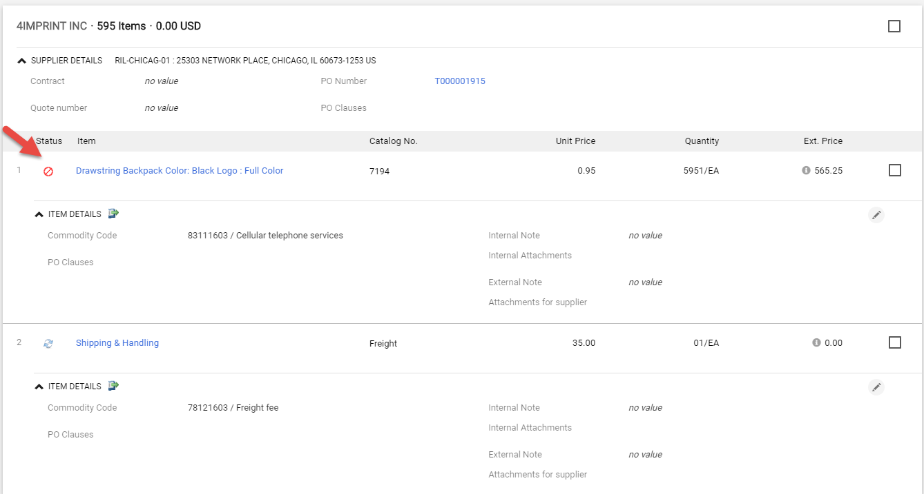
2. Scroll up to the top of the page and Click Submit Request. The Draft section will reflect the new subtotal.

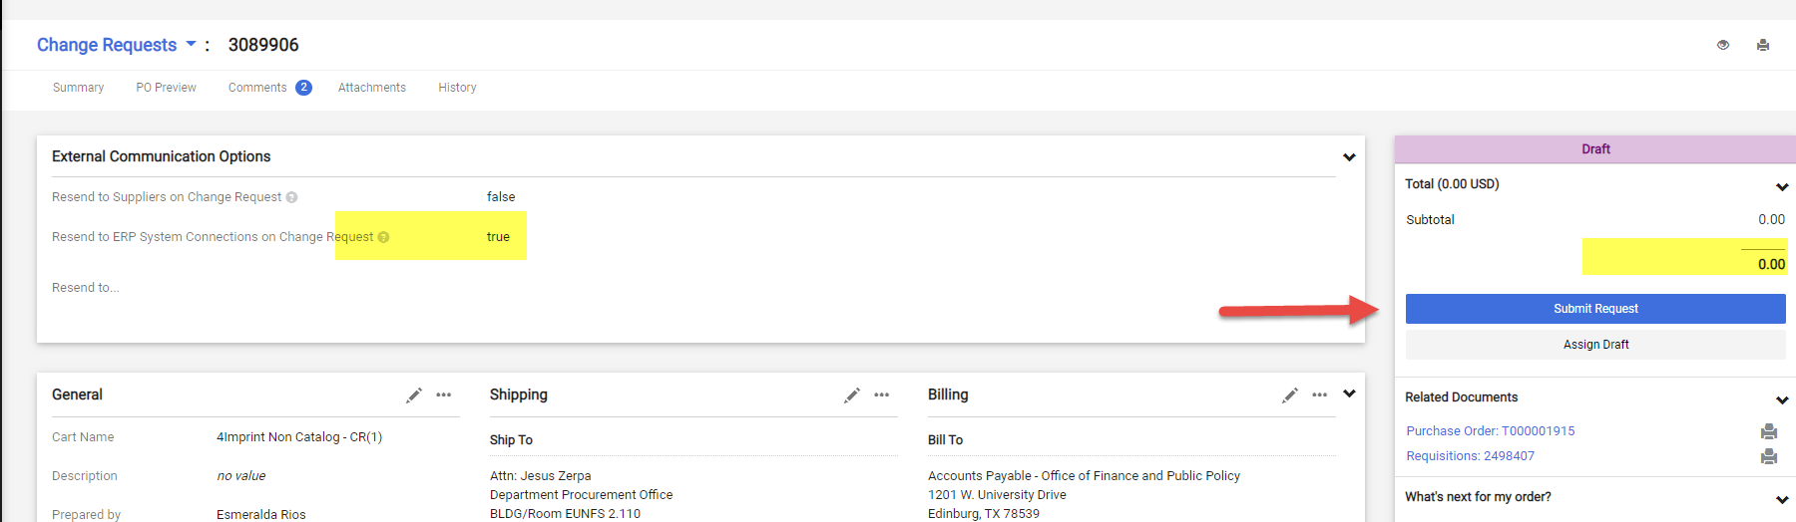

1. Change request submitted notification will be displayed. Note this shows the Change Request number. Click on Approval Status to see who needs to approve. You can send an e-mail to the approver to expedite the approval process.

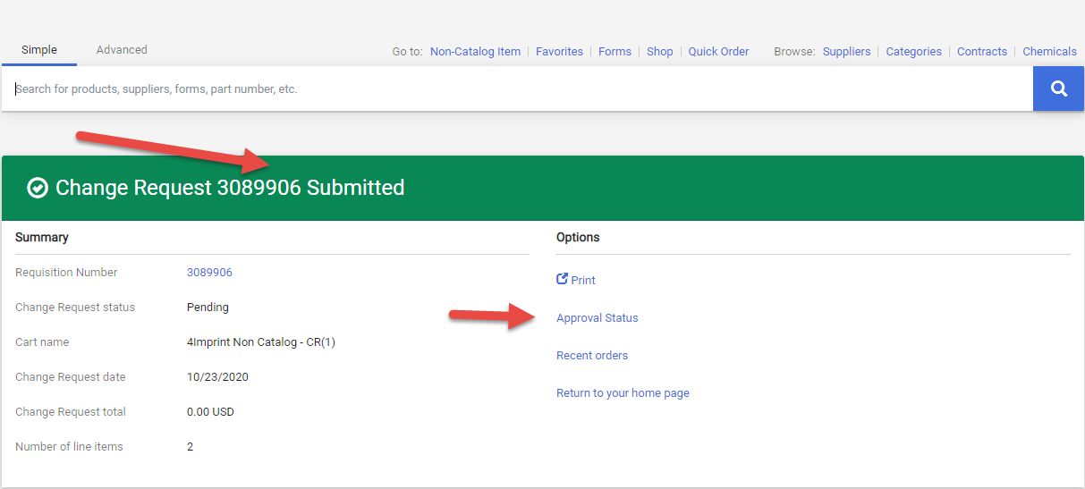

1. This is the workflow. The Cost Center/Project manager’s approval is required for this type of change orders. Click on “View approvers” to see who needs to approve. If the PO is higher than $15K, it will route to Procurement for buyer’s approval. The system will update the PO with the requested changes when the workflow approval is completed.

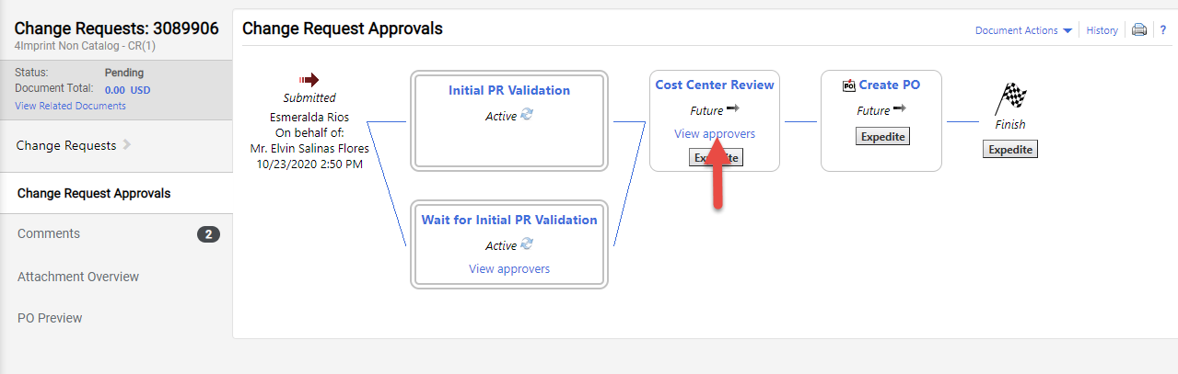

For questions, please send an e-mail to Esmeralda Rios at [esmeralda.rios@utrgv.edu](mailto:esmeralda.rios@utrgv.edu) or to [iShop@utrgv.edu](mailto:iShop@utrgv.edu).