The purpose of this document is to guide UTRGV users to on how to complete and submit a travel expense report within iTravel+.
*Effective April 18, 2022, all travel expenses submitted for reimbursement after 60 days from the transaction date will be subject to applicable federal and state tax withholdings, and IRS reporting requirements.
- Log into my.utrgv.edu using your UTRGV credentials.
- Select the iTravel+ application icon.
- If submitting for a UTRGV EMPLOYEE OR GUEST who is receiving a reimbursement, Search for the name to start the session. *Guests will be displayed in all caps.
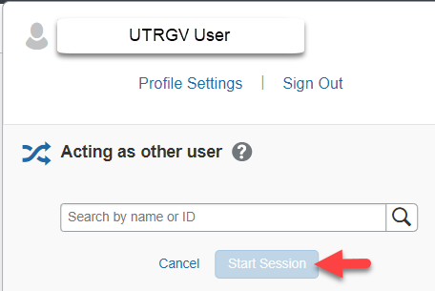
To be set up as a delegate, use the reference guide located on the Accounts Payable.

B. If submitting for GUEST that is NOT receiving a reimbursement, continue within your profile.

- From the Request tab, select the approved request expense request that will be reimbursed.

- Confirm travel details and request ID then select Create Expense Report. 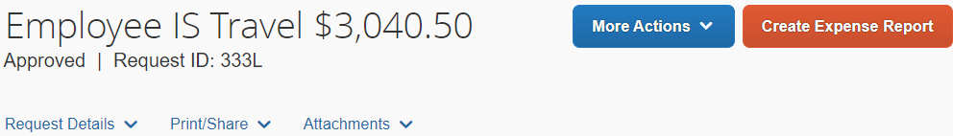

- View the Alerts Messages to review the Report Header.
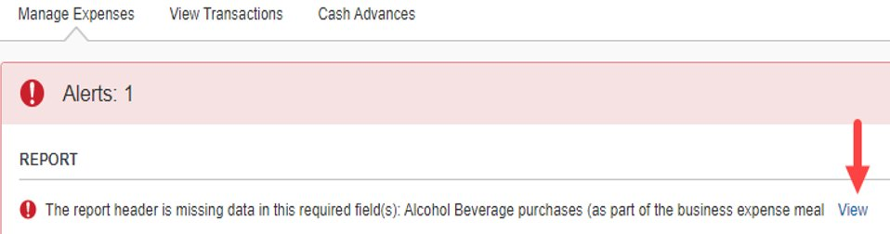

The information in the Report Header is from the approved Travel Request. At this point, details can be confirmed or updated as needed.
- Complete the alcohol purchase section of the request and select Save.
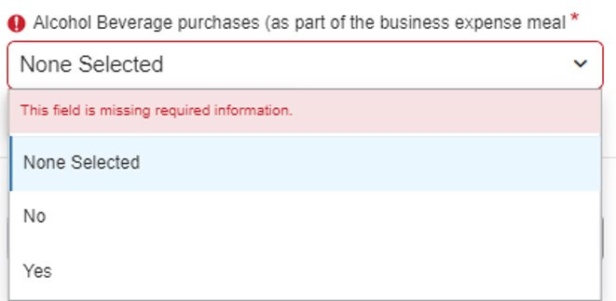

- Select Travel Allowance dropdown to select Manage Travel Allowance.
The travel allowance is used to calculate GSA rates.
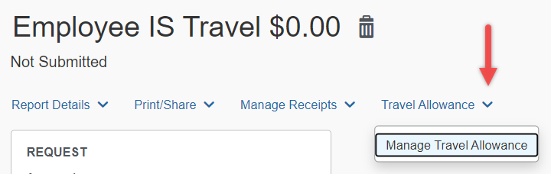

- Click on Create New Itinerary.
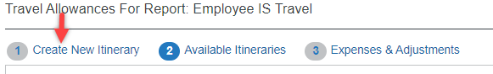

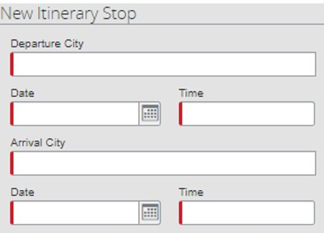
- Enter the departure city and arrival dates for the first day of travel and Save.
- Enter the departure city arrival dates for the last day of travel and Save.

- Review and select the two-line items then select Next.
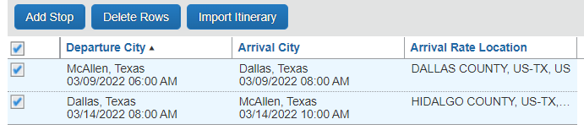

- Review the details of the new line items under Available Itineraries and select Next.
- Identify which meals were provided during travel. The system will update the allowances as per the departure and arrival times. When complete, select Create Expenses. 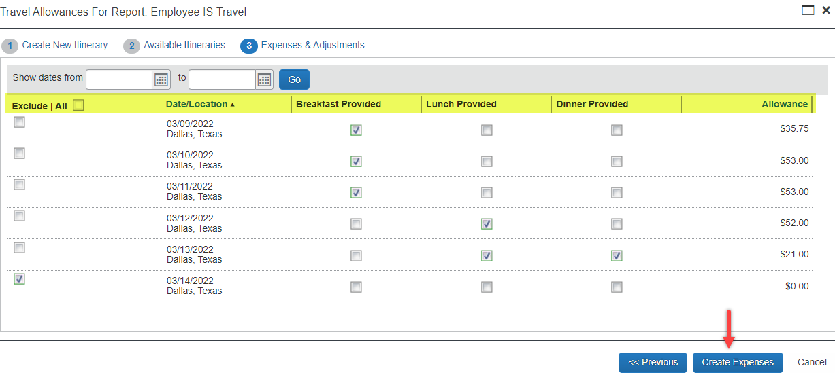
*When submitting on behalf of a guest that will not be reimbursed for meals, please click on Exclude All for all dates as this expense is not applicable. This will update the allowance to $0.00.

- Click on Add Expense to include out of pocket and university paid expenses.
From the Available Expenses tab, select only University Centrally Billed Credit Card transactions for this travel request and Add to Report.
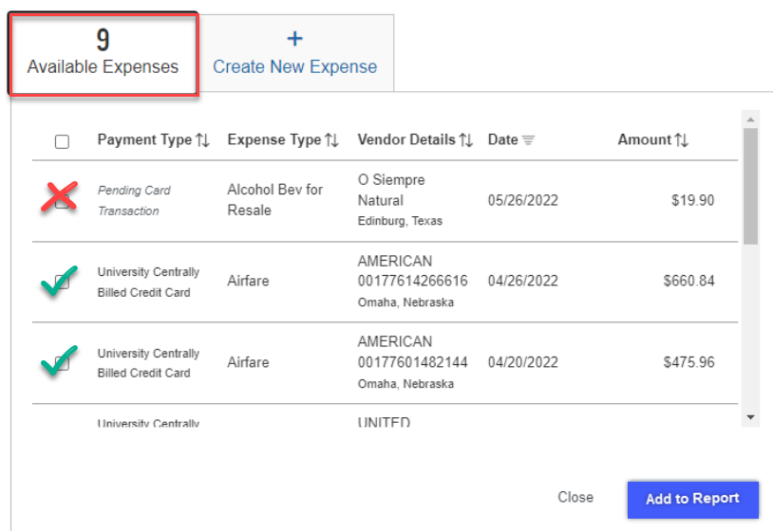

- The details will list on the Expense Report by date and Expense Type. 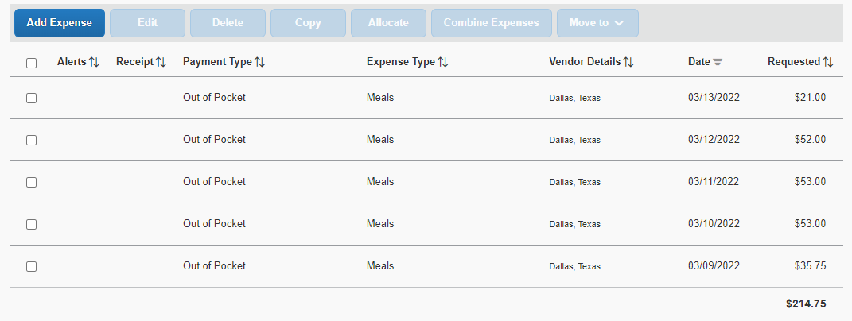

- Click on Add Expense. From the Create New Expenses tab, select the out of pocket expenses.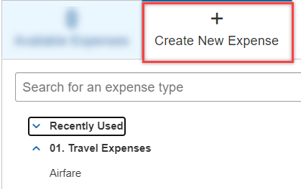

- Select Incidentals to include out of pocket travel fees
  - Include any information with a red asterisk as they are required fields.
  - The Business Purpose and Benefit to University are copied over from the travel request.
  - Keep the Payment type set to Out of Pocket.
  - It is recommended to include the Vendor name and City of purchases for expenses.
  - The currency field defaults to US dollar, however if other currency is selected, it will convert to US Dollar at the current exchange rate.
  - The amount can be modified from the original amount.
  - If expenses need to be allocated, select the allocate button on the top right to update the speedtypes.
See image on next page.

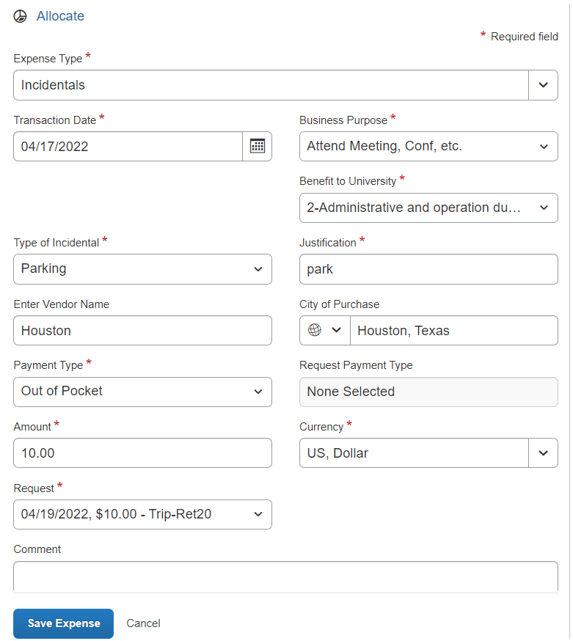

- If the expense is being paid by more than one Speedtype, click the Allocate button on top left
  - Click Add and Save the current Speedtype.
  - Click Add, select another Speedtype and click Save.
  - Allocations can be split by percentages or amounts.

- Attach receipts by clicking on the image to the right.
- Click Save Expenses or to continue with additional out of pocket expenses, click on Save and Add Another.
- The expense report will list line items by date and total the amount that will be reimbursed to the employee.
- Submit Report.
- Click on Accept & Continue on the User Electronic Agreement.
- New travel expense is located on the Expenses tab > Manage Expenses. 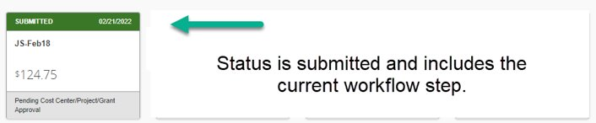

To view expense report details, use the drop-down menu from the Report Details.
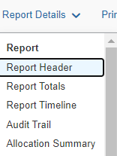
Report Header: Preview of expense details
Report Totals: amount of reimbursement
Report Timeline: approval status of the workflow
Audit Trail: lists actions taken from beginning to end
Allocation Summary: lists the percentages/amounts allocated for speed types selected.
Additional Notes:
- Budget check: A budget check against the cost center will be processed once the travel expense is submitted. If not available, expense report will be returned, giving the requestor the opportunity to allocate funds or change the cost center.
- Submission Requirements: Employees are required to submit expense reports for out-of-pocket expenses within 60 days from the date the expense was incurred (in the case of travel, within 60 days from the trip end date) along with all supporting documentation.
Effective April 18, 2022, all travel and business expenses submitted for reimbursement after 60 days will be subject to applicable federal and state tax withholding, and IRS reporting requirements.

