Best Practices for POLS Annual Review
The Annual Review Committee has created this document to assist faculty in submitting their annual review dossier.
The purpose of annual review is to celebrate the accomplishments of faculty colleagues and for the committee to make recommendations for a faculty member's continued success.
UTRGV is committed to retaining and promoting those faculty whose work achieves a high standard of excellence and who demonstrate, through the performance of their duties, a commitment to professionalism and to UTRGV’s mission.
The objectives of this annual evaluation process include providing faculty with a more concrete understanding of ways to achieve professional growth, and providing a job performance basis for possible merit salary increases.
1. Scope of Documents and Information in Dossier
The CLA policy for all tenure track faculty is that they must submit evidence for both annual and cumulative evaluations every year. This means that dossiers for TT faculty must include evidence for all years in the review cycle. Other faculty should submit evidence for the year(s) under review. Please refer to:
UTRGV HOP ADM 06 503 Appendix D
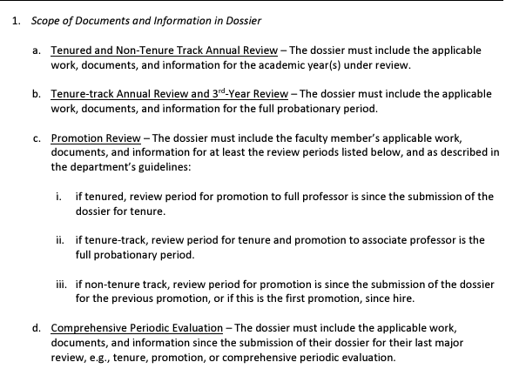
2. Evidence Organization in Dossier
The most efficient way to accomplish this is to create clearly labeled PDF files for each year and category. It is also possible to bookmark individual sections of the cumulative file for specific documents.
“Year 1 2022-2023 Research Evidence.pdf”
“Year 2 2023-2024 Research Evidence.pdf”
“Year 1 2022-2023 Teaching Evidence.pdf”
“Year 2 2023-2024 Teaching Evidence.pdf”
“Year 1 2022-2023 Service Evidence.pdf”
“Year 2 2023-2024 Service Evidence.pdf”
By creating a cumulative file at the end of each year you make things much easier in year 6 when you go up for promotion. At that point you can upload the cumulative files for each year and category. This is a good practice for tenured faculty as well because it keeps things organized for Comprehensive Periodic Evaluation.
3. Additional Files you need to upload
Please be sure you provide the following when you submit your dossier to FPT:
- The Department Evaluation Criteria and Standards for Annual Review, Tenure, Promotion, and Post Tenure Review. This can be found on the Department’s website.
- Syllabi from all years in the review cycle. For example, “2022-2024 Course Syllabi.pdf”.
- Peer observations: One is required every academic year for tenure track and lecturers and at least once every 3 years for tenured faculty and senior lecturers. Please include the evaluation, the signature form, and the response to the observation. For example, “Peer Observation Perez 2023.pdf”. In the past, faculty that don’t do this have faced severe consequences.
- Publications: Publications do not count for points or credit until published. Make sure to clearly name the files. For example, “Article APSR 2024 Democracy in Peril.pdf” or “Book Oxford 2024 Elections Matter.pdf”.
- Conference Presentations: The evidence must include the program listing your participation (a photocopy of the appropriate page in the program or screenshot of the session in the online program), and either the slideshow or paper that was presented. For example, “Conference Paper Midwest 2024 The Case for Imperialism.pdf” and “Conference Evidence Midwest 2024.pdf”.
- Teaching/Research workshop evidence: Faculty must provide either a certificate of completion, email of completion, or “thank you for attending” email. For example, “Workshop CTE 2023 Best Teaching Practices.pdf”.
- Media citations: Evidence needs to include a link or copy of the article/broadcast/transcript, or a thank you email. The media appearance needs to be published and/or broadcasted to count for points. Create one document for all media appearances. For example, “Media Appearances 2023-2024.docx”. Include the date, media outlet, and link for each appearance/interview. For those with multiple media citations simply use one line in the points accumulation template and adjust the points total. Instead of 30 .1s one 3.0 will save you some time. Then, all 30 would go into the single document.
- Conference Discussant: The evidence must include the program listing your participation (a photocopy of the appropriate page in the program or screenshot of the session in the online program). For example, “Discussant Evidence Midwest 2024 Contemporary Theory Panel.pdf”.
- Points Accumulation Spreadsheet: Some people carefully upload all their documented evidence but forget the critical Excel file that calculates the points. Do not forget this.

