Hyperion – Request for Production Access

- Go to the myUTRGV website at the following link: https://my.utrgv.edu/home

- Log in using your UTRGV user ID and password.

- Click on “IT Support Center”.


- Select “Get Access!”
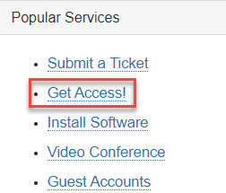

- Click on the “Request Access” button.
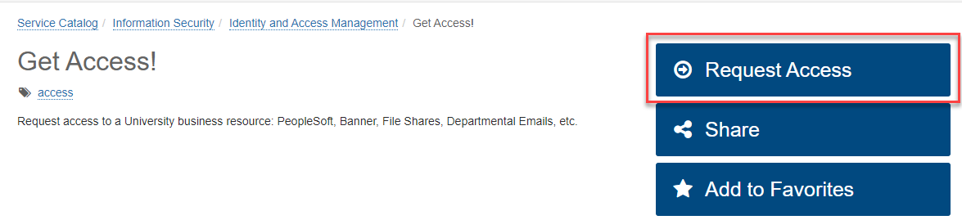

- The Requestor field will default to your name. If you are submitting for someone else, then type in their name.
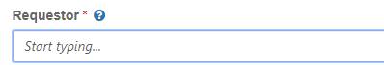

- Select “Departmental” under Category.
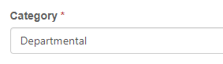

- Select “Hyperion” under Resource and select either “Dept User” for department budget updates or “Dept Manager” for the divisional level updates and review capability under Application Role.
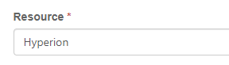

- List all departments you need access to update under Description. Please specify department number and name (e.g. 703000: Community Relations) then click on “Request”.

- If successful you will receive two emails, “TDX Service Request Created” and “TDX Workflow Step Assignment (EULA Agreement)”. The first email is informational only, to let you know that your access request was submitted. On the second email, click on the “EULA Agreement Workflow Step” link and then click on “Yes” to approve.
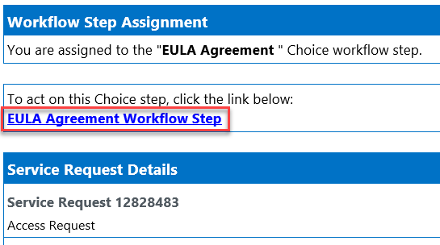

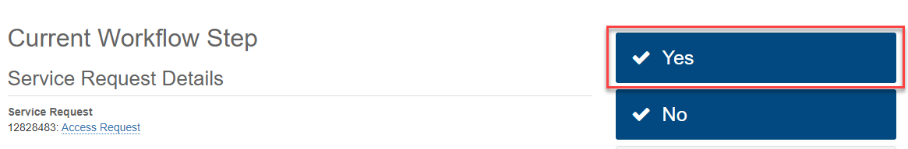

APPROVAL PROCESS:
- Once successfully submitted, your request will be routed to your supervisor for approval.
- After supervisor approval, the request is routed to the Hyperion Administrator/BA for approval.
- After Hyperion Administrator/BA approval, request is routed to Hyperion Data Owner for approval.
- After Hyperion Data Owner approval, the request is routed to the Access Admin Coordinator for approval.
- You will receive a confirmation e-mail once your access has been completely approved and created in Hyperion.

