How to run and interpret the Budget Overview query. (updated 3-23-22)
Query Name: RGV_KK_ACT_LOG_BY_BUDGET_PER (KK Activity Log by Budget Period)
This query is only for cost centers because it’s set up to only pull the ledgers within ledger groups OPE_CHILD1 and OPR.
Ledgers within Ledger groups:
OPE_CHILD1
OPE_CH_BUD (Budget)
OPE_CH_ENC (Encumbrances)
OPE_CH_EXP (Actual expenses)
OPR
OPR_BUD (Budget)
OPR_REC (Recognized)
OPR_COL (Collected)
- Navigate to Query Viewer by clicking on Commitment Control from the Employee Self Service drop-down menu.
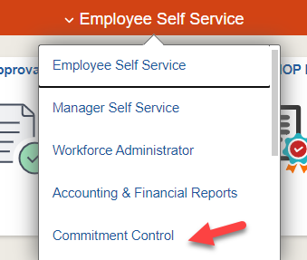

Then from the Commitment Control landing page choose the Budget Reporting tile.
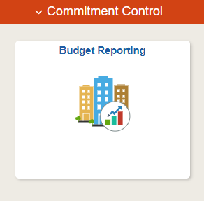

From the left side menu pick Query Viewer and in the search box enter the query name RGV_KK_ACT_LOG_BY_BUDGET_PER and hit search. Then click on either HTML or Excel hyperlink to bring up the criteria fields for the query.

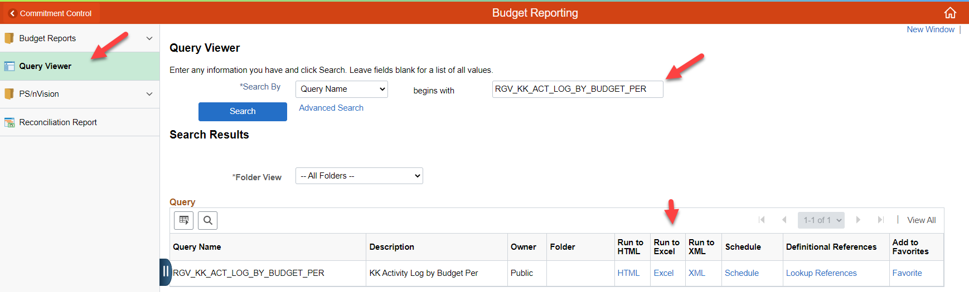

- Run the query from period “1” to whatever period you want to see the balances as of.
In this example, we are running the query from period 1 (Sep) to period 7 (Mar). Choose the Budget Period (Year), leave the department and cost center blank if you want all cost centers.

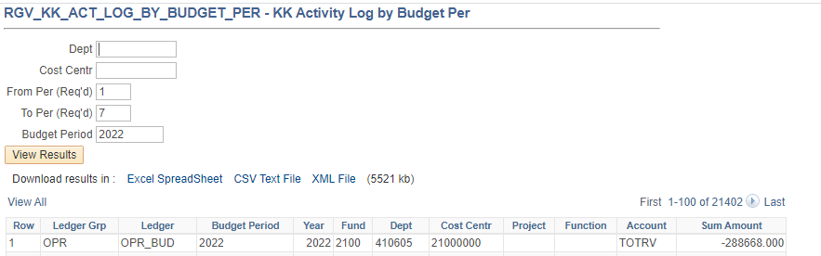

- Query results:
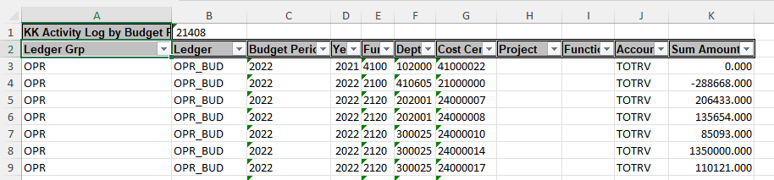

- Pivot Table Fields – choose the fields you want to see on the rows but make sure to put the ledger group and ledgers in the columns section with the ledger group above the ledgers. Put the sum of amount in the values.

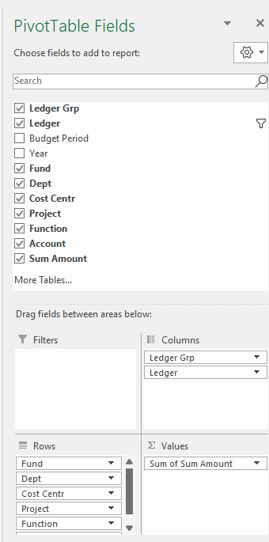
- On the pivot, in the ledger dropdown uncheck the OPR_COL (collected ledger) as it does not play a role in the calculation of the cost center available balance.

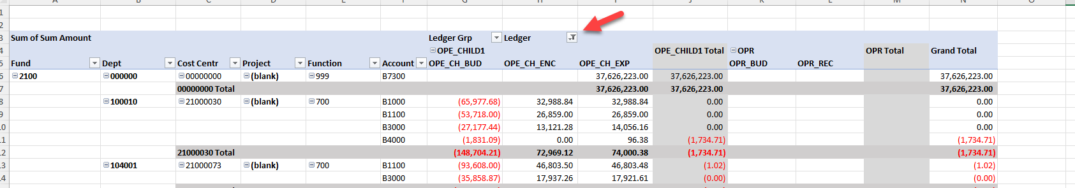

- This query shows the expense budget amounts and actual revenue amounts as negative values. This allows the encumbrance and actual amounts to net against the expense budget and calculates the OPE_CHILD1 total as the available expense budget.
The actual revenue is netted against the revenue budget to calculate the OPR Total as the available budget on the revenue side. Then the two totals are netted together to calculate the Grand Total, which is the overall cost center balance.
Negative grand totals are surplus balances, and positive grand totals are deficit cost center balances.

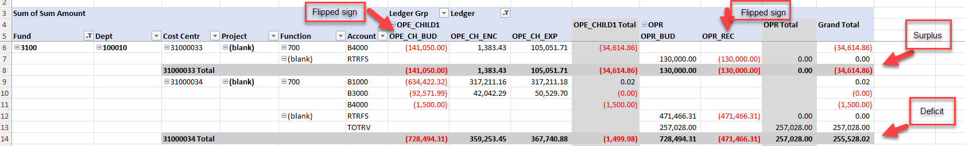

For more detailed instructions on how to create this exact pivot please see the following steps.

Pivot instructions:
- Place your cursor somewhere within the data set of your excel query results.
On the ribbon menu click on “insert” and then “Pivot Table”.
A box will come up and ensure your Table/Range starts with the $A$2 and goes through the end of the data set. If it does not click on the little arrow next to that field and highlight the data set. Ensure the pivot will be placed on a New worksheet and then click “ok”.
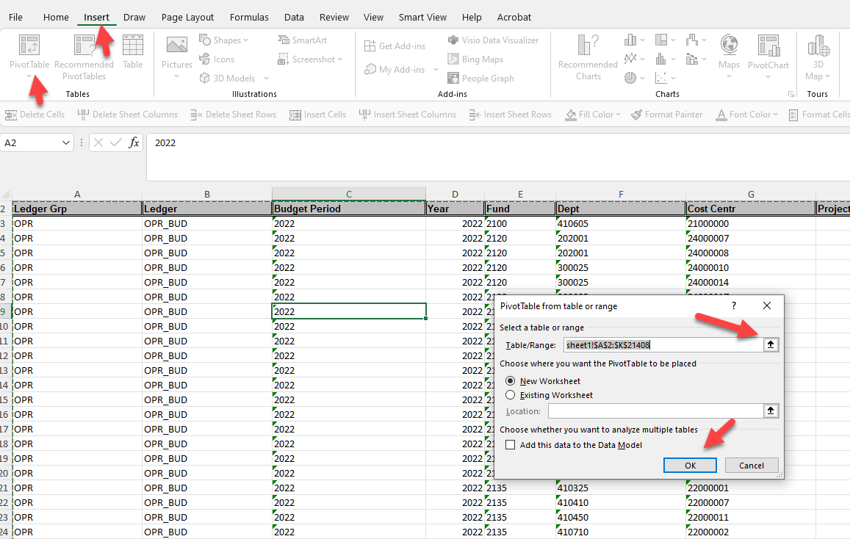

- The next step is to build the pivot table by dragging the fields into the pivot sections down below.

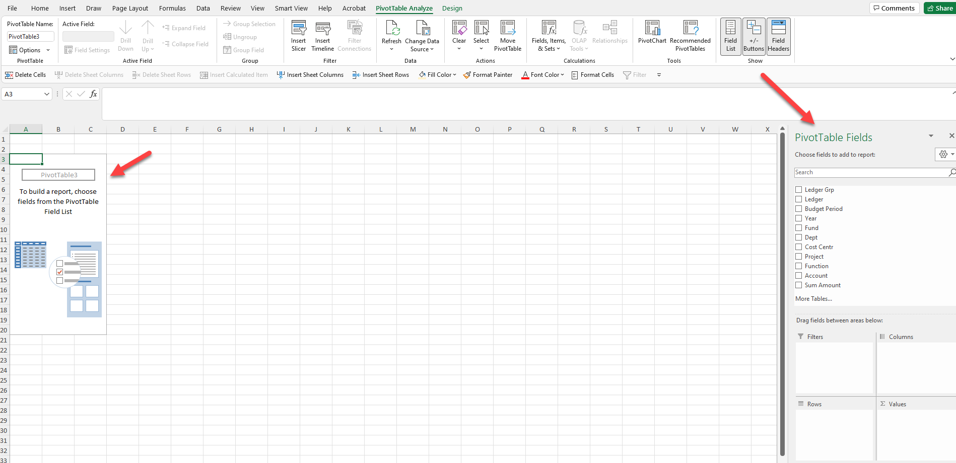

- Pivot Table Fields
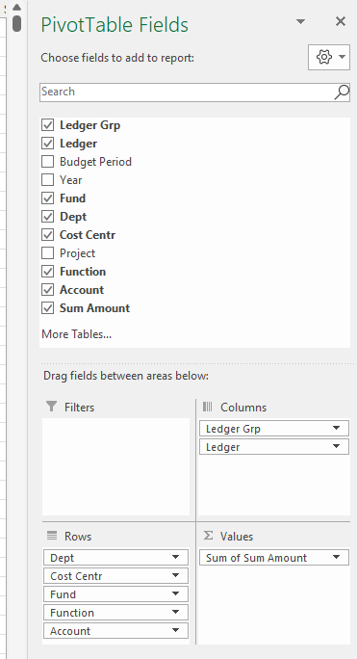

- Change the pivot design to tabular form.
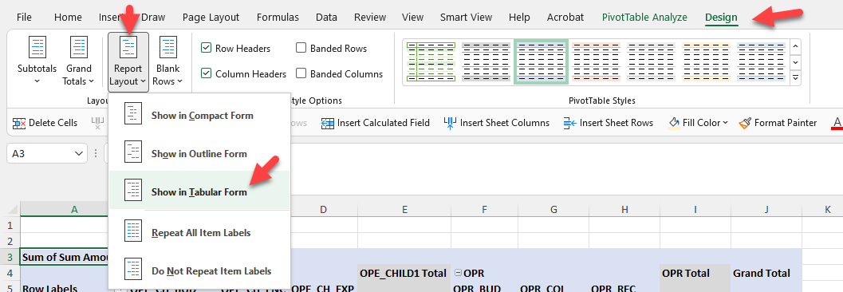

- Remove subtotals from the pivot.
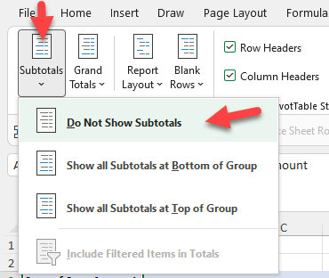

- Change the format for the amounts by choosing the Value Field Settings from the drop down menu of the “Sum of Sum Amounts”.
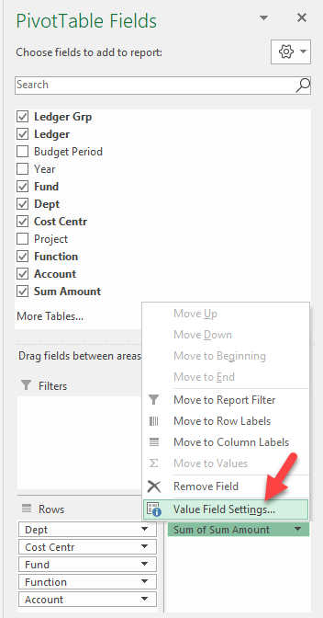

- Click on the Number Format button.

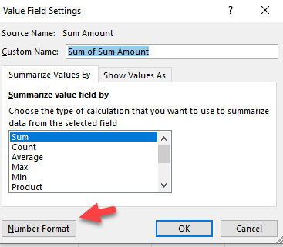

- Choose number, 2 decimals, check the 1000 separator box, and pick the format with negative red amounts. Click “ok” and click “ok” again to exist that value field settings.
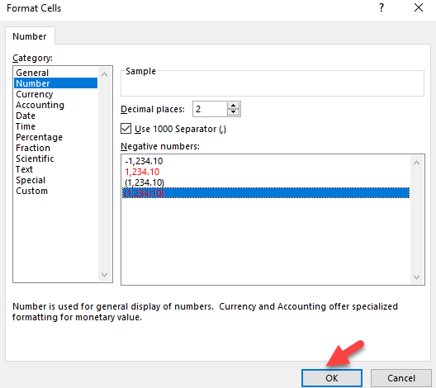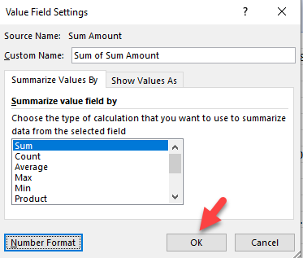

- Click on the drop down menu for Ledger and uncheck the OPR_COL, then click ok. This will remove the collected ledger from the pivot as that ledger is not part of the calculation of the cost center balance.
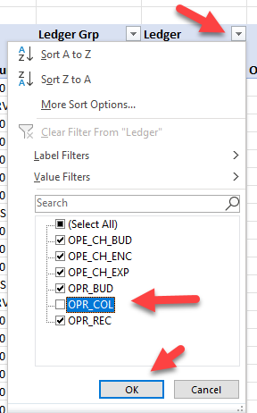
- Add a subtotals to the “Cost Centr” and “Ledger Grp” fields by doing a right click on those fields to get the following menu. Click on Subtotal.
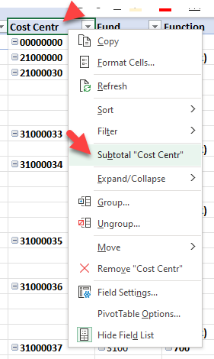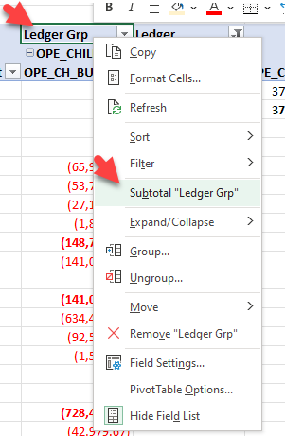

- Your pivot table should look like this at this point.
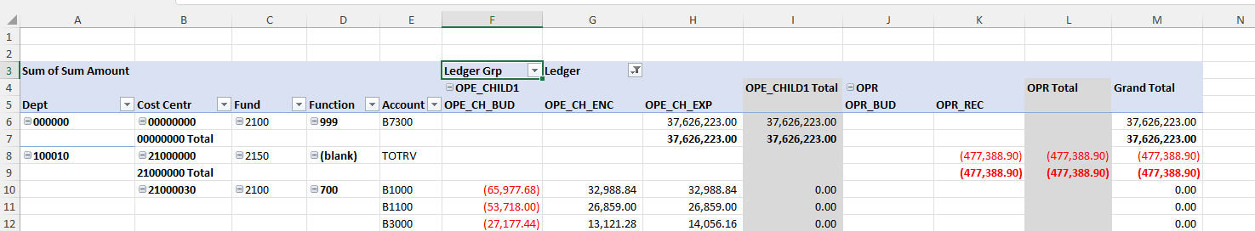

- Add formatting to the Cost Center totals rows by clicking on the edge of one of them and you will see all the cost center total rows get highlighted. 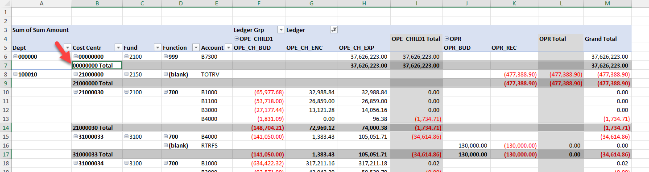

- Choose the color you want to use for this highlighting. I have chosen light gray.

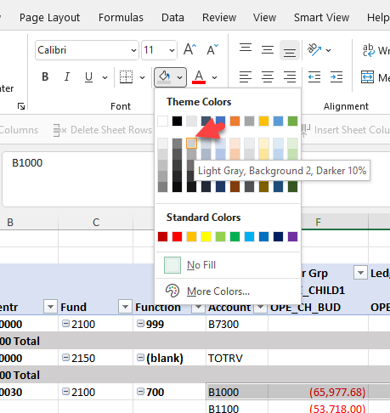

- Close the PivotTable Fields by clicking on the “X” in the upper right corner.
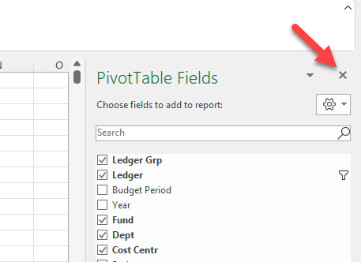

- Your pivot table should look like this.
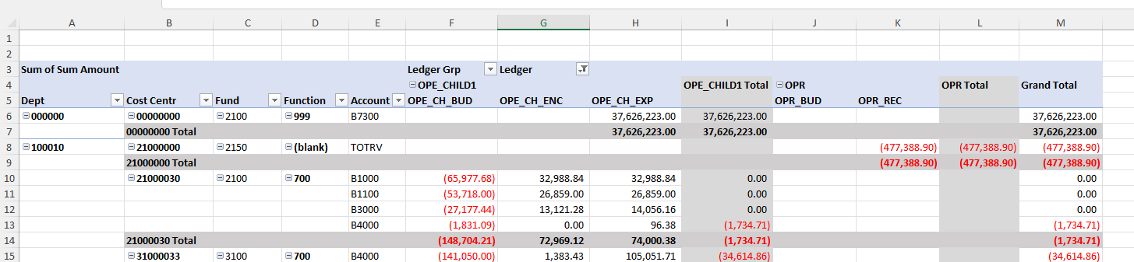

Feel free to customize the pivot rows and format as you wish. This is simply an example of the fields you can see but you can change the order or remove those you don’t want to see. However, if you plan to do budget revisions based on this data it is best to bring in the project field so you can see the complete GL string for cost shares.

End.

