Hiring Manager View Onboarding Status
1. Navigate to Manager Self Service Landing Page.
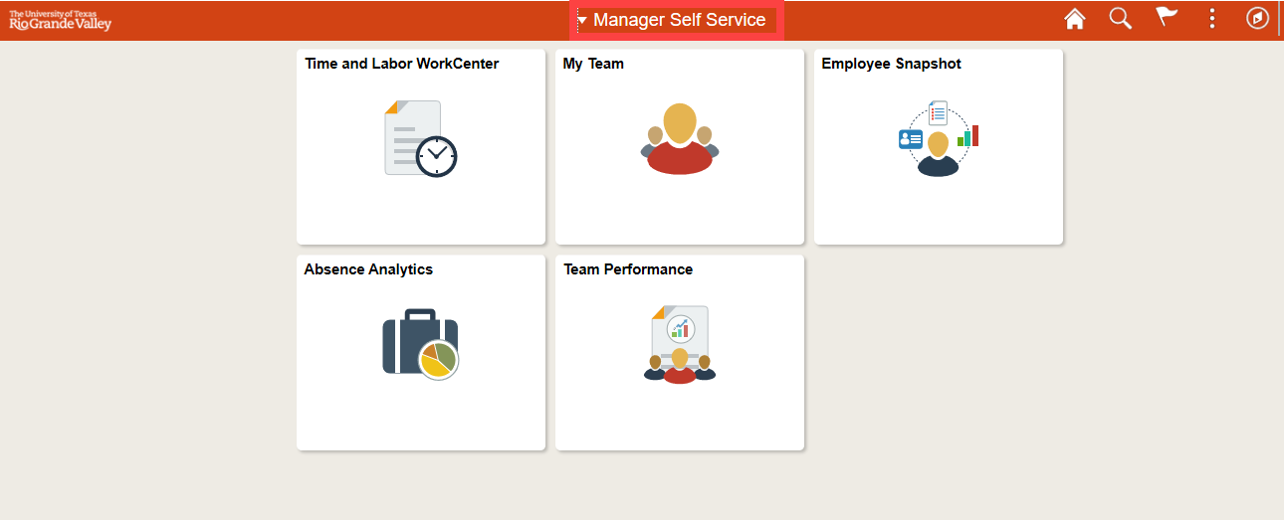

2. Select the My Team tile.
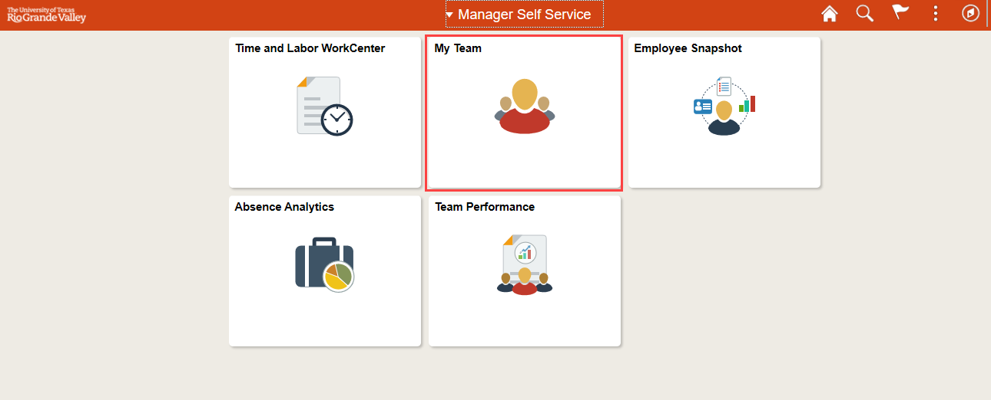

3. Select the green drop down “Action Menu” beside the name of the new hire (the employee must be in a positon that reports to the manager)
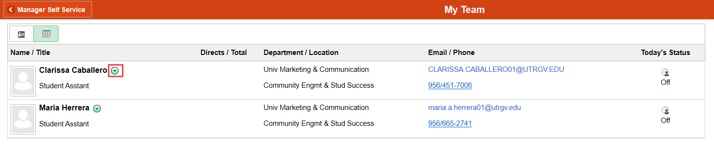
4. Select Onboarding Status.
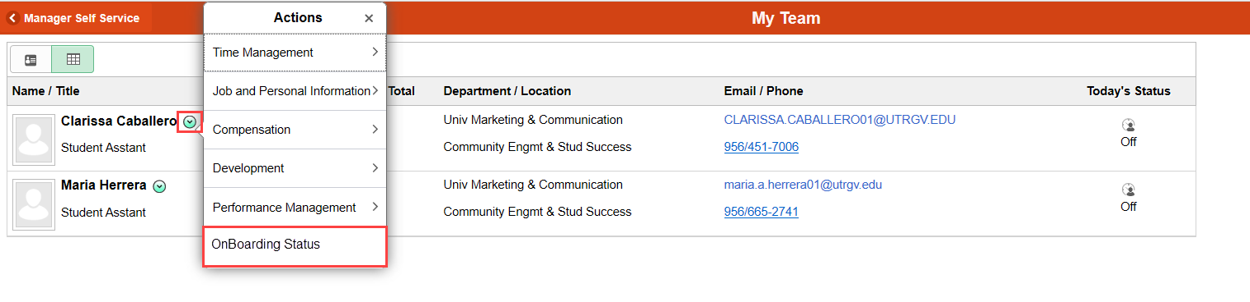

5. Review the status column for all pending onboarding events.

6. Select Remind Employee to generate an onboarding reminder email to employee.
