VOLT – Brownsville Campus Circulator Service

Effective: Fall 2026
VOLT service provides free, on-campus transportation at The University of Texas Rio Grande Valley (UTRGV) Brownsville campus and offers additional stops at Brownsville La Plaza Transit Terminal and Saint Joseph Academy. This document outlines operating schedules, route alignments, designated stops, and on-request (call stop) locations for all VOLT circuits serving the Brownsville campus.
VOLT operates Monday through Friday and is available to students, faculty, staff, and visitors. Vehicles operate on flexible circuit routes with clearly identified stops. An Americans with Disabilities Act (ADA) accessible vehicle will be available upon request.

Service Information

Free and open to the public
- First come, first served basis
- Reserved seating is unavailable
- Schedule is subject to change without notice
For questions, pickup requests or ADA accessibility needs, please call 956.882.2036 or email transportation@utrgv.edu.

Website: utrgv.edu/pts

VOLT – East Circuit

Starting August 26, 2026 | Brownsville
Service Hours: Monday–Friday | 7:30 AM–8:30 PM
Frequency: Approximately every 20 minutes

Route Stops

- Main Drive
- Biomedical and Health Building
- Brownsville Visual Arts Complex Building
- Lot B4

Call Stops (let the driver know you want to stop here)

- Life and Health Sciences Building

Circuit Alignment Description

Service begins at the UTRGV Main Drive and travels east along West University Boulevard, turns north on Jackson Street, and west on FJRM Avenue to stop next to the Biomedical and Health Building. Service continues north on East 24th Street and turns west on East Van Buren Street to stop at the Visual Arts Complex. It continues north on East 22nd Street, then east on East Harrison Street, and south on East 24th Street. The route continues east on Jackson Street and then turns on FJRM Avenue to arrive at lot B4. The route continues south on Tyler Street and west on West University Boulevard until concluding back at Main.

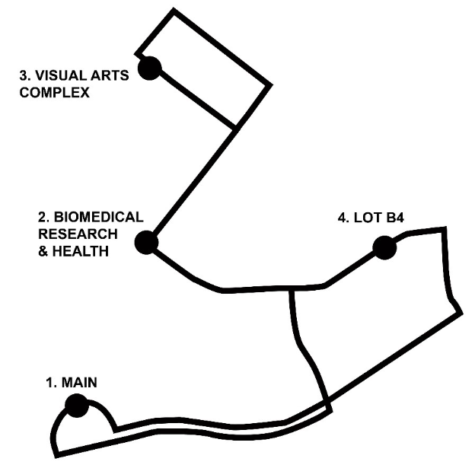
VOLT – West Circuit

Starting August 26, 2026 | Brownsville
Service Hours: Monday–Friday | 7:30 AM–8:30 PM

Service Hours for Saint Joseph Academy:

Tuesday & Thursday | 11:30 A.M.–8:30 P.M.

Wednesday | 4:00 P.M.–8:30 P.M
Frequency: Approximately every 20 minutes

Route Stops

- Main Drive
- Brownsville La Plaza Transit Terminal
- Saint Joseph Academy

Circuit Alignment Description

Service begins at the UTRGV Main Drive and travels west along West University Boulevard, turns northeast on International Boulevard, northwest on East Adams Street, northeast on 13th Street, and southeast on East Jefferson Street to stop at the Brownsville La Plaza Terminal. The route continues southeast on East Jefferson Street and turns northeast on International Boulevard. It travels north to U.S. Highway 69E and travels north there until the Palm Boulevard exit and then travels southwest. The route turns northwest on Calle Retama, then right on Saint Joseph Drive and arrives at UTRGV at Saint Joseph Academy. The route returns through Palm Boulevard, U.S. Highway 69E, and International Boulevard and arrives at Main Drive.

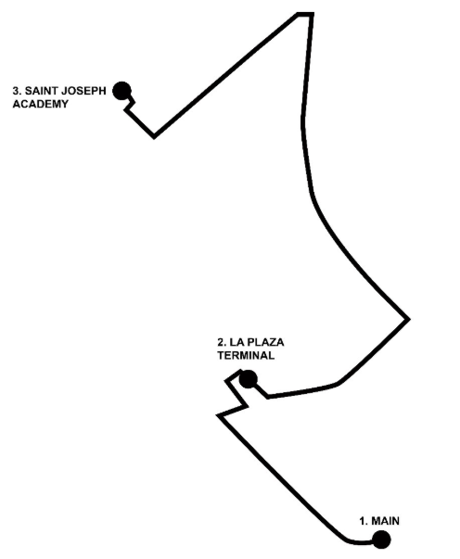

VOLT – South Circuit

Starting August 26, 2026 | Brownsville
Service Hours: Monday–Friday | 7:30 AM–6:00 PM
Frequency: Approximately every 20 minutes

Route Stops

- Sabal Hall
- Recreation Center

Call Stops (let the driver know you want to stop here)

- Brownsville Early College High School
- Life & Health Science Building

Circuit Alignment Description

Service begins on the west side of Sabal Hall and travels west along West University Boulevard and turns south on Ringgold Road to arrive at the Recreation Center. If requested, it continues south on Ringgold Road and turns north into the Brownsville Early College High School. Or, if requested, it can continue north on Ringgold Road and turn east to the Life and Health Science Building at parking lot B2. It then returns on Ringgold Road and West University Boulevard to Sabal Hall.
