VOLT – Remote West Circuit
Starting September 9, 2026 | Edinburg
Service Hours: Monday–Friday | 7:30 AM–6:00 PM
Frequency: Approximately every 15 minutes

Route Stops
- Visitor Center
- Parking Lot E35 – VOLT Sign
- Parking Lot E34 – Passenger Shelter
Circuit Alignment Description
The VOLT – Remote West Circuit begins at the Visitors Center. The vehicle will exit the area and proceed toward University Drive / Hwy 107, turning right onto the roadway. The vehicle will continue westbound and then turn right onto Jackson Road, following the roadway toward Parking Lot E35.
Upon reaching Parking Lot E35, the VOLT will enter the parking lot and proceed to the designated VOLT sign, where passengers may board or exit the vehicle. After completing the stop, the vehicle will follow the designated parking-lot circulation and exit E35.
The vehicle will then continue east toward Parking Lot E34 and proceed to the designated passenger shelter on Schunior Road, which will serve as the second passenger stop. After serving E34, the vehicle will depart the parking lot and follow the roadway back toward the Visitors Center, completing the circuit and preparing to begin the next trip.
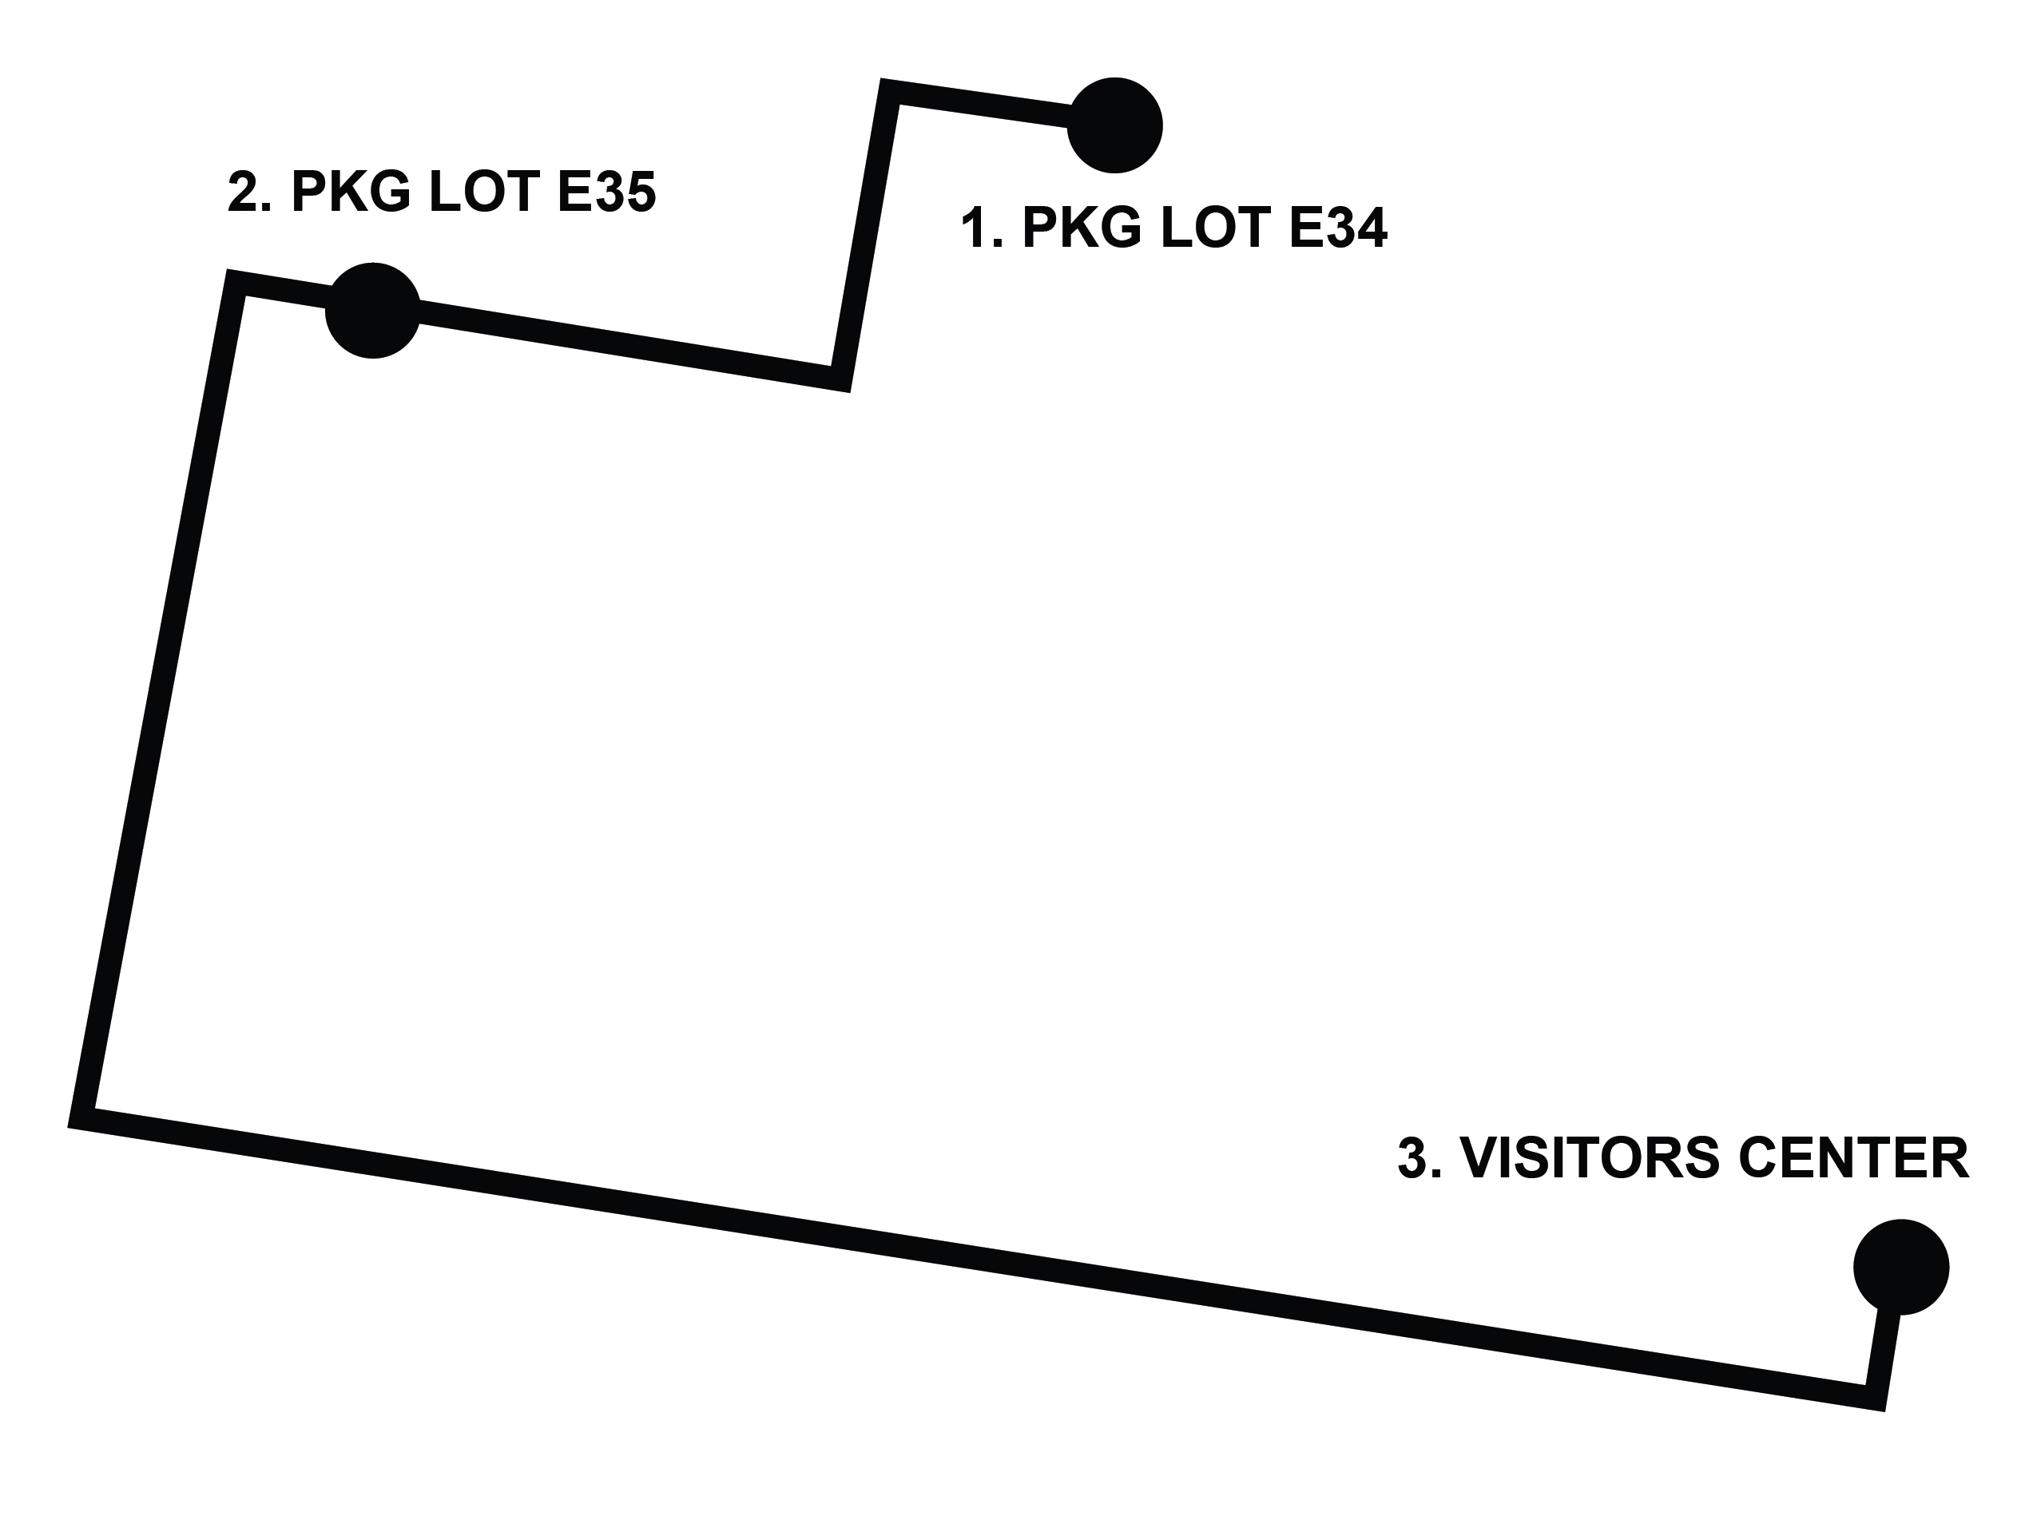

VOLT – Remote East Circuit

Starting September 9, 2026 | Edinburg
Service Hours: Monday–Friday | 7:30 AM–6:00 PM
Frequency: Approximately every 15 minutes

Route Stops
- Visitor Center
- Parking Lot – Kuhn Street & 6th Avenue

Circuit Alignment
The VOLT – Remote West Circuit begins at the Visitors Center. The vehicle will exit the area and proceed toward University Drive / Highway 107. The vehicle will turn left onto University Drive / Highway 107, continue east along the roadway, and then turn left onto North 7th Avenue.
The vehicle will continue north on North 7th Avenue and turn left onto West Peter Street. The vehicle will then continue along West Peter Street and turn left onto North 6th Avenue.
The vehicle will proceed along North 6th Avenue toward West Kuhn Street and serve the designated stop at the corner of North 6th Avenue and West Kuhn Street. Passengers may board or exit the vehicle at this location.
After completing the stop, the VOLT will depart the area and follow University Drive / Highway 107 back toward the Visitors Center, completing the circuit and preparing for the next trip.
