VOLT – Edinburg Campus Circulator Service

Effective: Fall 2026
VOLT service provides free, on-campus transportation at The University of Texas Rio Grande Valley (UTRGV) Edinburg campus. This document outlines operating schedules, route alignments, designated stops, and on-request (call stop) locations for all VOLT circuits serving the Edinburg campus.
VOLT operates Monday through Friday and is available to students, faculty, staff, and visitors. Vehicles operate on flexible circuit routes with clearly identified stops. An Americans with Disabilities Act (ADA) accessible vehicle will be available upon request.

Service Information

- Free and open to the public
- First come, first served basis
- Reserved seating is unavailable
- Schedule is subject to change without notice
For questions, pickup requests or ADA accessibility needs, please call 956.665.2036 or email transportation@utrgv.edu.

Website: utrgv.edu/pts

VOLT – North Circuit
Starting August 26, 2026 | Edinburg
Service Hours: Monday–Friday | 7:30 AM–6:00 PM
Frequency: Approximately every 15 minutes

Route Stops

- Parking Lot E34
- University Recreation Center (EUREC)
- Liberal Arts Building North (ELABN)
- University Library
- Mathematics and General Classrooms (EMAGC)
- Education Complex (EEDUC)
- Village Apartments
- Texas Manufacturing Assistance Center (EASFC)

Call Stops (let the driver know you want to stop here)

- Unity Hall
- Parking Lot E31
- Parking Lot E32
- Parking Lot E33
- Parking Lot E35
- Performing Arts Complex (EPAC)
- International Trade and Technology Building (EITTB)

Circuit Alignment Description

Service begins at Parking Lot E34 with two stops, then continues to the University Recreation Center (EUREC), Liberal Arts Building – North (ELABN), University Library, Mathematics and General Classrooms, Education Complex, Village Apartments, and concludes at the Texas Manufacturing Assistance Center (EASFC).
The circuit alignment begins at the first stop located along the east side entrance/exit of Parking Lot E34 on the right-hand side, facing north toward West Schunior Street. To reach the second stop, the vehicle continues straight to a stop sign and turns right onto West Schunior Street, where the second stop is located on the right-hand side.
To reach the third stop, the vehicle continues west toward North Sugar Road. At the traffic signal, it turns right onto North Sugar Road and proceeds along the roadway to the stop located in front of the University Recreation Center. From there, the vehicle continues south on North Sugar Road and turns left onto West Van Week Street.
The fourth stop, located at the Liberal Arts Building – North, is on the right-hand side adjacent to Parking Lot E10. The route continues along West Van Week Street to the fifth stop at the University Library, located on the right-hand side near accessible parking in Parking Lot E15.
The sixth stop, serving the Mathematics and General Classrooms building, is located along the sidewalk on the right-hand side. Continuing along West Van Week Street, the seventh stop serves the Education Complex, also located on the right-hand side along the sidewalk.
The vehicle then performs a U-turn within Parking Lot E25 and travels back along West Van Week Street, crossing North Sugar Road to reach the eighth stop at Village Apartments, located in Parking Lot E36 on the left-hand side. The route continues to the ninth and final stop at the Texas Manufacturing Assistance Center, located at the stop sign on the right-hand side. Additional stops may be accommodated along the route upon request (call stops).

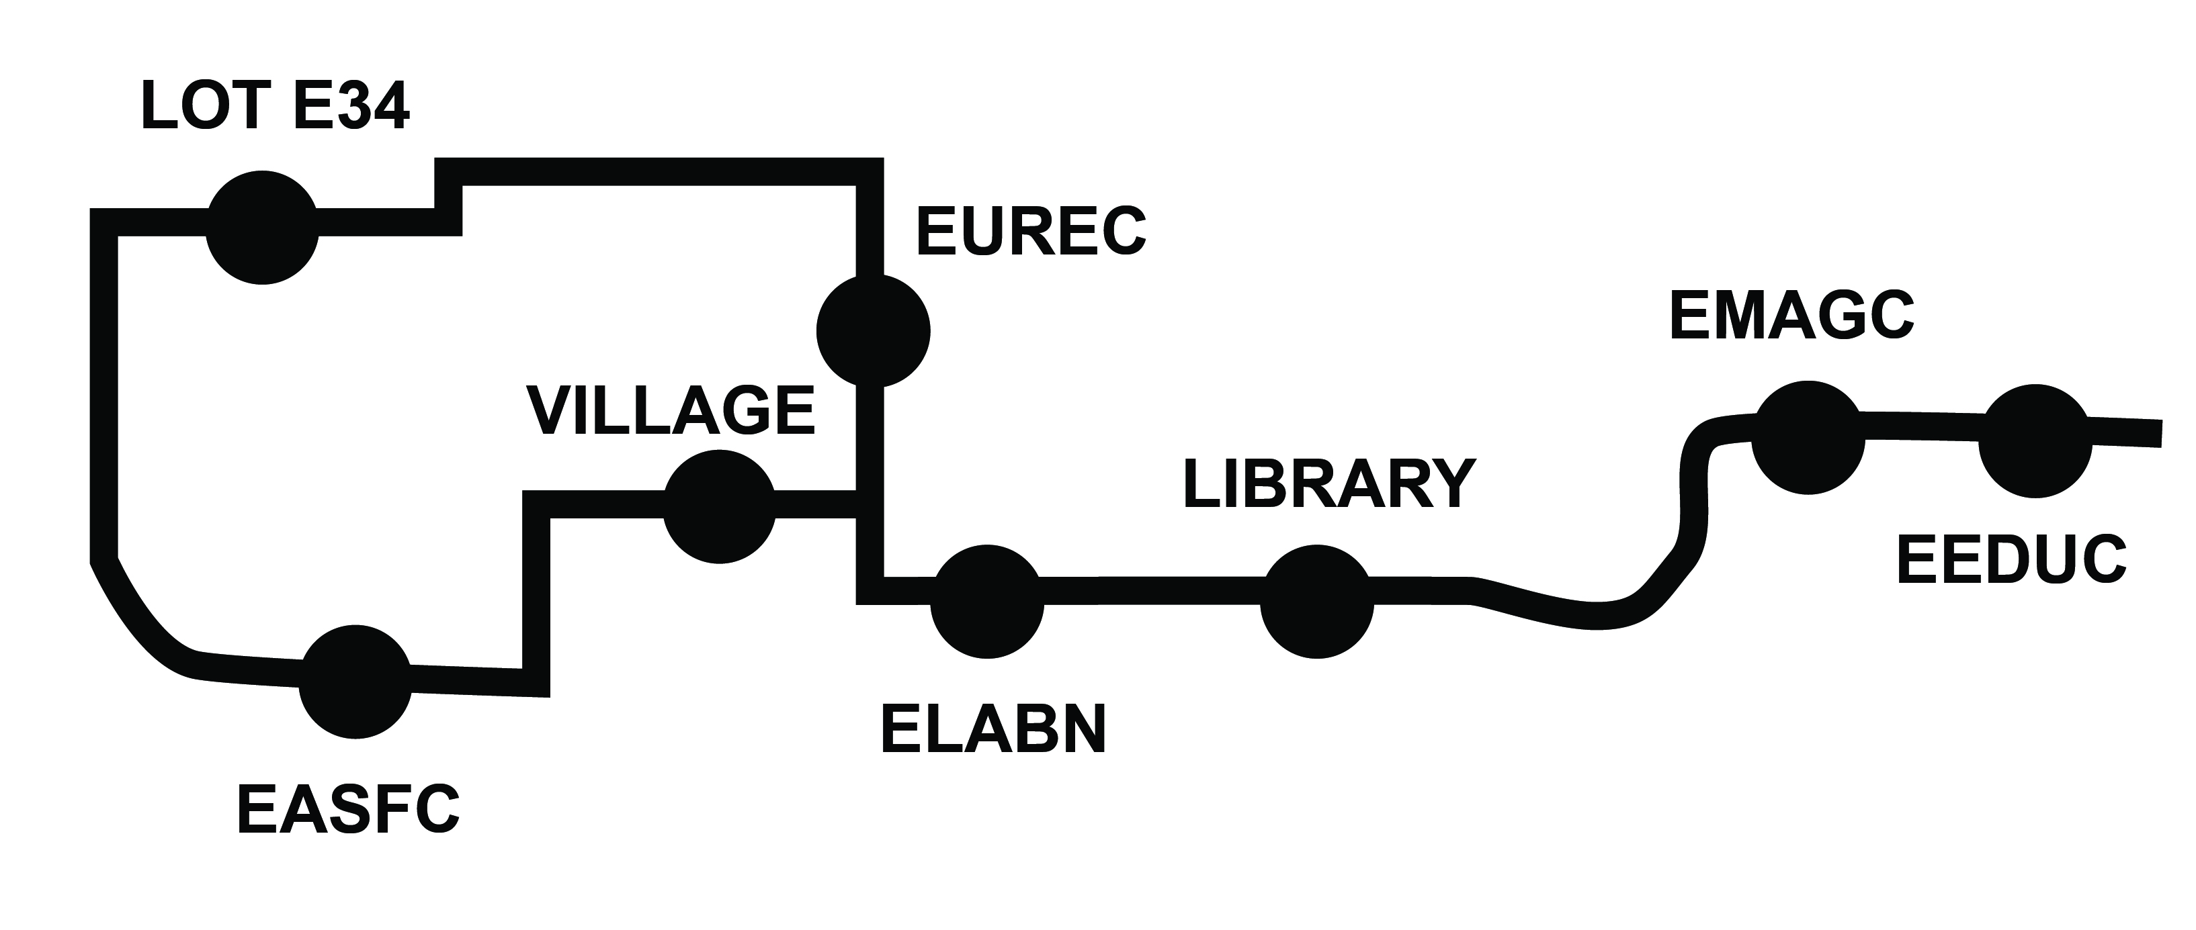

VOLT – West Circuit

Starting August 26, 2026 | Edinburg
Service Hours: Monday–Friday | 7:30 AM–6:00 PM
Frequency: Approximately every 15 minutes

Route Stops
- Village Apartments
- Visitors Center
- Student Academic Center (ESTAC)

Call Stops (let the driver know you want to stop here)
- Unity Hall
- Performing Arts Complex (EPAC)
- International Trade and Technology Building (EITTB)

Circuit Alignment Description

The circuit alignment begins at Village Apartments, located in Parking Lot E36. Facing west toward North Sugar Road, the vehicle proceeds straight to the stop sign and turns right onto North Sugar Road, heading south. The route continues along North Sugar Road to a two-way stop, where the vehicle turns left into Parking Lot E7.
After immediately turning right and following the curved roadway, the vehicle proceeds through a three-way stop and continues forward until reaching another stop sign on the right-hand side. The route then turns left, passes the campus information booth, and reaches the Visitors Center stop located on the right-hand side.
After serving the Visitors Center, the vehicle turns left at the first stop sign and immediately turns right into Parking Lot E5. It continues through the lot to the next stop sign and turns right into Parking Lot E8, where the Student Academic Center stop is located on the right-hand side.
From there, the vehicle turns left and continues through Parking Lot E8, then turns right onto the curved roadway. At the next stop sign, the vehicle turns left, proceeds to another stop sign, and turns right back onto North Sugar Road. The route continues north on North Sugar Road before turning left into the entrance of Parking Lot E38 to arrive at Village Apartments.
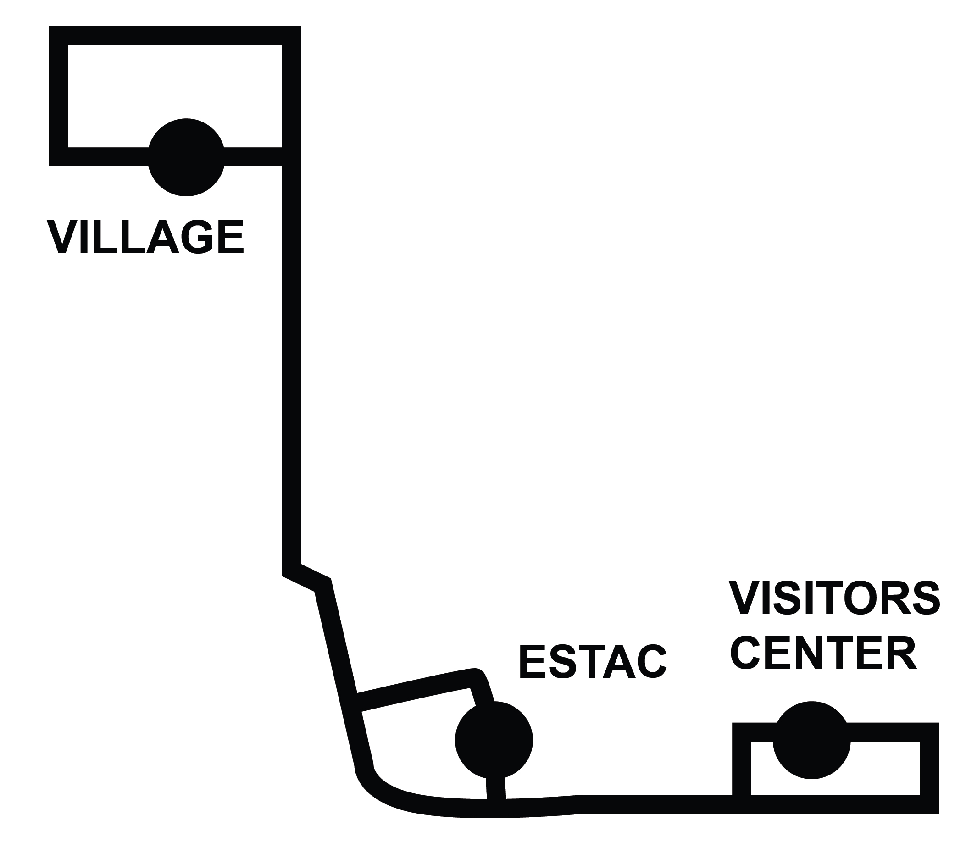

VOLT – East Circuit

Starting August 26, 2026 | Edinburg
Service Hours: Monday–Friday | 7:30 AM–6:00 PM
Frequency: Approximately every 15 minutes

Route Stops
- Parking Lot E22
- Parking Lot E21 (two stops)
- Health and Physical Education Complex (EHPE1)
- Sundial

Call Stops (let the driver know you want to stop here)
- Performing Arts Complex (EPAC)
- International Trade and Technology Building (EITTB)

Circuit Alignment
The route begins in Parking Lot E22, exits on the west side of the lot and turns right onto West Van Week Street It continues until a four-way stop. At the intersection, it turns left onto Dr. Miguel A. Nevarez Drive and proceeds south until it turns left into Parking Lot E21.
After serving two stops in E21, it crosses Dr. Miguel A. Nevarez Drive into Parking Lot E16 and continues straight through Parking Lot E16, then follows the roadway as it curves to the right. Then it turns left onto the designated path leading to the Field House (EHPE1). The fourth stop will be on the right-hand side. After departing from the Field House, it continues along the designated path to the final stop at the Sundial, located between the Science (ESCNE) and Engineering (EENGR) buildings.
