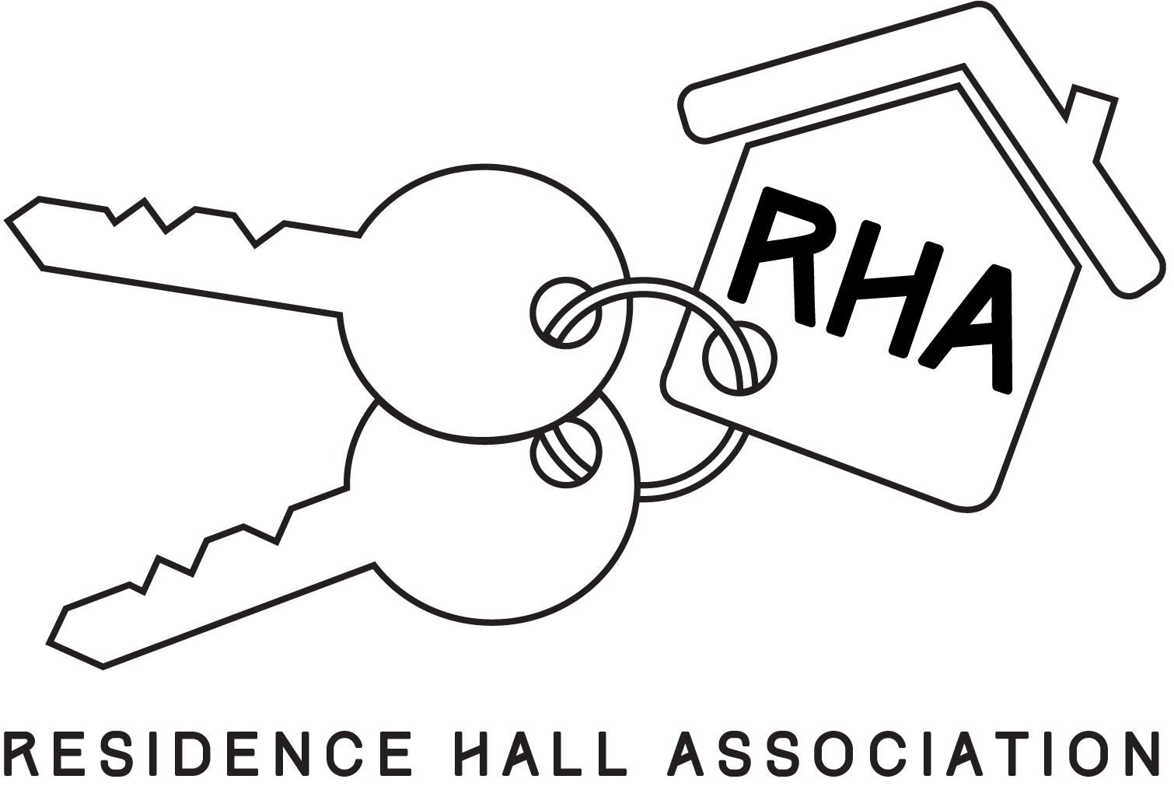

RHA Constitution
Preamble
The Residence Hall Association is a student led organization whose purpose is to provide a sense of community, leadership development opportunities, and community engagement for students that live in UTRGV housing communities.
The RHA is a representative body of a diverse student population in which individual differences are accepted. Ultimately, we strive for a unified organization with an emphasis in appreciation, understanding, and acceptance. Finally, we encourage member collaboration throughout the organizational structure in order to achieve a meaningful campus experience for residents.
Article I: Name
The name of this organization shall be Residence Hall Association, hereafter referred to as RHA.
Article II: Mission/ Purpose of Goals
The objective of RHA is to promote the development of a residential community that provides residents with programs that encourage communication, education, leadership development, engagement and a sense of unity; additionally, RHA will serve as a forum for residents to voice ideas, opinions, and concerns to Residence Life administration.
Article III: Non-Discrimination/Accessibility Provision
Section 1: Nondiscrimination Policy
- This organization shall not discriminate toward persons on the basis of race, color, sex, religion, national origin, age, disability, citizenship, political affiliation, veteran status, sexual orientation, gender identity, or gender expression.
Section 2: Disability Accommodations
- RHA will make reasonable accommodations in coordination with Accessibility Services to support participation of members that have a documented disability. If full physical participation is limited, this will not negatively impact the participant’s membership in the organization.
Article IV: Membership
Section 1: Membership Requirements
- The majority of the total membership of RHA shall be comprised of students currently enrolled in The University of Texas Rio Grande Valley. Membership to RHA can be extended to employees of UTRGV, unless doing so would cause majority membership to no longer be comprised of students.
Section 2: Inherent Membership
- Inherent membership shall be extended toward those who are provided housing by The University of Texas Rio Grande Valley. Those who have been granted this membership may relinquish this membership at any time.
Section 3: Latent/Active Members
- Members will be deemed active if they have attended a minimum of two consecutive functions (meetings, events, etc…) of RHA. To maintain active status within the organization, members must not meet or exceed two consecutive function absences within any period of the semester programming. Members who meet or exceed the function absence limit will be deemed inactive, unless excused by a majority vote of the Executive Board, or by an Adviser.
Article V: Executive/Officer Qualification, Structure, & Responsibilities
Section 1: The Executive Board
- The executive board of RHA shall consist of a President, Vice-President/National Communication Coordinator, Marketing Coordinator, Secretary, Programming Coordinator, Budget Comptroller, and Parliamentarian. Officer positions may be added, removed or consolidated as needed (deemed by an Adviser), for each respective campus. Each campus that has an established RHA must have its own Executive Board independent of each campus. Officers may only represent the campus in which they reside. In the event of an emergency in which the E-Board is unable to finish their term and vote a new board, the RHA Advisors are able to appoint current/previous residents as officers for the new school year based on an application and interview process.
Section 2: Qualifications for Officers
- Officers Requirements:
- Have at least a 2.5 GPA to apply.
- Have completed at least 12 hours/credits at UTRGV.
- Have been an active member of RHA for at least one semester.
- Be a current member of RHA.
- Have completed at least one full semester at UTRGV.
- Be enrolled as a student at UTRGV.
- Have lived on UTRGV campus housing (The Village, Unity Hall, Heritage Hall, Troxel Hall, or Casa Bella) for at least one semester prior to applying for office.
- Be in good academic and conduct standing with UTRGV and UTRGV Housing.
- Be limited to 2 terms.
- Reside in housing provided by UTRGV.
- Residence Assistants may be officers, but may not comprise a majority of the Executive Board or assume the position of President.
- Exceptions will be made for the inaugural year, and the following year of UTRGV.
Section 3: Duties of Officers
- Officers shall:
  - Participate in monthly feedback sessions as an Executive Board.
  - Be accountable for their successes or failures.
  - Attend all RHA related functions, unless excused by a majority of the Executive Board.
  - Devote at least three hours a week toward RHA functions.
  - Plan and execute a minimum of 2 programs per semester.
  - Speak to their RHA Adviser(s) regarding their performance, as an officer, once-a-month.
  - Participate in Executive Board training and development each semester, which may include parts of departmental student staff training as deemed necessary with the consultation from the Adviser(s).
  - Maintain cleanliness and professionalism of the RHA office and/or work room.
  - Attend weekly Executive Board meetings.
  - Meet all expectations that are set by the Office of Housing and Residence Life.
  - Submit a weekly report to advisers about RHA activities.
  - Perform other duties as assigned by a majority of the Executive Board.
  - Attend at least 2 RA programs per semester.
  - Inform the Executive Board regarding resignation 2 weeks in advance.
- Specific Duties of Officers
  - President:
    - To serve as a representative and spokesperson for RHA in various university settings or to appoint a representative as is necessary.
    - To set and preside over all RHA meetings or appoint a replacement to do so and set the agenda for those meetings.
    - Coordinate Executive Board.
    - Set agenda for RHA Executive Board meetings.
    - Execute RHA General Meetings.
    - To work as a liaison between RHA and other university organizations, university faculty, and administration.
    - Responsible for coordinating Executive Board Officer retreats along with Adviser(s).
    - Dissolve or create committees as needed (with the approval of a majority of the Executive Board).
    - Ensure yearly establishment and fulfillment of goals.
    - Prepare upcoming President for the new term.
    - Appoint members to respective campus committees.
    - To know, uphold, and conform to this constitution and other regulations of RHA.
  - Vice President/ National Communications Coordinator
- Maintain communication with colleges and universities within the local, regional, and national conferences areas, and elsewhere as needed through weekly chats.
- Compile and distribute conference information to the Executive Board, submit required forms and information to conferences, and ensure all is in order in preparation for conferences.
- Have a working knowledge of SWACURH and NACURH.
- Provide reports to the Executive Board regarding conferences.
- Serve as an RHA representative at all conferences.
- Keep constant communication with regional and national organizations.
- Serve as a conference coordinator.
- Work with President, Budget Comptroller, and Adviser(s) for the conference budget.
- Must attend SWACURH, NACURH, and NOFRILLS, unless excused by a majority of the Executive Board.
- Prepare upcoming National Communication Coordinator for the new term.
  - Secretary:
- Record detailed and accurate minutes at every Executive board meeting.
- Prepare communication to all RHA (active and non-active) members about meetings and upcoming events (via E-mail, text messages, group message etc.).
- Present minutes at each Executive Board and General Meeting.
- Take role at each Executive Board and General Meeting.
- Do administrative duties including preparing minutes, and forming general meeting agendas.
- Prepare upcoming secretary for the new term.
  - Programming Coordinator:
    - Plan and execute at least 1 large scale RHA event per semester.
    - Responsible for delegating event tasks and working with the Executive Board, committee chairs and members in the execution of events.
    - Coordinate at least 1 RHA social event per semester.
    - Act as a resource to members in planning campus programs, and shall facilitate organization of programs within RHA.
    - Prepare upcoming Programming Coordinator for the new term.
  - Marketing Coordinator:
- Prepare advertisements for RHA events.
- In charge of recruitment of new members.
- Responsible for the effective marketing of events and meetings to residents through social media outlets.
- In charge of all art work for RHA.
- Coordinate and take pictures of all RHA events.
- Prepare upcoming Marketing Coordinator for the new term.
  - Budget comptroller:
    - Prepare yearly Budget with help from the Executive Board and Adviser(s).
    - Prepare Weekly/Monthly expense reports with assistance from the Adviser(s).
    - Keep records of financial activity.
    - Give financial reports at general meetings.
  - Parliamentarian:
- Ensure that all protocols and intricacies of the constitution are followed in organizational sessions.
- Ensure that the organization acts in accordance with all UTRGV, local, state, and federal policies/laws.
- Ensure that meetings occur in an orderly and efficient manner.
- Serve as an officiator in regard to proposals, votes, and due process.
Section 4: Selection of Officers
- Selection of officers will be determined by a majority vote by the active members at the end of the Spring Semester.
- Duration of terms: terms will span from the end of the spring semester until the end of the subsequent spring semester.
- Re-selection of officers shall not exceed the maximum term limit of 2 terms, regardless of position held.
- Nominations for officer positions shall be emailed to the Adviser or current President.
- Exceptions will be made for the inaugural and subsequent year of UTRGV.
Section 5: Vacancies
- If any position becomes vacant, the Executive Board will appoint a current active member of RHA to fill the respective position. If the president position becomes vacant, the Vice-President will serve as interim president until a decision is made.
Article VI: Committees
Section 1: RHA Committees
- Community Service- To provide residents the opportunity to give back to the UTRGV and Rio Grande Valley communities.
- Special Events- In charge of planning and executing homecoming activities, spirit week activities and other tradition-based events in the housing facilities.
Section 2: Forming and dissolving committees
- The Executive Board retains the rights to create or dissolve ad-hoc committees as needed.
Section 3: Committee chairs
A. The committee chair will be selected by the Executive Board.
B. The committee chair is responsible for conducting committee meetings, reporting and presenting minutes to the Executive Board.
C. Committee chair is responsible for weekly meeting with the Executive Board to discuss committee progress.
Section 4: Removal of Committee Chair
    - A Committee Chair may be removed at the discretion of the Executive Board and Advisor.

Section 5: Committee Membership
- The members of the committee will be comprised of any interested members of RHA on a first-come-first-served basis until a limit is reached, which will be chosen by the Committee Chair, and a majority of the Executive Board.
Section 6: Removal of Committee Member
- A Committee Chair may remove a member of their respective committee with the approval of a majority of the Executive Board.
Section 7: Due Process of Committee Members
- In the removal process of a Committee Member, due process will be given in accordance with Article XII, Section 5.

Article VII: Advisers
Section 1: Selection
- An Adviser must be a full-time faculty/staff member of UTRGV working for the Housing and Residence Life Department.
- Must be appointed by the Director or Assistant Director of Housing and Residence Life of the respective campus where an Adviser is needed.
Section 2: Role
- Required to be present at least once a month to committee meetings, Executive Board meetings, and any events RHA is hosting/participating in. (Unless excused by the Housing and Residence Life Director or Assistant Director)
- Serve as a liaison between the Executive Board and administrative staff at UTRGV’s Housing department.
- Provide Feedback on officer performance on a monthly basis.
- Serve as a mentor for the Executive Board, regarding the mechanics and procedures of UTRGV housing.
- Provide counsel to the Executive Board on an as-needed basis.
- Serve as a liaison between the Adviser(s) of each respective UTRGV housing facility.
- Provide weekly updates on organizations budget to the Executive Board during Executive Board meetings.

Article VIII: Meetings and Voting
Section 1: Meetings
A. The executive board will hold RHA general monthly meetings or meetings deemed necessary by the President or Adviser(s).
B. RHA Executive Board Meetings.
i. All Executive officers will meet at least once a week, or as deemed necessary by the President or Adviser(s).
ii. The time and place of all meetings is at the discretion of the Executive board and changes or cancelations will be given at least 24 hours in advance.
Section 2: Voting
- The outcome of a vote shall be determined by a majority vote of each respective party involved (e.g. Executive Board, Committees).
- Voting is limited to students currently enrolled in UTRGV.
- In the event of a tie, the Adviser(s) will determine the outcome of the respective vote.
- An executive decision may be made if two officers are present, or if the individual carrying out the executive decision, has received permission from the Adviser(s).
  - All executive decisions are subject to review by the Adviser(s); if any executive decisions are deemed to be malicious by the respective Adviser(s), penalties may range from removal of their officer position to expulsion from RHA.
  - Any executive decision(s) found to be unlawful shall be subject to legal action.
Article IX. Finances
Section 1: Funds
- Funds shall be allocated to RHA by the Office of Housing and Residence Life every fiscal year of UTRGV.
- Any funds gathered by RHA from an outside source, other than that of the Office of Housing and Residence Life, shall be managed by the Executive Board and Adviser(s), based on the interests of the general active members. These interests shall be ascertained through a poll, throughout the year, as deemed necessary by a majority vote of the active members.
Section 2: Budget
A. The President, Budget Comptroller, and Adviser(s) shall prepare an annual budget to be presented to the outgoing and incoming Executive Board.
B. The RHA member overseeing a particular event or committee is in charge of the budget for specified event with the approval of the executive board and Adviser(s).
C. The Budget Comptroller shall be tasked to create a weekly budget report forecasting all expenditures and revenue to give at the general meeting.
Article X. Affiliations
Section 1: Local
- This organization shall be affiliated with the Office of Housing and Residence Life.
Section 2: Regional and National
- This organization may be affiliated with the Southwest Affiliate of College and University Residence Halls, referred to as SWACURH; and the National Association of College and University Residence Halls, referred to as NACURH.
- This affiliation shall be contingent on the Vice President/NCC’s performance on their respective duties.
Article XI. Amendments
Section 1: Submitting an Amendment
A. Amendments must be submitted to the President and Adviser(s) two weeks prior to the presentation of the amendment to the executive board at a weekly meeting.
B. The proposal will be introduced at a general meeting and be voted-on in that same meeting or tabled until the next one, by a majority vote of the active members.
Section 2: Voting and Placement of Amendment
A. This constitution can only be amended by a majority vote of the active members and approval of the Adviser(s).
B. Each amendment must be read to the Executive Board at least once, one meeting prior to voting on the amendment.
C. If the amendment is adopted, it shall be placed at its respective location on this document.
D. If a new amendment replaces a preceding amendment, the preceding amendment can be removed from the document.
E. Any amendment proposed by the organization must be approved by the CSO (Committee on Student Organizations).
Article XII. Expulsion
Section 1: Grounds of Expulsion
- Violation of any provision in the University of Texas Rio Grande Valley student conduct code as expressed in the Handbook of Operating Procedures.
- Actions deemed to be detrimental to RHA or to society in general are grounds in which a grievance may be presented to the Executive Board by any member, officer, or Adviser(s).
Section 2: Expulsion of Members
- Upon grievances that call for the expulsion of a member, a majority vote of the Executive Board and approval of Adviser(s) will be required for the respective member to be expelled.
Section 3: Expulsion of Officers
- Upon grievances that call for the expulsion of an Officer, a majority vote of active members present, who do not hold an Officer position, and the approval of the Adviser(s) will be required for the respective Officer to be expelled.
Section 4: Expulsion of Advisers
- Any grievances regarding Adviser(s) may be brought to the attention of the Director of Housing and Residence Life. The Director of Housing and Residence Life will have discretion toward any actions or penalties they wish to impose.
Section 5: Due Process
- Every member, or officer, who is up for expulsion must be given due process; an opportunity to present their case and rebut accusations. Any rebuttals will be heard by officers and active members. After a rebuttal is given by the accused party, a rebuttal may be given by the accusing party. This shall conclude due process, a vote will then be made in accordance to its respective section under Article XII.

Section 6: Appeal Process
- Any member, or officer who has had their position abdicated shall be allowed to make a written appeal of their abdication to the Director, or Assistant Director, of Housing and Residence Life for reinstatement of membership and/or officer position.
Article XIII. Disbandment
If at any time RHA is dissolved or disbanded, all assets shall be given to UTRGV Housing and Residence Life. In the case that the University of Texas-Rio Grande Valley is no longer a university, all assets shall be returned to the UT System.
Article XIV. Interpretation
If, at any time, interpretation of any part of this constitution is needed, it will be provided by the Executive Board. Upon agreement of interpretation by a majority of the Executive Board and approval of the Adviser(s), the President shall write an amendment conveying the interpretation. This amendment shall abide by amendment procedure.
Article XV. Policy
RHA hereby agrees to abide by all University, local, state and federal laws.

