
Registration Form

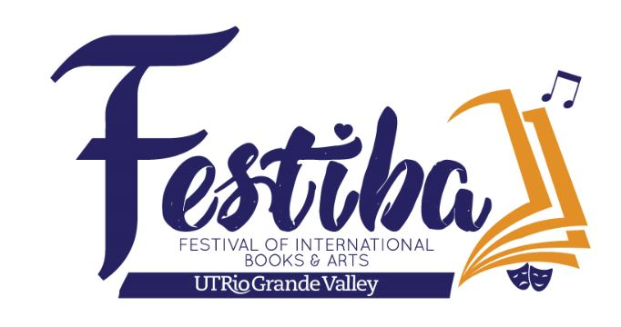
MARIACHI FESTIVAL 2026
February 27 & 28, 2026

School: _______________________________ City: ______________________________

Circle One: Individual Elementary Middle School High School

No. of Students Registering For Workshop: ________ No. of Directors: ________

Check appropriate participation(s): Competition ____Showcase ____ Workshops/Masterclass Only ____

List all directors: _________________________________________________________________________

Email Address: ___________________________________________________________________________

School Phone: ____________________________ Cell Phone: ___________________________________

Enrollment Fee: $50 per student (includes Workshops/Masterclass and Group Competition/Showcase)
If registering after February 17th, fee will increase to $60.00 per student

Additional $20 per student competing in Vocal Competition.

All Vocal Contestants must be registered for the workshops ($50.00 registration fee applies).
Directors may attend all events free of charge.

Total number of paying students: ________________ @ $50.00 = $ _________________

If registering after February 17th: ________________ @ $60.00 = $ _________________

Total number of Grand Concert tickets: __________ @ $20.00 = $ _________________

Individual Grand Concert Tickets will go on sale on Friday, February 27th from 9am-5pm.

Submit registration forms to festiba@utrgv.edu

Please submit payment at the time of registration at the PAC lobby. For more information call 956-665-3471 or email norma.salinas@utrgv.edu.

Workshop Registration Form cont.

School: _______________________ City: _______________________________

Circle One: Individual Elementary Middle School High School

Student Name Instrument
1
2.
3.
4.
5.
6.
7.
8.
9.
10.
11.
12.
13.
14.
15.
16
17.
18.
19.
20.
21.
22.
23.
24.
25.
26.
27.
28.

Group Competition Registration Form
MARIACHI FESTIVAL 2026
February 27 & 28, 2026

School: ______________________________________________City: _____________________________

Circle One: Middle School High School Junior Varsity 1A - 6A

High School Varsity 1A - 3A High School Varsity 4A High School Varsity 5A

High School Varsity 6A

Stage Name: ___________________________________________________________________________

No. of Students Competing: ______________________________________________________________

List all directors: _______________________________________________________________________

School Phone: _________________________________Cell Phone: ______________________________

Email Address: __________________________________________________________

Performance Times: Middle School: 6 to 8 minutes; High School: 8 to 10 minutes

Rules and Regulations of Competition
1. Groups may enter the following categories: High School Varsity (Classifications: 6A, 5A, 4A, 1A - 3A), High School Junior Varsity
1A - 6A, or Middle School. If there are not 2 or more groups in a single category, the groups will be moved up to the next category. Each category awards 1st, 2nd, and 3rd place winners. A Grand Champion from the High School 1A - 6A categories will be selected to play on the concert. Winners of the Vocal Competition and Middle School Competition will also perform on the concert.
2. High School Groups are allowed to play from 8 to 10 minutes. Middle School Groups are allowed to play from 6 to 8 minutes. Groups exceeding the time limit established for the competition will not be disqualified, but will be deducted points.
The clock starts with the first note played, and stops with the last note played. Directors, please refrain from excessive preparation time on stage. No sound check. Directors may only help students with adjustment of the microphones.
3. The stage plot will be the same for all groups. To assure the same sound quality for everyone, please do not move any microphones with the exception of the cordless mics.
4. All members of the performing group must be registered for FESTIBA 2026 Mariachi Festival.
5. Students may compete with only one mariachi ensemble and must be registered under one school.
6. If your school has only one mariachi, the group must compete at the Varsity level.
7. A Middle School student may compete at the HS level, but not vice-versa. Students may compete with only one mariachi ensemble.
8. Please be ready at least thirty minutes before scheduled competition time.

Public Admission to Competition: $10.00 at the door

Vocal Competition Registration Form
MARIACHI FESTIVAL 2026
February 27 & 28, 2026

Student’s Name: ______________________________________________________________________

Circle One: Middle School High School

Director(s): ___________________________________________________________________________

Email Address: _________________________________ School: ________________________________

Cell Phone: ____________________________________

Name of song to be performed: ____________________________________________________________

Are you registered with a school group? __________________

If yes, name of mariachi: __________________________________________________________________

Online vocal submissions are due February 15th. Audition videos should be uploaded to YouTube.
Please submit the link through the provided Google Form: Festiba Vocal Competition Submission
The videos will be reviewed by a panel of distinguished mariachi musicians.

Finalists will be announced February 17th. The finalists will be presented at the Vocal Competition Finals Concert.

Enrollment Fee: $20 per student competing in vocal competition.
If the Vocal Contestant wishes to attend the workshops, the $50.00 registration fee applies.

Submit registration form to festiba@utrgv.edu

Please submit payment at the time of registration at the PAC lobby. For more information call 956-665-3471 or email norma.salinas@utrgv.edu.

