USDA Research and Extension Experiences for Undergraduates (REEU) Undergraduate Scholars Internship Program
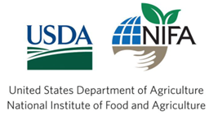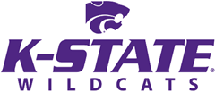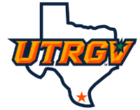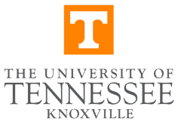

This REEU Program aims to offer student interns research and extension activities in the production of bioproducts from biomass. We seek to recruit undergraduates who are interested in achieving a sustainable bioeconomy. Student interns will take an active role in defining research challenges, performing experiments, analyzing data, and presenting results. The five areas of study are: M1: biomass deconstruction; M2: saccharification and fermentation; M3: metabolic engineering; M4: bioprocess engineering; and M5: economic and environmental evaluation.
Students participating as interns will engage in the following program activities:
- A stipend of $6,100 for interns to cover the costs of the summer research activities for 8 weeks.
- A spring seminar series to train interns in the fundamental skills and knowledge of biomanufacturing.
- 8-week summer hands-on research and extension experience in five modular areas of study. (M1-M5).
- A 2-day symposium to showcase intern research findings in the fall semester.

Specific activities for M1 include: (1) compositional analysis of biomass; (2) conducting pretreatment in various parr, sand baths, and oil bath reactors; (3) characterization of raw and pretreated biomass; and (4) providing insights into pretreatment mechanisms. Mentors: Dr. Jikai Zhao and Dr. Juhee Lee (UTRGV students are eligible to apply for this activity).
Specific activities for M2 include: (1) enzymatic hydrolysis of biomass; (2) bacterium and yeast cultivation; (3) product separation, purification, and analysis by using GC and HPLC; and (4) kinetic modeling of SHF and SSF processes. Mentors: Dr. Jikai Zhao and Dr. Juhee Lee (Dodge City Community College and UTRGV students are eligible to apply for this activity).
Specific activities for M3 include: (1) cell culturing; (2) molecular cloning; (3) metabolic pathway and strain design; (4) enzyme kinetics; and/or (5) genome engineering. Mentor: Dr. Cong Trinh (Southern Adventist University students are eligible to apply for this activity).
Specific activities for M4 include: (1) cell growth kinetics; (2) basics of bioreactor design; (3) dimensional analysis; (4) general scale-up rules and theories; and (5) mixing systems. Mentor: Dr. Hyun-Seob Song (UTRGV students are eligible to apply for this activity).
Specific activities for M5 include: (1) process simulation using SuperPro Designer; (2) conduct technoeconomic analysis and life-cycle assessment. Mentors: Dr. Jikai Zhao and Dr. Juhee Lee (Dodge City Community College and UTRGV students are eligible to apply for this activity).

Intern applicant qualifications:
1. Be enrolled at their respective college or university as a full-time undergraduate student in the spring semester before the summer internship and the fall semester after the summer internship.
2. Have a strong interest in learning one or more of the research modules and being a team player.
3. Have an overall GPA of at least 3.0. Major in Biology, Biochemistry, Chemistry or related STEM Field.
4. Will not graduate with a BS degree before the end of the fall 2027 semester from UTRGV.

Important dates and information:
Interested candidates should download an application via the link (https://www.utrgv.edu/usdareeu/) before November 16th, 2026 and email it to Dr. Michael Persans (michael.persans@utrgv.edu). The review committee will begin reviewing applications on November 17th, 2026, and continue until suitable candidates are selected. The accepted candidates will be informed via email of their selection for the program.

