

OIA: Contract+ Contract Request Guide (Academic Affairs)

Frequently Asked Questions

How to request Contract+ access?

To request access to Contract+, please submit a request to the Business Contracts Office at purchcontracts@utrgv.edu.

What is Contract+?

Contract+ is The University of Texas Rio Grande Valley’s contract management system used to submit, route, review, approve, and execute contracts and agreements. The system supports the full contract lifecycle, including initial request submission, institutional review, legal review when applicable, electronic signatures, and issuance of the fully executed agreement to all parties.

What is a Contract Request?

A contract request is the entry submitted in Contract+ to begin the review and approval of a contract or agreement.

Who is responsible for initiating the agreement?

The program coordinator/clinical coordinator initiates the agreement with the entity.

What types of educational agreements is OIA responsible for reviewing and processing?

The Office of Institutional Accreditation, Program Development, and Analysis (OIA) is responsible for reviewing and processing educational agreements that require signature by the appropriate university signatory, as delegated by the President. Common types of educational agreements reviewed and processed by OIA include the following:

• Educational Experience Affiliation Agreements
• Program Agreements
• Interlocal Cooperation Contracts
• Memoranda of Understanding
• Agreements of Cooperation with Foreign Institutions

What is a Work Group in Contract+?

In Contract+, a Work Group identifies the university office or functional area responsible for reviewing and processing a contract request after submission.

When a contract request is submitted, it is routed to the selected Work Group based on the type of agreement. The Work Group oversees the review process, coordinates required approvals, and manages next steps within the Contract+ workflow.

Are contract templates required to be accessible?

Yes. All contract templates must meet applicable accessibility standards. Departments are responsible for ensuring that all contract templates are accessible prior to submission, review, or execution.

When is legal review required from UTRGV’s Office of Legal Affairs?

Legal review is required when a non-standard contract is proposed. Non-standard contracts include agreements that contain substantive changes to an approved standard contract form or contracts that were not developed and approved by the UT System Office of General Counsel.

Changes limited to the names of the parties, amount of consideration, effective dates, or contract term are considered non-substantive and do not, by themselves, require legal review.

Does OIA track educational agreements that involve payments?

No, The Office of Institutional Accreditation, Program Development, and Analysis does not track or verify any monetary transactions or payment obligations outlined in educational agreements. Responsibility for monitoring, processing, and confirming payments associated with an agreement rests with the requesting department.

Can the student be placed at an agency without an agreement?

No, students should not be placed in an agency without a fully executed agreement.

Who should I contact if I have questions or need access to the Educational Agreements database?

For questions, concerns, or requests for access to the Educational Agreements database, please contact EducationalAgreements@utrgv.edu.

Submitting a Contract Request: Academic Affairs Workflow

Contract Request Name

To help differentiate contract requests, please use a clear name and descriptive contract name. Include the facility name, program name, agreement type, and Year of the contract.

Examples:

ABC Facility_EEAA_Std.
SON_ABC Facility_PA_Std.
ABC Facility_MOU_Nstd.
SON_ABC Facility_MOU Program_Nstd.

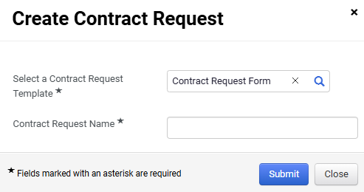

Attachments
Include all required attachments, including but not limited to the agreement, cover sheet, routing form, contract administrator certification form, etc.

Note:

Please review the following attachment requirements carefully before submitting your contract request:

- Attach the complete agreement, not just the signature page.
- Ensure all signatures and date fields are completed if the agreement has been partially executed prior to submission.
- Remove any blank pages, unless they are part of the agreement.
- If the agreement is non-standard, submit it in Word format and ensure it is fully completed (e.g., facility information, start and end dates), with no signatures.
- If the agreement is an approved standard contract, obtain the facility’s signature first and submit the document in PDF format.
- If submitting more than one agreement (ext. Affiliation and Program), each agreement must be submitted separately in Contracts+. Confirm that the agreement and all additional attachments are saved and uploaded as separate documents.
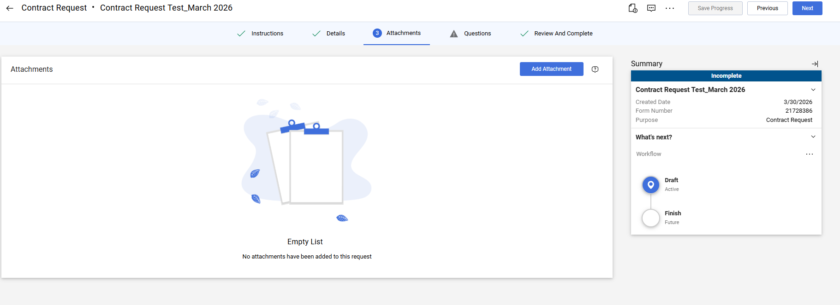

Work Group

For educational agreements, select Academic Affairs.

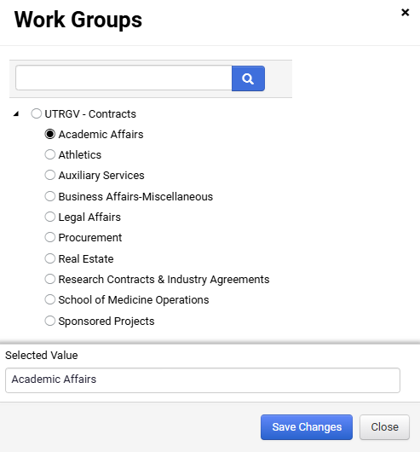

Type of Request

Please select one of the following: New Contract, Amendment, or Renewal.
For Amendments or Renewals, provide the original contract number and attach the fully executed agreement.

Examples:
DOHA-AFFISOM-XXX-XXXX
ACADAFF-AFFIL-XXXXXX

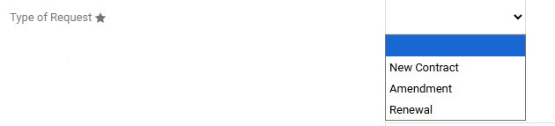

Summary

Provide a brief description of the agreement.

Examples:
- Standard educational affiliation agreement between UTRGV and XYZ.
- This is a Program Agreement between Department of XYZ and the identified agency for the provision of XYZ services by student interns.

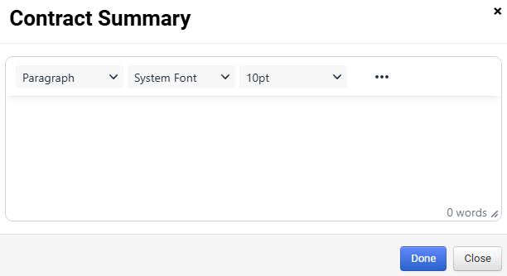

Benefit for UTRGV to execute this agreement

Add a brief description of the benefit of the agreement.

Examples:
- To enhance student clinical education
- This agreement allows UTRGV students to engage with the community by providing XYZ services to enhance student education

Start and End Dates

Enter the dates stated in the agreement. If applicable, select Update Start Date Upon Execution.
Note agreements with automatic or written renewal terms.

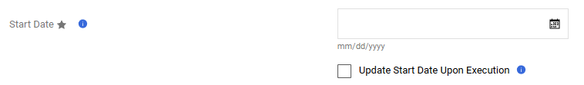

- Expires On – Contracts have specific start and end date (Agreement automatically ends; unless renewed) (i.e. start 1/1/2026; expires on 1/1/2031.
- No Expiration: Contracts do not have a defined end date and remain valid until terminated by one or both parties.
- Term: Length of time the contract is valid. This can be tied to an expiration date or renewal term.
- (i.e. This agreement has a term of 1 year starting 1/1/2026. Initial term is 2 years with automatic 1-year renewals.

Term | What it means | Example
Contract Expires | Has a fixed end date | Ends Dec 31, 2026
No Expiration | No end date | Continues until canceled
Term | Length of the contract | 1-year term

Estimated Total Contract Value

For standard educational agreements, enter “0” as the estimated total contract value. If the agreement states a different total value, enter the amount listed in the agreement.

Personal Information

Select “Not Applicable” for standard agreements.
If the agreement is a standard form with substantive changes or a non-standard form, UTRGV’s Office of Legal Affairs will review and incorporate the appropriate language as needed.

FERPA protected records: These include students’ personally identifiable information excluded from Directory Information such as but not limited to student ID numbers, student social security numbers, transcripts, GPA, financial records, and assignments. This also includes any directory information students have chosen to withhold from release to non-authorized parties. Visit here for more information: https://www.utrgv.edu/ucentral/registration/student-confidentiality-ferpa/index.htm.

HIPAA protected information: individually identifiable health information held or transmitted by a covered entity or its business associate, in any form or medium, whether electronic, on paper, or oral.

GDPR protected information: If the agreement is with a company located in the European Union or services will be accessible from a European Union Country and they will have access to Protected Personal Data or Special Category Personal Data as defined on GDPR such as name, an identification number, location data, credit card information, an online identifier as email address or to one or more factors specific to the physical, physiological, genetic, mental, economic, cultural or social identity of that natural person.

Personally Identifiable Information: Information that can identify an individual such as Social Security numbers, Drivers License, or other similar confidential information.

Additional Form Questions
- Software, Web Access, or Credit Card Payments: Select No for standard educational agreement unless otherwise stated.
- Dean/Department Chair Approval: Select Yes only if approval has already been obtained. If approval is still pending, select “No” and obtain approval before submission (or note the status in the Discussion section).
- Agreement Outside the U.S.: Select “Yes” if the agreement involves a second party located outside the United States or work/activities occurring outside the United States. Otherwise, select “No.”
- ARGO Number: Enter the ARGO number if one has been assigned to the request. If an ARGO number has not been created/assigned, leave this field blank (or enter “N/A,” if the field requires an entry).
  - Note: Use the ARGO number shown in the request record (if available).

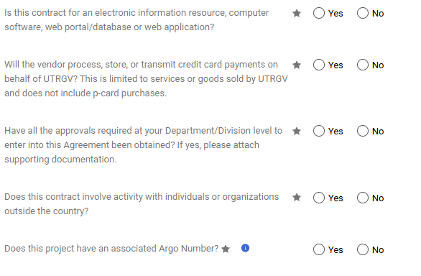

Requesting Department

This should include the UTRGV requestor’s name (or primary contact).

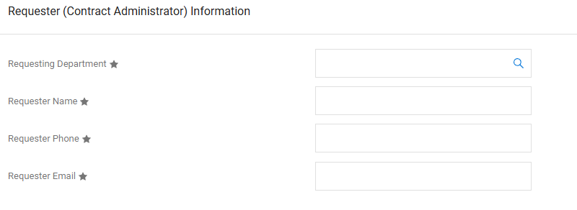

Second Party

Search for the second party first. If they are listed, please select the second party. Include, the second party’s Contact Name, Phone, and email address.

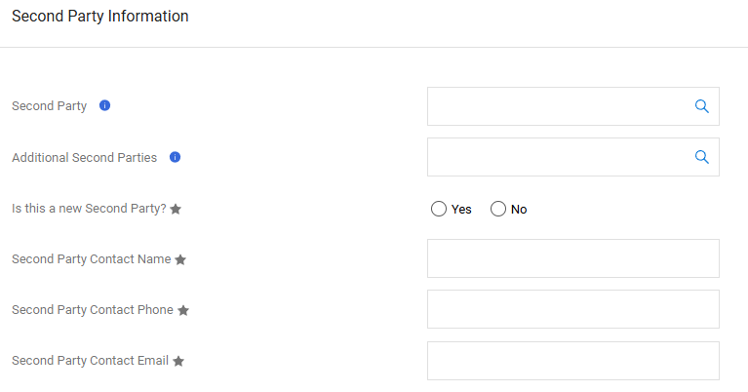

Is this a new Second Party?

If not listed, select Yes, enter the legal name, address, and other required information. Please ensure the second party is identified as a new entity, as this designation is critical and will impact the processing of the agreement.

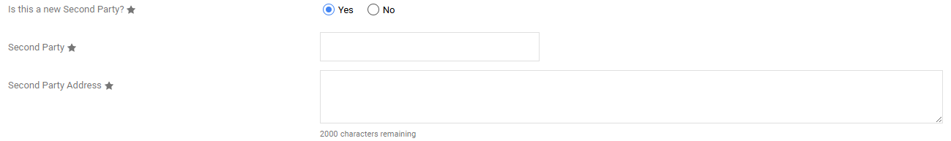

Encumbrance/Revenue Generating/Non-Monetary Contract

Standard educational agreements are typically non-monetary contracts. Verify agreements language before selecting responses. For Revenue Generating Contracts, please verify language.

Note: OIA is not responsible for any tracking or confirmation of money exchange outlined in the agreement. These responsibilities fall within the requesting department.

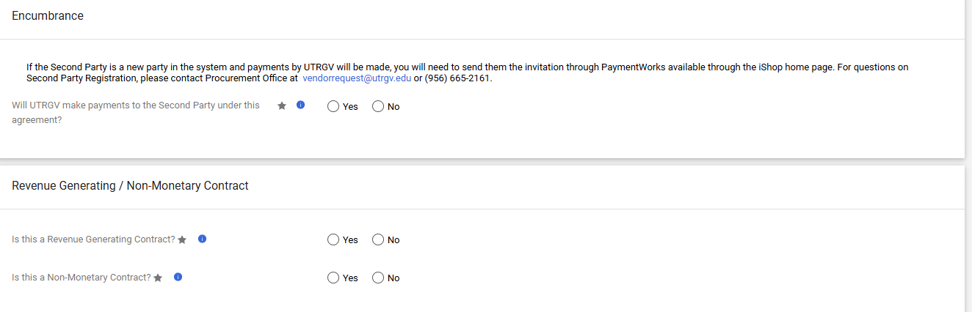

Discussion
If the agreement has undergone UTRGV legal review or requires UTRGV legal review, note this in the discussion section. If additional comments are needed, they should also be included in the discussion section.
Example:

Departmental approval or information

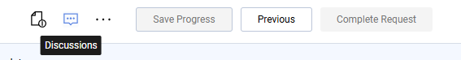

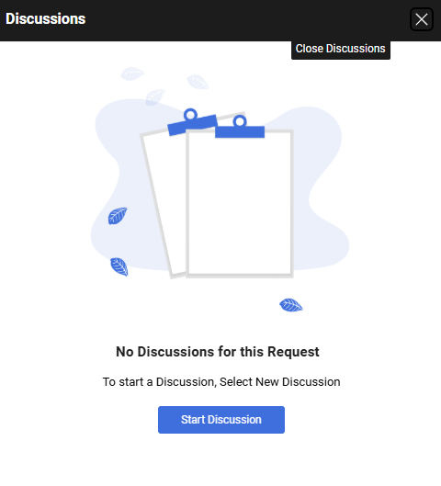

Review and Complete

Confirm all sections are completed before submitting.
Green check marks for each section will indicate completion.

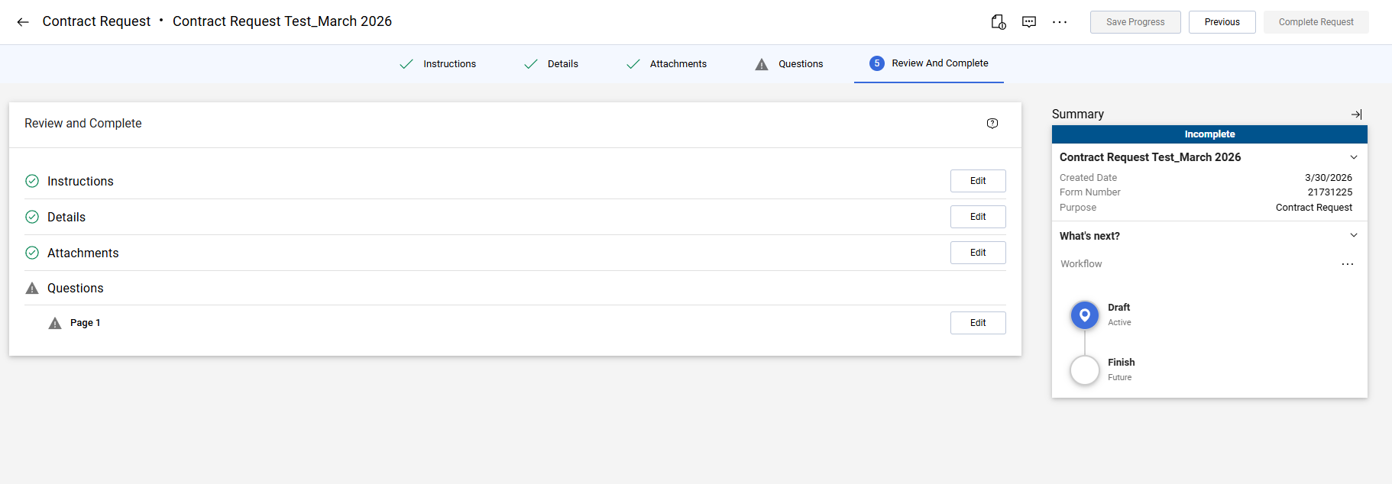

Contract Request Workflow

This section will update the contract requester with the workflow of the contract.

Below is the workflow for Second Parties that are not new.

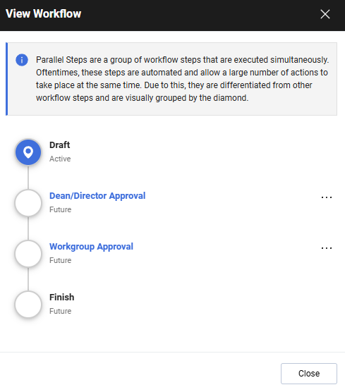

Below is the workflow for the Second Parties that are new to Contract+.

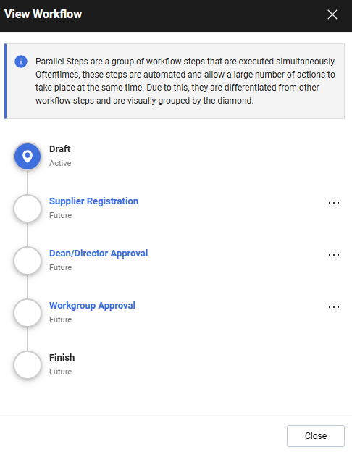

Important Details

- No students should be placed in an agency without a fully executed affiliation agreement on file.
- Program Coordinator/Clinical Coordinators should be vigilant of expiration dates for all Affiliation Agreements, MOUs, and Contracts. If a program would like to renew or extend an agreement, please contact EducationalAgreements@utrgv.edu three to four months before the agreement expires.
- No students should be contacting the OIA, or UTRGV’s Office of Legal Affairs for status regarding contracts.
- Please allow a minimum of 90-120 business days for full execution of Non-Standard agreements as they will require legal review from both parties, and in some cases, may require UT System approval.
- Please allow a minimum of 30 business days for full execution of standard agreements.

